* Copy all the files of 2X44 to CCS 12.8.1 from the directory AWR2X44P_CSP.zip

* CCS – we need to download a specific CCS version (12.8.1)
* Make sure device is in flashing mode – both jumper are closed
* Building the environment - C:\ti\mmwave_mcuplus_sdk_04_07_00_01\mmwave_mcuplus_sdk_04_07_00_01\scripts\windows Cmd →setenv.bat

Change the device to awr2x44P → SAVE

Run → Setenv.bat

In file C:\ti\mmwave_mcuplus_sdk_04_07_00_01\mmwave_mcuplus_sdk_04_07_00_01\tools\awr2x44P → default.cfg change to the correct device

* Now the environment is built, Change in default file the following :
* Debug mode: --file=../../ti/utils/ccsdebug/awr2x44P_ccsdebug.appimage --operation=flash --flash-offset=0xA0000
* we are in flashing mode

**Step 1 :** switch to UART Boot Mode (SOP0: 1, SOP1: 0, SOP2: 1)

* C:\ti\mmwave_mcuplus_sdk_04_07_00_01\mcu_plus_sdk_awr2x44p_10_00_00_07\tools\boot

**Step 2** : run Python command

C:\ti\mmwave_mcuplus_sdk_04_07_00_01\mmwave_mcuplus_sdk_04_07_00_01\tools\awr2x44P>python C:\ti\mmwave_mcuplus_sdk_04_07_00_01\mcu_plus_sdk_awr2x44p_10_00_00_07\tools\boot\uart_uniflash.py -p COM10 --cfg=default.cfg

{ Remark : using this command when the bottom does not work , python uart_uniflash.py -p COM<x> --cfg=sbl_prebuilt/awr2x44p-evm/default_sbl_null.cfg }

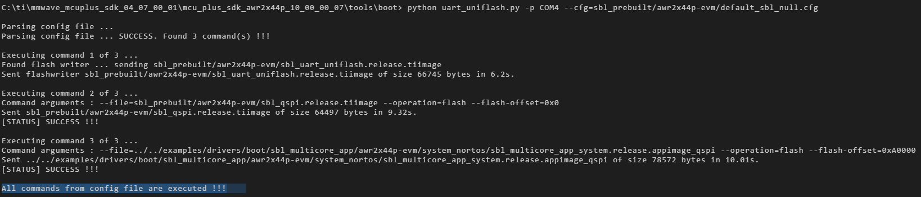

* Transition from Functional mode to Debug mode
* Open CCS – 12.8.1
* open view --> target configuration --> create ccxml file (with the correct AWR)

🡪 right click 🡪 launch selected configuration

* Group 🡪 connect
* CPU reset for each core 🡪
* Run -- > load program 🡪 Load 🡪 C:\ti\mmwave_mcuplus_sdk_04_07_00_01\mmwave_mcuplus_sdk_04_07_00_01\ti\demo\awr2x44P\mmw_ddm
* Do it for each core .
* For each core press play (green button) , correct output in the green text below
  + - [Cortex_R5_0] **********************************************
    - Debug: Launching the MMW Demo on MSS
    - **********************************************
    - Debug: Launched the Initialization Task
    - BSS is powered up...
    - Debug: mmWave Control Initialization was successful
    - Debug: mmWave Control Synchronization was successful
    - Debug: CLI is operational
* User Define – New Target configuration - Set configuration for the right device “target configuration” you should see the AWR2x44
* Connect target (Each Core) in case this is not working,
  + Make sure device is in debug mode
  + Reset device and do again
* Upload for each core the program using this path -> C:\ti\mmwave_mcuplus_sdk_04_07_01_03\mmwave_mcuplus_sdk_04_07_01_03\ti\demo\awr2x44P\mmw_ddm each file to the right core.
* After run all the 3 cores (clicking run) make sure you are restarting the cores
* You can use Putty  / terra term to see that we are receiving data

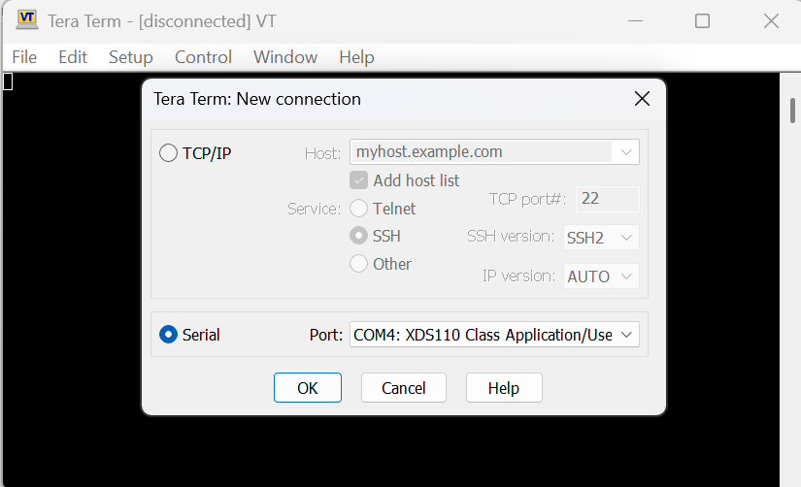

* Set baudrate to 115200 , press enter in the terminal
* 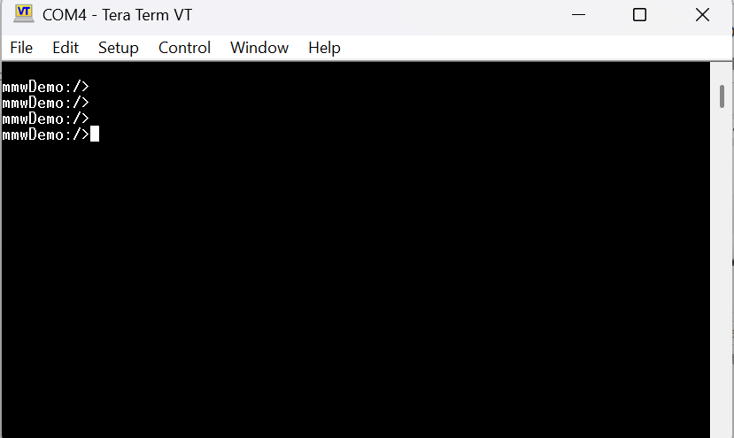

* Open another tera term for auxiliary 🡪 output
* Open folder for configuration files C:\ti\mmwave_mcuplus_sdk_04_07_00_01\mmwave_mcuplus_sdk_04_07_00_01\ti\demo\awr2x44P\mmw_ddm\profiles\awr2E44P
* Copy the information to tera win application