**Com port**

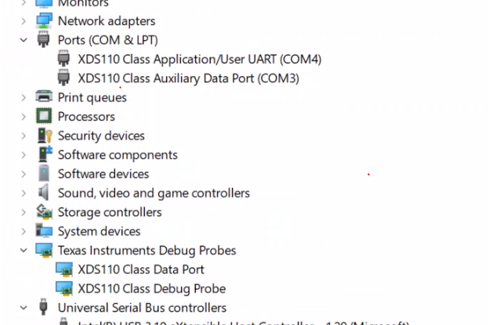

**Bin File**

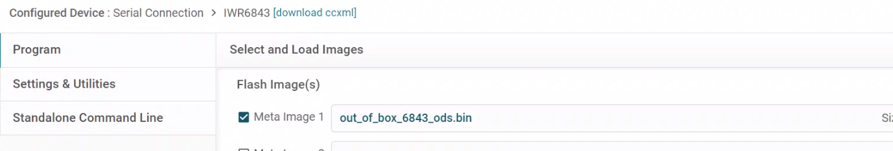

**Com port Select while flashing**

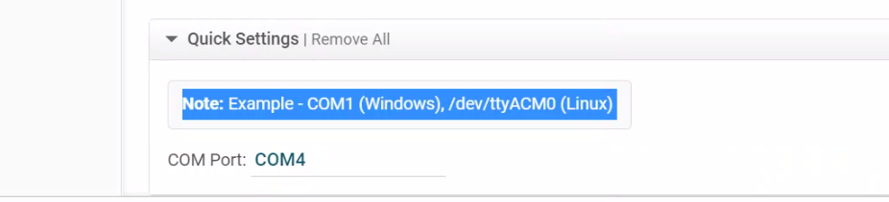

**Connecting Error:**

