**Changing the IWR6843 Com from the XDS110 to the FTDI FT4232**

**Background**

The IWR6843 Boost Carrier board uses the TI debug IC, XDS110 to create two virtual com ports for communication to the IER6843 radar IC. One port called UART is used to send setup data to the IC and the other com port used to receive high speed data from the radar IC. This steam is called “Data”. The two ports look like this in Device Manager:

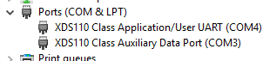

When setting up the People Tracking Lab 19, the GUI requests these two ports to setup and gather data from the radar.

We will be using the FTDI FT4232 quad com chip to service two IWR6843 radar ICs. The Boost board has a FT4232 that can connect to radar IC. This will allow us testing to see if this com system will work.

**Connecting the FT4232**

The FT4232 on the TI boost board has a special eeprom that configures it to a specific name:

AR-DevPack-EVM-012.

Using the FTDI drivers on the FTDI web site will not work for this part. The correct drivers can be found at the install site for the TI SDK:

C:\ti\mmwave_sdk_03_00_00_08\tools\ftdi

Once connected the 4 UARTs in the FT4232 will be given virtual com ports similar to below:

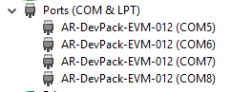

Remember that the USB cable from the PC to the Boost board must be plugged into the FTDI_USB connector on the boost board and not the XDS110 connector.

**Setting the Muxes to Connect to the FTDI Chip**

The DIP style switch S1 on the front of the boost board is used to set the multiplexer options on the radar.

Three signals need to be connected. They are the RADAR_RS232RX and TX as the UART setup data and

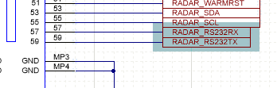Radar Setup UART on J4,

The RADAR_RS232RX/TX can be directed to the FT4232 by setting switch S1.5 to off.

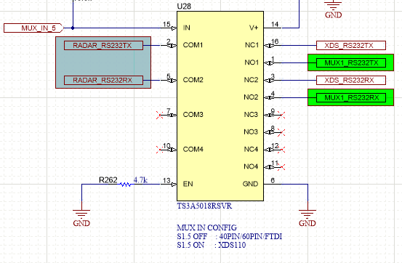

And checking that S1-7 is on:

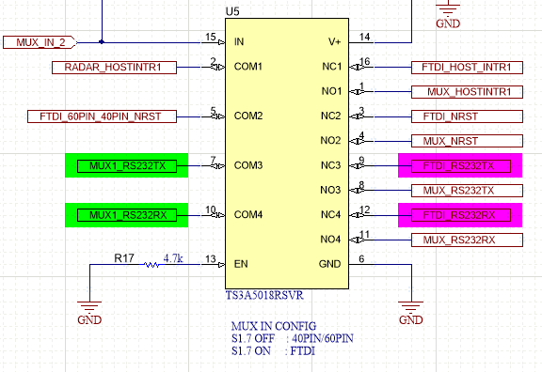

This port connects to UART-C on the FT4232. The corresponding port address is COM7.

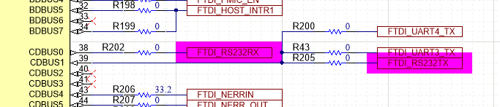

R200, R202, R205 and R43 are all populated. FTDI_UART3/4 are not connected with S1.3 off.

The high speed data leaves the MSS_LOGGER pin on the radar connector:

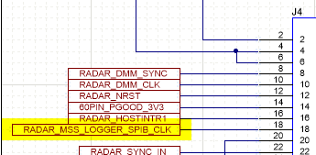 Radar HS data output on J4

Setting S1.3 off connects this to MUX_CLK2.

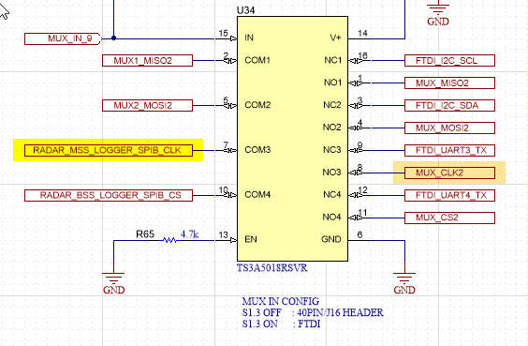

S1.2 on sets MUX_CLK2 to the 40PIN_BSS_LOGGER.

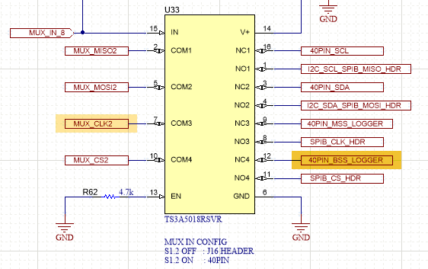

The BSS_LOGGER net connects to two other nets through R362. This resistor needs to be installed. One of the nets is the FTDI_DSS_LOGGER through R361. This will lead to UARTD on the FT4232. The other net is RADAR_DP7 on the radar board. This may or may not get in the way of signals on the BSS_LOGGER net so to be safe R28, 20Ω on the ISK radar board needs to be removed.

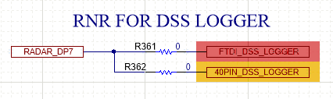

The FTDI_DSS_LOGGER signal connects to the TX input on UARTD of the FT4232. R211 is not populated isolating FTDI_UART4_TX.

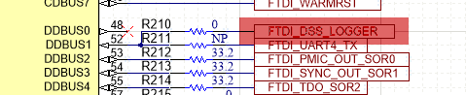

**Summary of Changes to Test the FT4232**

Switch S1 settings:

S1.1 OFF  
S1.2 ON  
S1.3 OFF  
S1.4 ON  
S1.5 OFF Turn this switch back on to use the XDS110 USB port.  
S1.6 ON  
S1.7 ON  
S1.8 OFF  
S1.9 OFF  
S1.10 ON  
S1.1 1 ON  
S1.1 2 ON

Resistors:

Remove R26 on the IWR6843ISK radar board.

Port Setup:

Third virtual com port is the setup UART  
 Fourth virtual com port is the HS Data.