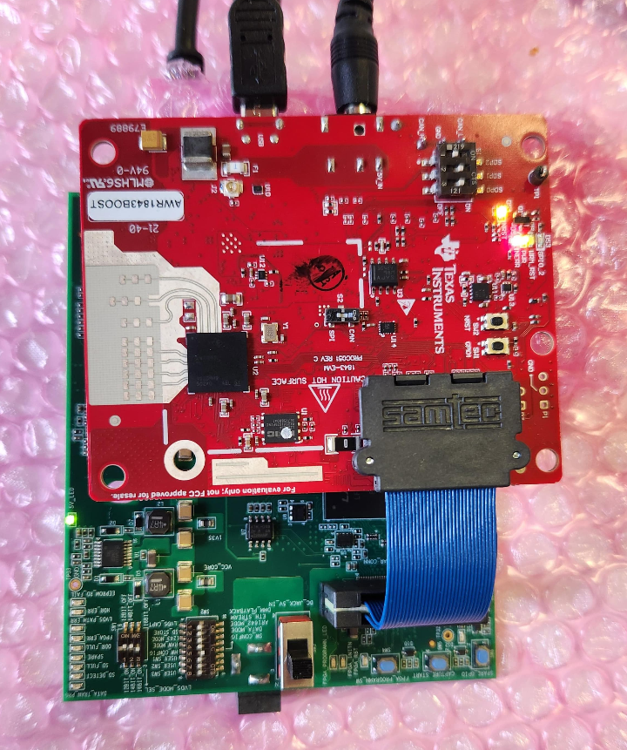

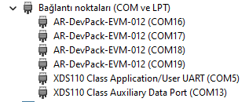

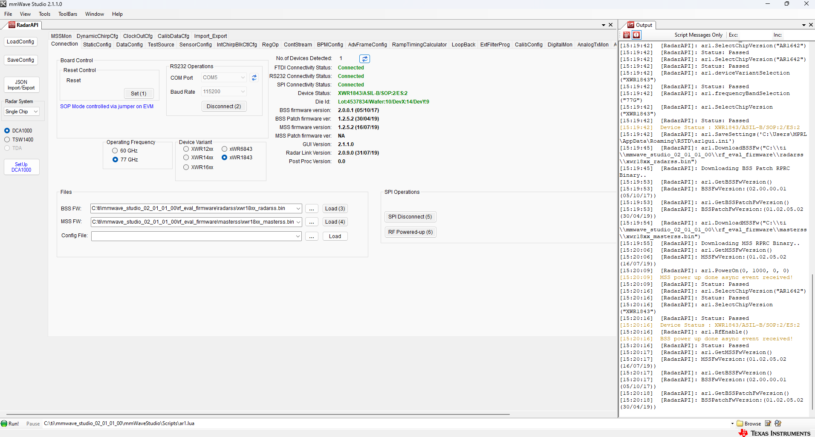
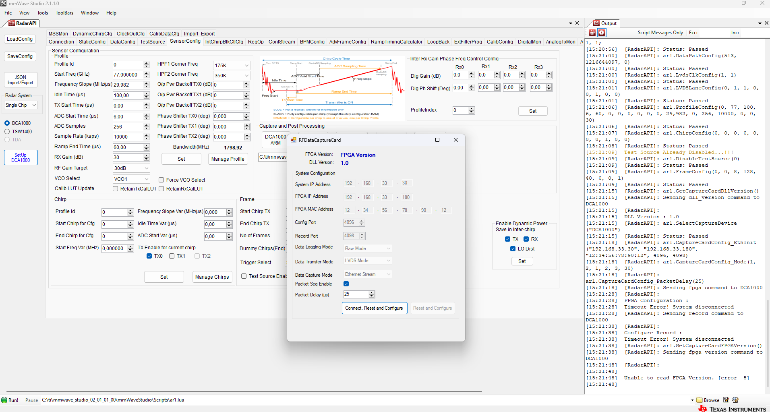

GM: Constructor
GM: Thu May 09 15:16:06 2024
RSTD.Transmit("/Settings")
[15:16:07]
[15:16:07] ### Running Startup script: "C:\ti\mmwave_studio_02_01_01_00\mmWaveStudio\Scripts\Startup.lua" ###
[15:16:07] RSTD.SetAndTransmit ("/Settings/Scripter/Display DateTime" , "1")
[15:16:07] RSTD.SetAndTransmit ("/Settings/Scripter/DateTime Format" , "HH:mm:ss")
[15:16:07] Scripter ignored: Attempt to UnBuild() again or before Build.
[15:16:07] RSTD.SetVar ("/Settings/Clients/Client 0/Dll" , "C:\\ti\\mmwave_studio_02_01_01_00\\mmWaveStudio\\Clients\\\\LabClient.dll")
[15:16:07] RSTD.SetVar ("/Settings/Clients/Client 0/Use" , "TRUE")
[15:16:07] RSTD.SetVar ("/Settings/Clients/Client 1/Use" , "FALSE")
[15:16:07] RSTD.SetVar ("/Settings/Clients/Client 2/Use" , "FALSE")
[15:16:07] RSTD.SetVar ("/Settings/Clients/Client 3/Use" , "FALSE")
[15:16:07] RSTD.SetVar ("/Settings/Clients/Client 4/Use" , "FALSE")
[15:16:07] RSTD.SetVar ("/Settings/AL Client/AL Dll" , "C:\\ti\\mmwave_studio_02_01_01_00\\mmWaveStudio\\RunTime\\SAL.dll")
[15:16:07] RSTD.SetVar ("/Settings/Clients/Client 0/GuiDll" , "")
[15:16:07] RSTD.SetVar ("/Settings/AutoUpdate/Enabled" , "TRUE")
[15:16:07] RSTD.SetVar ("/Settings/AutoUpdate/Interval" , "1")
[15:16:07] RSTD.SetVar ("/Settings/Monitors/UpdateDisplay" , "TRUE")
[15:16:07] RSTD.SetVar ("/Settings/Monitors/OneClickStart" , "TRUE")
[15:16:07] RSTD.SetVar ("/Settings/Automation/Automation Mode" , "false")
[15:16:07] RSTD.Transmit("/")
[15:16:07] RSTD.SaveSettings(): Settings saved to "C:\Users\MPRL\AppData\Roaming\RSTD\config.xml"
[15:16:07] RSTD.Build()
[15:16:07] RSTD.SaveSettings(): Settings saved to "C:\Users\MPRL\AppData\Roaming\RSTD\config.xml"
[15:16:07] RSTD.Transmit("/")
[15:16:07] RSTD.AL_Build()
[15:16:07] RSTD.AL_LoadXml()
[15:16:07] RSTD.Transmit("/")
[15:16:07] RSTD.AL_Init()
[15:16:07] RSTD.Clients_Build()
[15:16:07] GM: Init
[15:16:07] GM: Loaded 'C:\ti\mmwave_studio_02_01_01_00\mmWaveStudio\Clients\\LabClient.dll'
[15:16:07] GM: 1 Guest (s) init
[15:16:07] GM: 1 Module(s) init
[15:16:07] GM: 2 Tab (s) init
[15:16:07] RSTD.Client_LoadXml()
[15:16:08] [RadarAPI]: ar1.selectRadarMode(0)
[15:16:08] [RadarAPI]: Status: Passed
[15:16:08] Matlab Runtime Engine is installed
[15:16:08] [RadarAPI]: Starting Matlab Engine..
[15:16:29] [RadarAPI]: Matlab Engine Started!
[15:16:31] [RadarAPI]: ar1.selectCascadeMode(0)
[15:16:31] [RadarAPI]: Status: Passed
[15:16:31] [RadarAPI]: ar1.LoadSettings('C:\Users\MPRL\AppData\Roaming\RSTD\ar1gui.ini')
[15:16:31] [RadarAPI]: Error: Dizin, dizi sınırlarının dışındaydı.
[15:16:31] Trace:
[15:16:31] konum: AR1xController.ScriptOps.getMatlabPostProcVersion()
[15:16:31] TESTING = false
[15:16:31] RstdNet: Port 2777: Listening..
[15:16:31]
[15:16:31] ***Script completed successfully.***
[15:19:23] [RadarAPI]: Opening Gpio Control Port()
[15:19:23] [RadarAPI]: Status: Passed
[15:19:24] [RadarAPI]: Opening Board Control Port()
[15:19:24] [RadarAPI]: Status: Passed
[15:19:25] [RadarAPI]: ar1.FullReset()
[15:19:25] [RadarAPI]: Status: Passed
[15:19:26] [RadarAPI]: Closing Board Control Port()
[15:19:26] [RadarAPI]: Status: Passed
[15:19:26] [RadarAPI]: Closing Gpio Control Port()
[15:19:26] [RadarAPI]: Status: Passed
[15:19:26] [RadarAPI]: ar1.SOPControl(2)
[15:19:26] [RadarAPI]: Status: Passed
[15:19:40] [RadarAPI]: ar1.Connect(5,115200,1000)
[15:19:41] [RadarAPI]: ar1.Calling_IsConnected()
[15:19:42] [RadarAPI]: ar1.SelectChipVersion("AR1642")
[15:19:42] [RadarAPI]: Status: Passed
[15:19:42] [RadarAPI]: ar1.SelectChipVersion("AR1642")
[15:19:42] [RadarAPI]: Status: Passed
[15:19:42] [RadarAPI]: ar1.deviceVariantSelection("XWR1843")
[15:19:42] [RadarAPI]: Status: Passed
[15:19:42] [RadarAPI]: ar1.frequencyBandSelection("77G")
[15:19:42] [RadarAPI]: ar1.SelectChipVersion("XWR1843")
[15:19:42] [RadarAPI]: Status: Passed
[15:19:42] Device Status : XWR1843/ASIL-B/SOP:2/ES:2
[15:19:42] [RadarAPI]: ar1.SaveSettings('C:\Users\MPRL\AppData\Roaming\RSTD\ar1gui.ini')
[15:19:45] [RadarAPI]: ar1.DownloadBSSFw("C:\\ti\\mmwave_studio_02_01_01_00\\rf_eval_firmware\\radarss\\xwr18xx_radarss.bin")
[15:19:45] [RadarAPI]: Downloading BSS Patch RPRC Binary..
[15:19:53] [RadarAPI]: ar1.GetBSSFwVersion()
[15:19:53] [RadarAPI]: BSSFwVersion:(02.00.00.01 (05/10/17))
[15:19:53] [RadarAPI]: ar1.GetBSSPatchFwVersion()
[15:19:53] [RadarAPI]: BSSPatchFwVersion:(01.02.05.02 (30/04/19))
[15:19:54] [RadarAPI]: ar1.DownloadMSSFw("C:\\ti\\mmwave_studio_02_01_01_00\\rf_eval_firmware\\masterss\\xwr18xx_masterss.bin")
[15:19:55] [RadarAPI]: Downloading MSS RPRC Binary..
[15:20:06] [RadarAPI]: ar1.GetMSSFwVersion()
[15:20:06] [RadarAPI]: MSSFwVersion:(01.02.05.02 (16/07/19))
[15:20:09] [RadarAPI]: ar1.PowerOn(0, 1000, 0, 0)
[15:20:09] MSS power up done async event received!
[15:20:09] [RadarAPI]: Status: Passed
[15:20:16] [RadarAPI]: ar1.SelectChipVersion("AR1642")
[15:20:16] [RadarAPI]: Status: Passed
[15:20:16] [RadarAPI]: ar1.SelectChipVersion("XWR1843")
[15:20:16] [RadarAPI]: Status: Passed
[15:20:16] Device Status : XWR1843/ASIL-B/SOP:2/ES:2
[15:20:16] [RadarAPI]: ar1.RfEnable()
[15:20:16] BSS power up done async event received!
[15:20:16] [RadarAPI]: Status: Passed
[15:20:17] [RadarAPI]: ar1.GetMSSFwVersion()
[15:20:17] [RadarAPI]: MSSFwVersion:(01.02.05.02 (16/07/19))
[15:20:17] [RadarAPI]: ar1.GetBSSFwVersion()
[15:20:17] [RadarAPI]: BSSFwVersion:(02.00.00.01 (05/10/17))
[15:20:18] [RadarAPI]: ar1.GetBSSPatchFwVersion()
[15:20:18] [RadarAPI]: BSSPatchFwVersion:(01.02.05.02 (30/04/19))
[15:20:54] [RadarAPI]: ar1.ChanNAdcConfig(1, 1, 0, 1, 1, 1, 1, 2, 1, 0)
[15:20:55] [RadarAPI]: Status: Passed
[15:20:56] [RadarAPI]: ar1.LPModConfig(0, 0)
[15:20:56] [RadarAPI]: Status: Passed
[15:20:56] [RadarAPI]: ar1.RfInit()
[15:20:56] RF Init async event received!
[15:20:56] [RadarAPI]: Time stamp, Temperture: 40235,40; APLL Status, Update: 1, 0; SynthVCO1 Status, Update: 1, 1; SynthVCO2 Status, Update: 1, 1; LODist Status, Update: 1, 1; RxADCDC Status, Update: 1, 1; HPFcutoff Status, Update: 1, 1; LPFcutoff Status, Update: 1, 1; PeakDetector Status, Update: 1, 1; TxPower Status, Update: 1, 1; RxGain Status, Update: 1, 1; TxPhase Status, Update: 1, 1; RxIQMM Status, Update: 1, 1;
[15:20:56] [RadarAPI]: Status: Passed
[15:21:00] [RadarAPI]: ar1.DataPathConfig(513, 1216644097, 0)
[15:21:00] [RadarAPI]: Status: Passed
[15:21:00] [RadarAPI]: ar1.LvdsClkConfig(1, 1)
[15:21:00] [RadarAPI]: Status: Passed
[15:21:01] [RadarAPI]: ar1.LVDSLaneConfig(0, 1, 1, 0, 0, 1, 0, 0)
[15:21:01] [RadarAPI]: Status: Passed
[15:21:06] [RadarAPI]: ar1.ProfileConfig(0, 77, 100, 6, 60, 0, 0, 0, 0, 0, 0, 29,982, 0, 256, 10000, 0, 0, 30)
[15:21:06] [RadarAPI]: Status: Passed
[15:21:07] [RadarAPI]: ar1.ChirpConfig(0, 0, 0, 0, 0, 0, 0, 1, 0, 0)
[15:21:08] [RadarAPI]: Status: Passed
[15:21:09] Test Source Already Disabled...!!!
[15:21:09] [RadarAPI]: ar1.DisableTestSource(0)
[15:21:09] [RadarAPI]: Status: Passed
[15:21:09] [RadarAPI]: ar1.FrameConfig(0, 0, 8, 128, 40, 0, 0, 1)
[15:21:09] [RadarAPI]: Status: Passed
[15:21:15] [RadarAPI]: ar1.GetCaptureCardDllVersion()
[15:21:15] [RadarAPI]: Sending dll_version command to DCA1000
[15:21:15] [RadarAPI]:
[15:21:15] DLL Version : 1.0
[15:21:15] [RadarAPI]: ar1.SelectCaptureDevice("DCA1000")
[15:21:15] [RadarAPI]: Status: Passed
[15:21:18] [RadarAPI]: ar1.CaptureCardConfig_EthInit("192.168.33.30", "192.168.33.180", "12:34:56:78:90:12", 4096, 4098)
[15:21:18] [RadarAPI]: ar1.CaptureCardConfig_Mode(1, 2, 1, 2, 3, 30)
[15:21:18] [RadarAPI]: ar1.CaptureCardConfig_PacketDelay(25)
[15:21:18] [RadarAPI]: Sending fpga command to DCA1000
[15:21:28] [RadarAPI]:
[15:21:28] FPGA Configuration :
[15:21:28] Timeout Error! System disconnected
[15:21:28] [RadarAPI]: Sending record command to DCA1000
[15:21:38] [RadarAPI]:
[15:21:38] Configure Record :
[15:21:38] Timeout Error! System disconnected
[15:21:38] [RadarAPI]: ar1.GetCaptureCardFPGAVersion()
[15:21:38] [RadarAPI]: Sending fpga_version command to DCA1000
[15:21:48] [RadarAPI]:
[15:21:48]
[15:21:48] Unable to read FPGA Version. [error -5]
[15:21:48]

