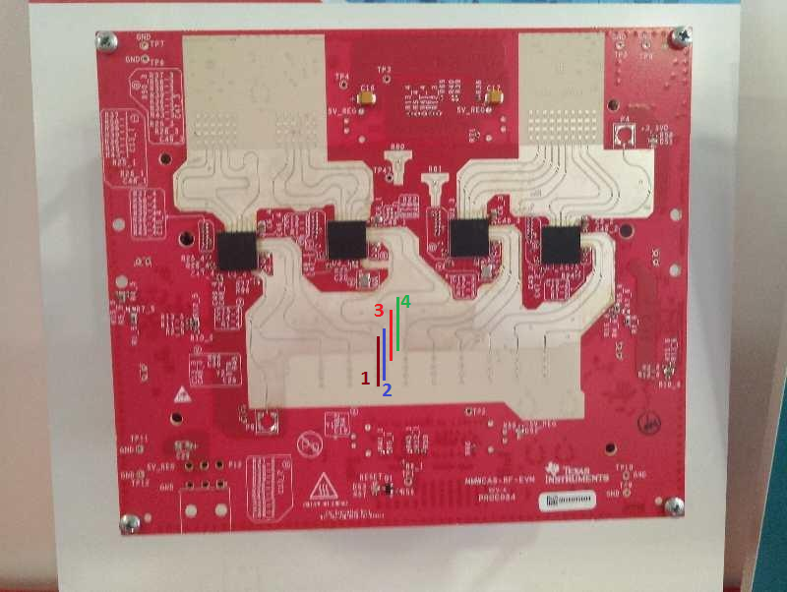

It is four Chip cascade Ti demo system. The antennas 1,2,3,4 in the figure respectively represent transmitting antennas, and the antennas 2,3 and 4 are used to measure vertical angles. I found that the vertical spacing between the 2, 3, and 4 antennas is not equidistant. What is the horizontal and vertical spacing between antennas 1,2,3 and 4?

Regards,
Steven

