 Nicole,

Hope you are doing well. There is no external temperature sensor. As mentioned above the temperature is being read via the thermal register inside the proximity sensor.

Do you have a SPICE model of the LMP91300 that I can use in LTspice to do simulations?

Is the typical high output of output driver on the SWDRV pin 5V?

I have been at US Cargo Systems for about 3 months. I have inherited this design and have been given the task to resolve the temperature issues so we can go into production. They have basically copied the typical application (3-Wire NPN Configuration) shown in figure 19, except there is no LED between the V+/EXT and LED terminals. The V+/EXT and LED terminals are shorted. In analyzing and simulating this circuit, I have noticed two things.

1. For the Rsense resistor they put 0K ohms. With that said, you are unable to meet the specification for the output driver current on the SWDRV terminal (SWDRV current (00b) of 2.5mA. In figure 19, they do not have a series resistor on the output of the SWDRV terminal. If the typical high output of the output driver on the SWDRV pin is 5V, then you will be exceeding the specification for the over current detection threshold of 310mV across the Rsense resistor. Two things I have done in my simulation (**see next page**), that is not in the current design, I changed Rsense from 0 ohms to 1 ohm (want to keep Rsense a small value) and added a series resistor on the output of the SWDRV terminal. This will allow me to meet the specification for the output driver current on the SWDRV terminal (SWDRV current (00b) of 2.5mA and it will allow me to meet the specification for the over current detection threshold of 310mV across the Rsense resistor. Please let me know if you see any issues with the simulation done in LTspice

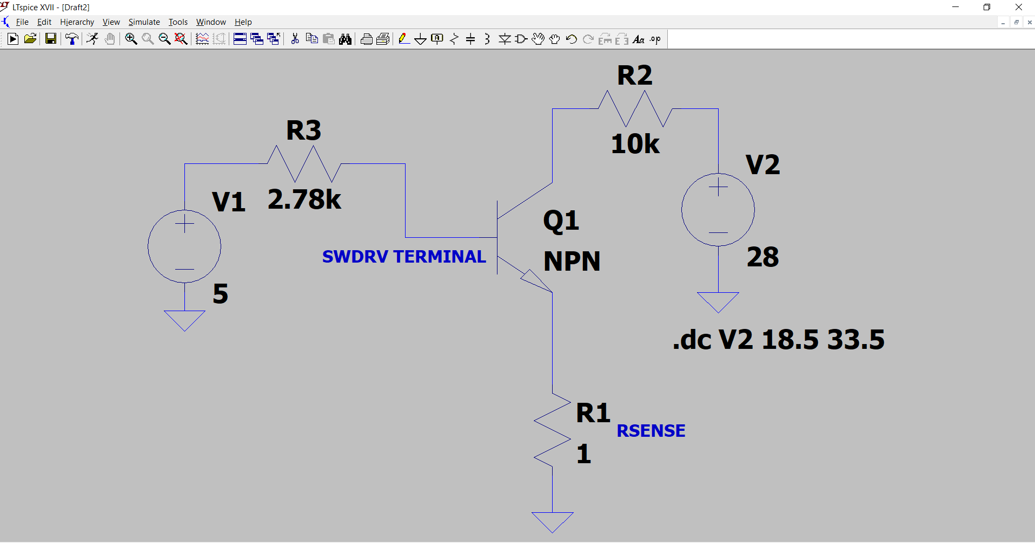

1. Given the output of regulator at the V+/EXT E terminal is typically 5V, when the NPN transistor turns on it will be shorting the loop voltage (6.5V to 40V) to 5V. That is assuming the NPN transistor is operating as a switch (saturation mode), not linear mode. I do not see a current limiting resistor between the V+/EXT and LED terminals in figure 19, unless it is internal to the LMP91300. I asked the question earlier, during a read of registers are they modulating the current by bringing the LED terminal to ground? Two things I have done in my simulation (**see next page**), that is not in the current design, is add a series resistor on the collector of the NPN transistor to isolate the loop voltage and 5V and added a resistor between the V+/EXT and LED terminals. This will allow me to meet the specification for the supply current (Iv+) of 3mA. Please let me know if you see any issues with the simulation done in LTspice.

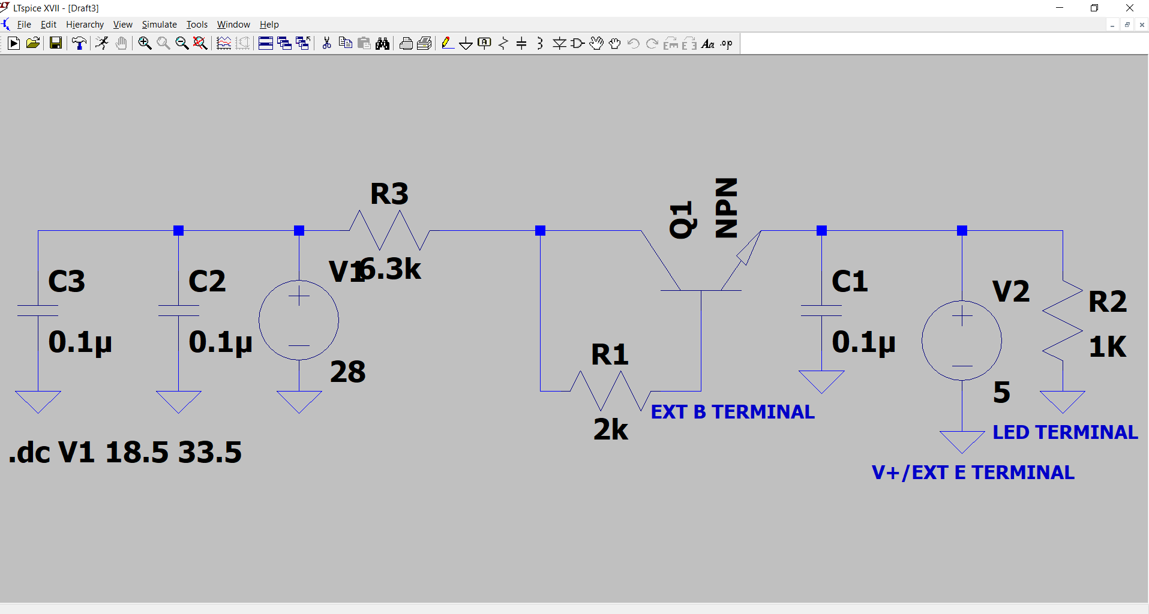

Do you think making the above changes to the physical board, that I have simulated, will resolve the issues we are seeing in failure scenarios 1-3?

Thanks,

Craig