Hardware:
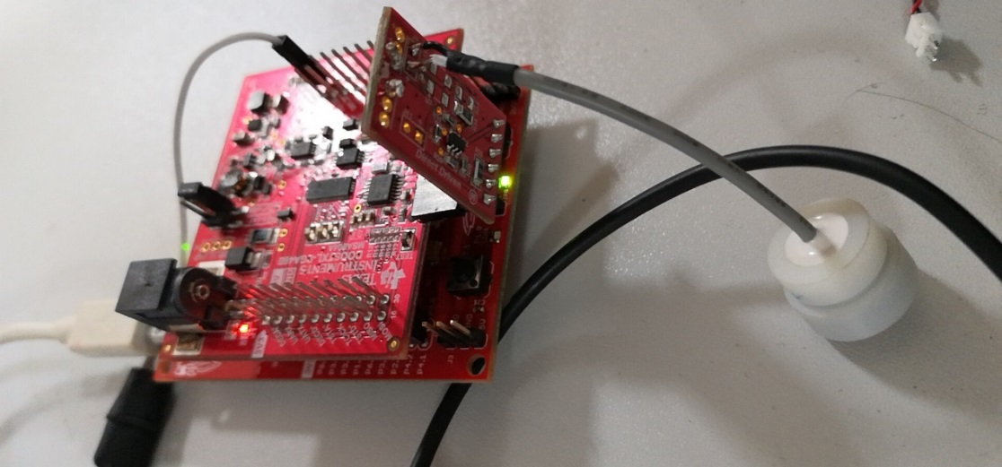

Direct-driven schematic diagram:
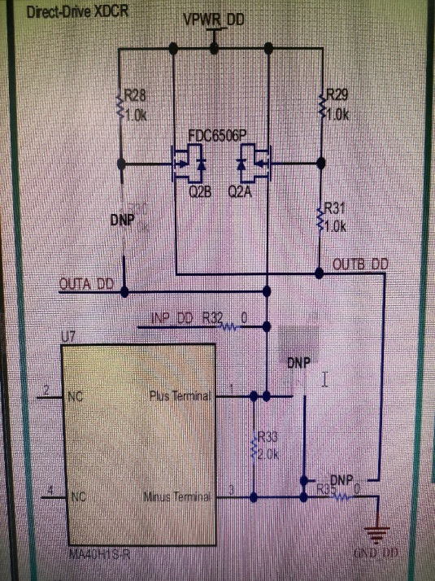
The hardware connection has been modified according to the schematic diagram. But something has been change, remove U7 and R33 =3.3k

PGA460-Q1 schematic diagram:
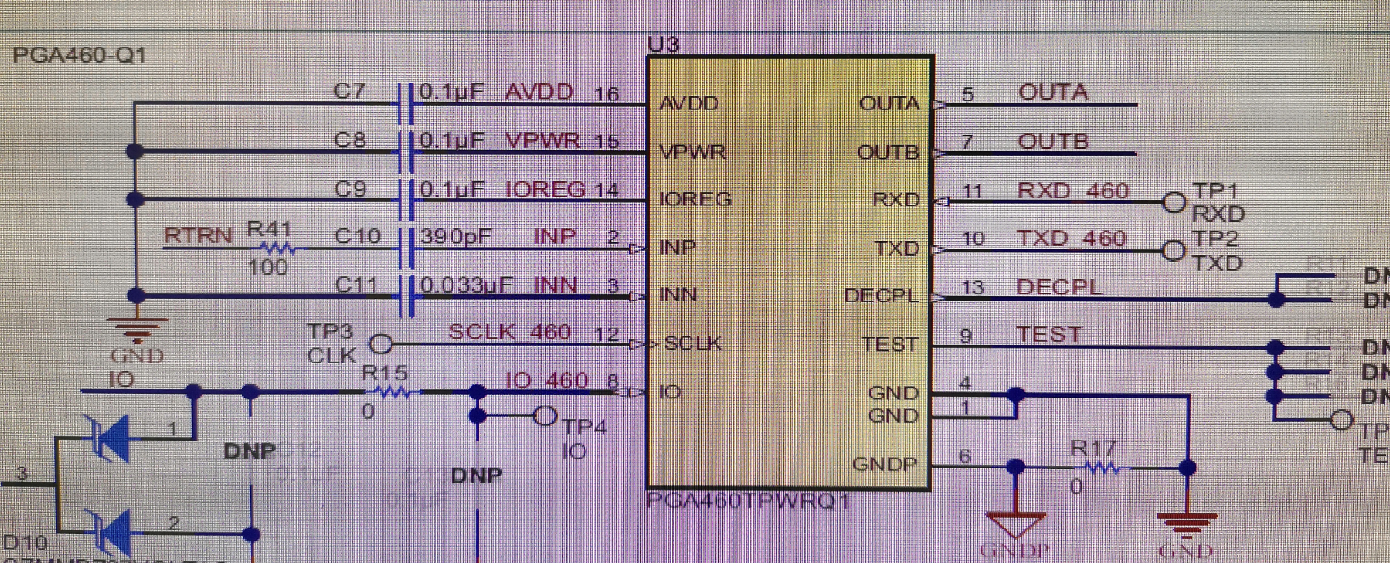
Modified: C10 = 75pF, C11 = 6.38nF
Software Configuration:
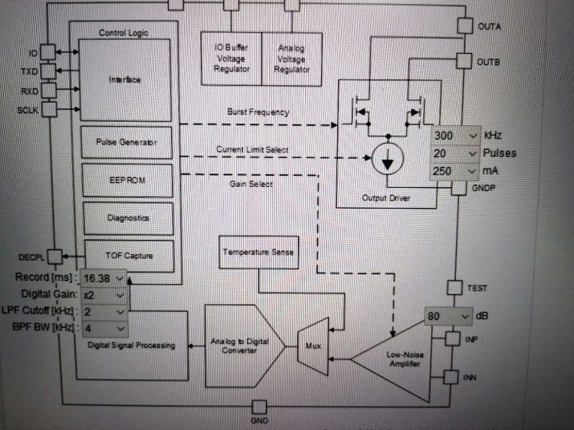
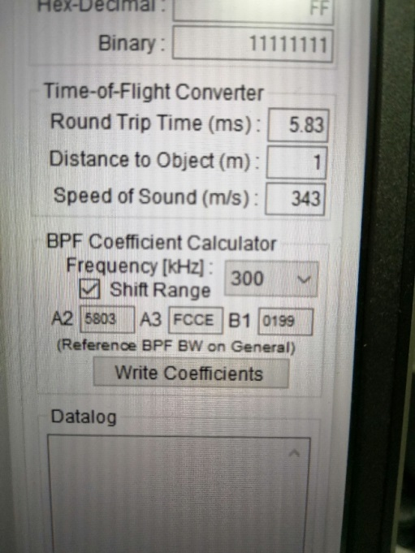
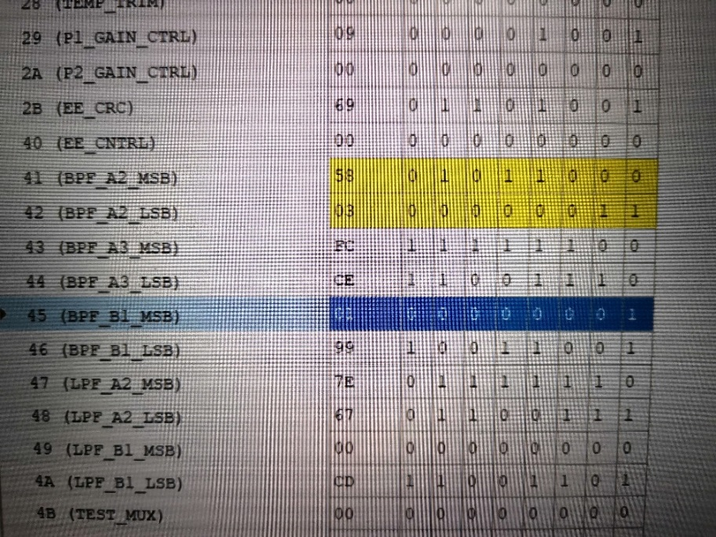

The driving signal of PGA A-OUT Pin:
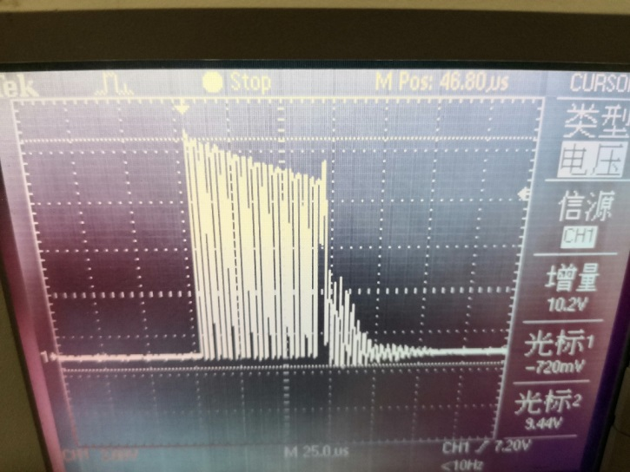
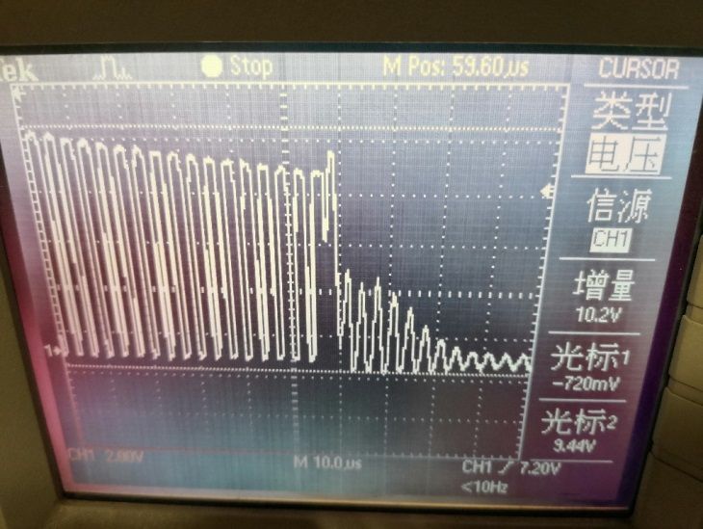
The driving signal is close to the requirement.

The envelope what we get on PGA 460-Q1 EVM:
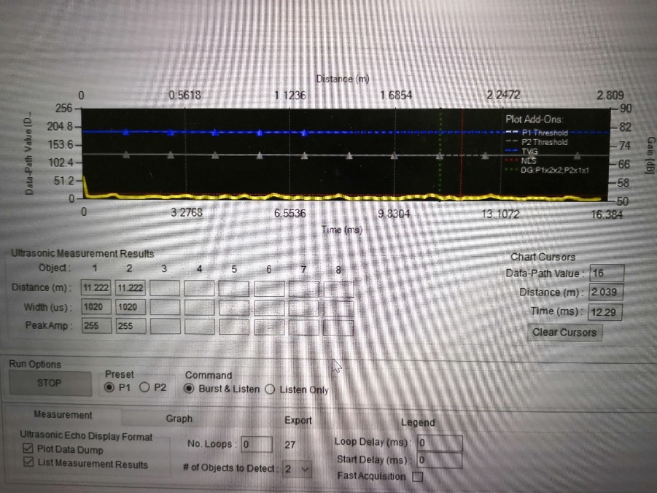

When we connect the daughter board, the driving signal which we get on A-OUT pin is close to requirement. But I cannot get target on the upper computer (PGA 460-Q1 EVM).

The final signal which we want to find:
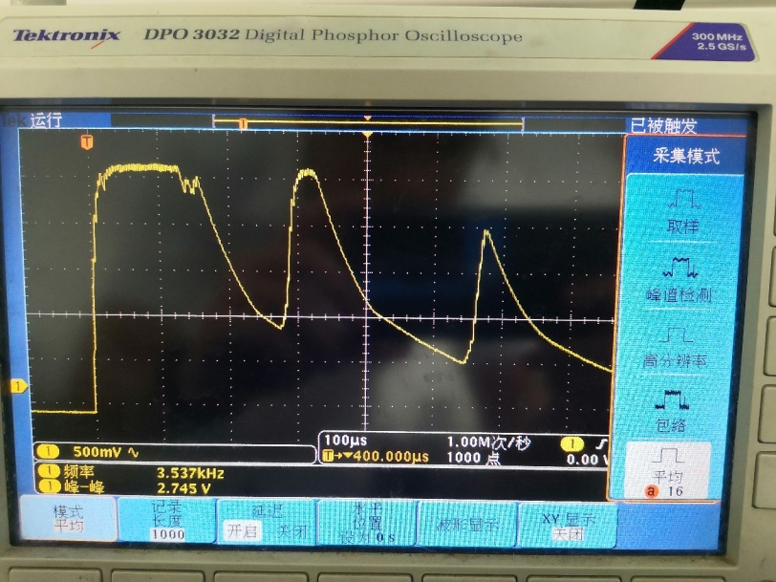
Driving signal:
