Step 1:First Power off the board Disconnect the ISK-IDS and ICBOOSt Board back side images of jumper.
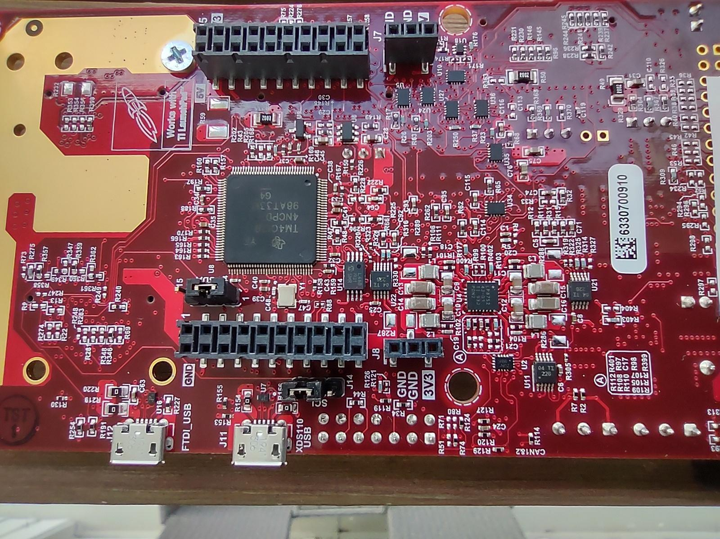

Step 2: ISK ODS Board Config As Flash
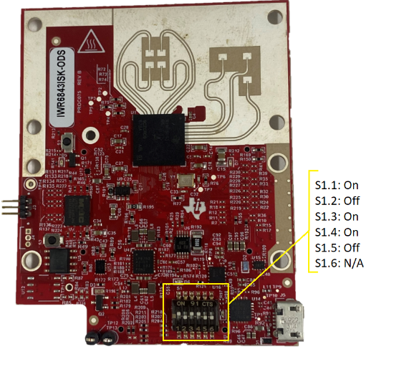

Step 3: Connect the USB cable and Attach To Desktop and click on Reset
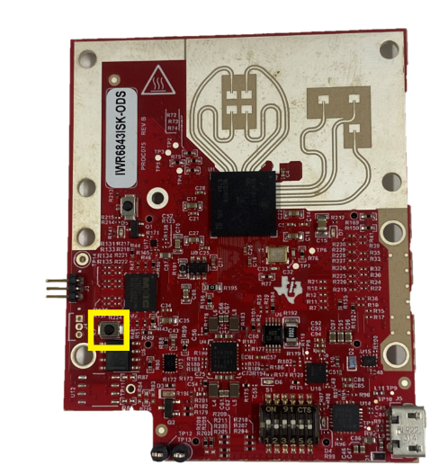

Step 4: after configuration Flash the Out of the Box Pre Built Binary and Flash on Board

Step 5: Now Disconnect USB of ISK-ODS Board and set DIP SWITCH Config.
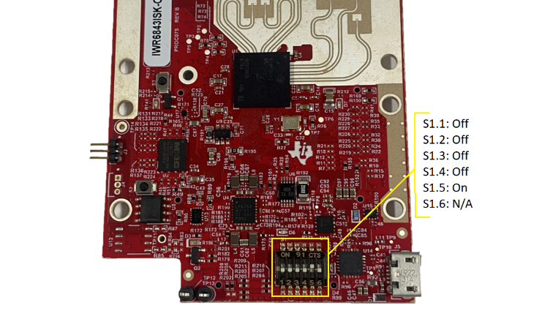

Step 6: ICBOOSt Board Set below config
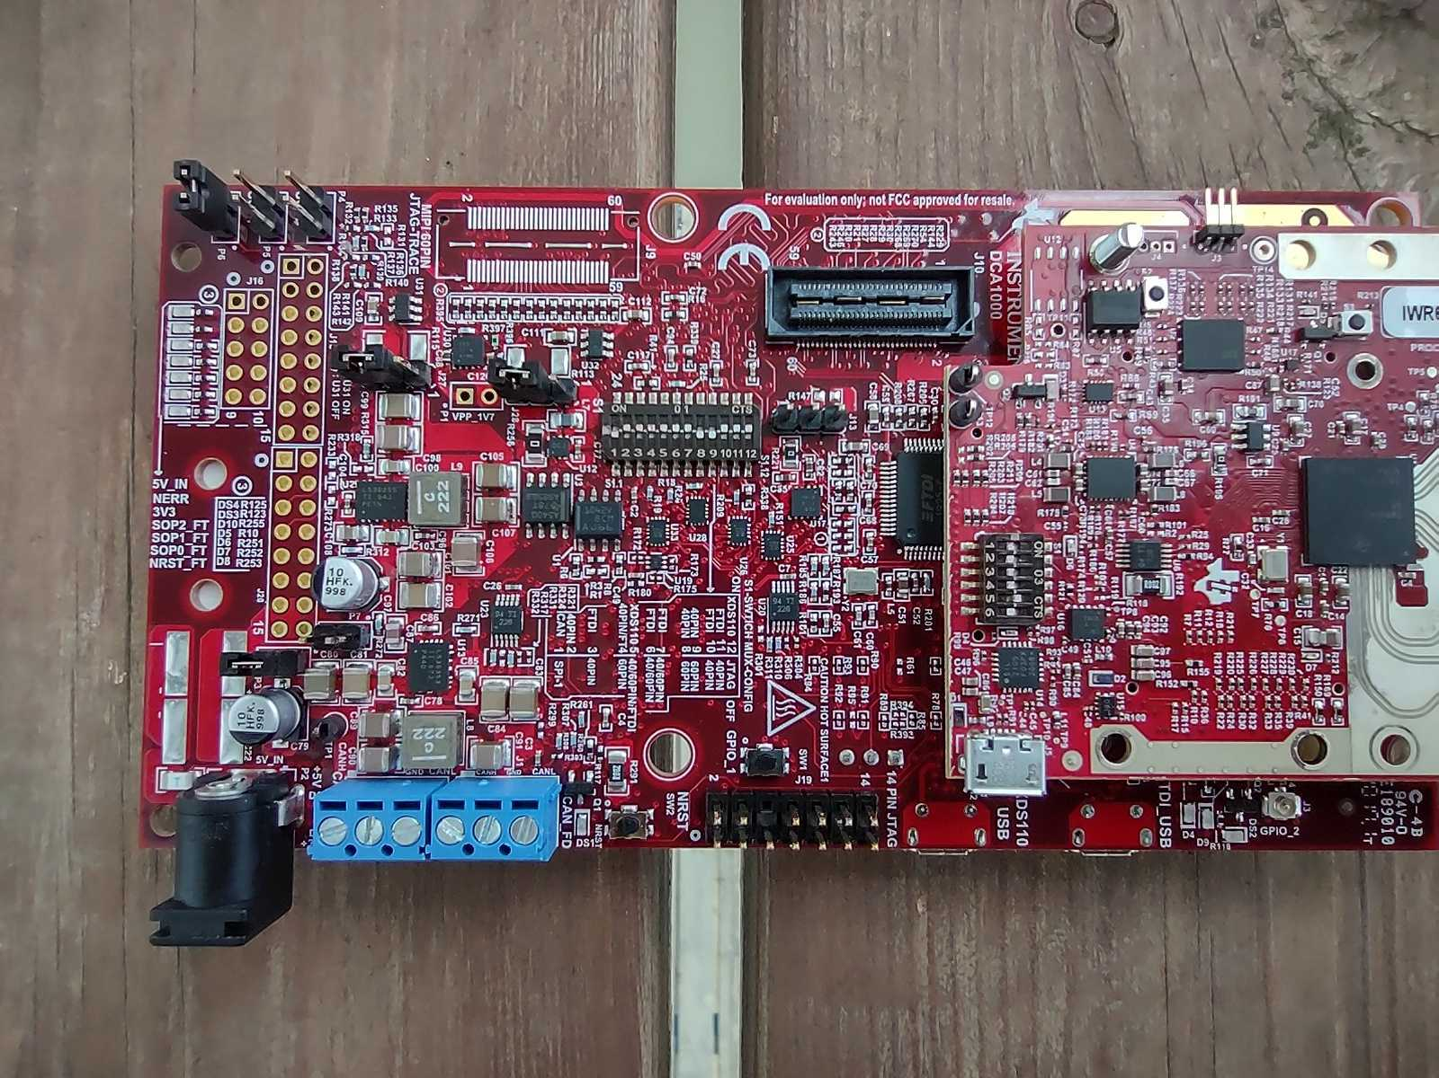

Step 7 : SET SOP Jumper for functional mode
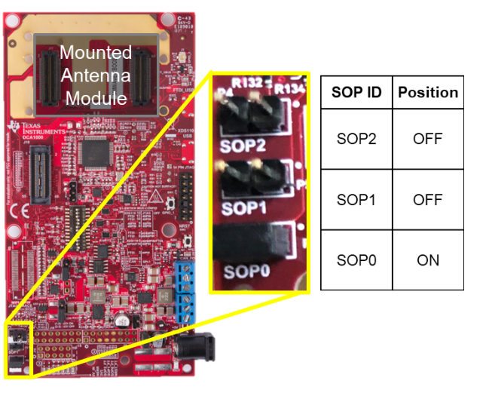

Step 8: APPLY the Power and Connect the USB CABLE on the ICBOOST and click on RESET on the ICBOOST

Step 9: Select com port and connecting to the board.