Step 1: : First Power off the board Disconnect the ISK-IDS and ICBOOSt Board

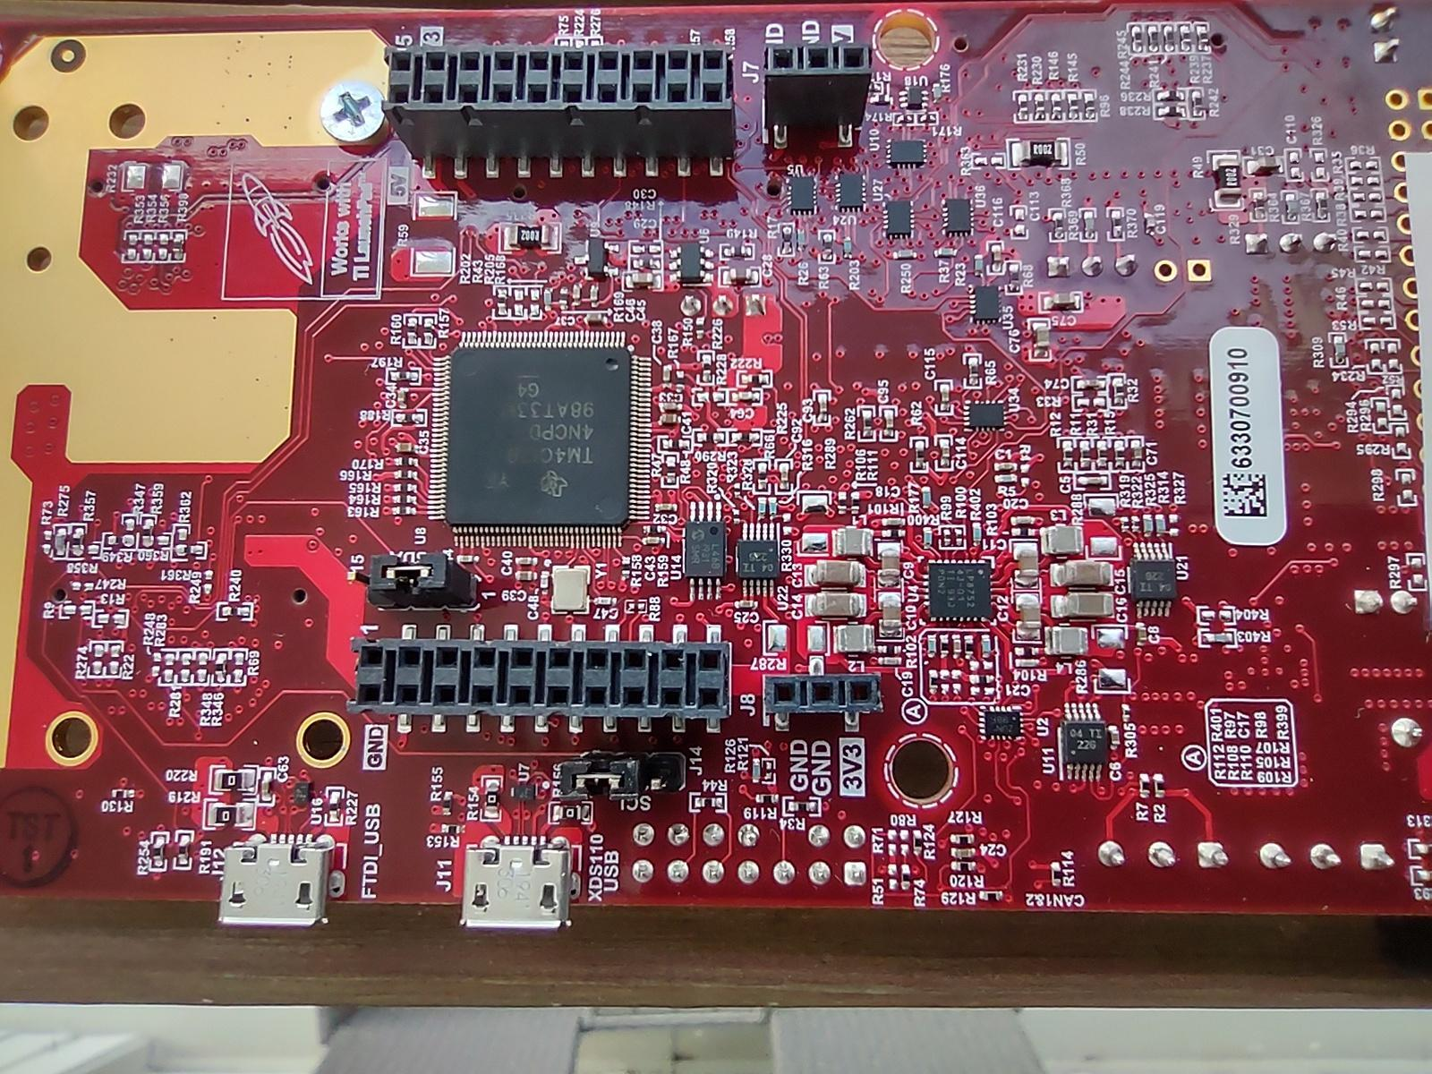

Step 2: ISK ODS Board Config As Flash

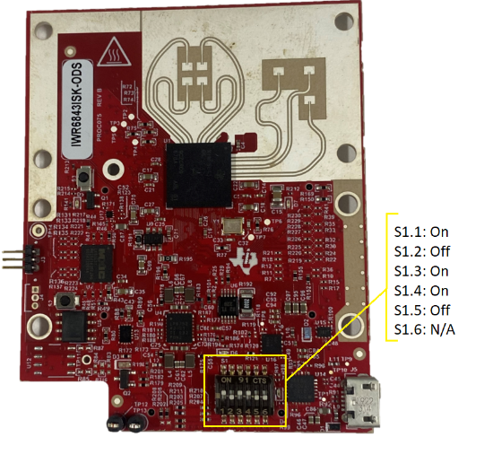

Step 3: Connect the USB cable and Attach To Desktop and click on Reset

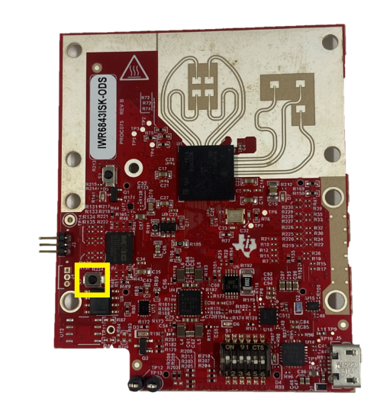

Step 4: after configuration Flash the Out of the Box Pre Built Binary and Flash on Board

Step 5: Now Disconnect USB of ISK-ODS Board and set DIP SWITCH Config.

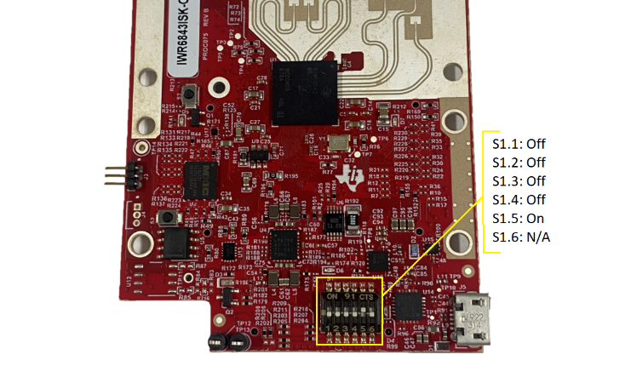

Step 6: ICBOOSt Board Set below config

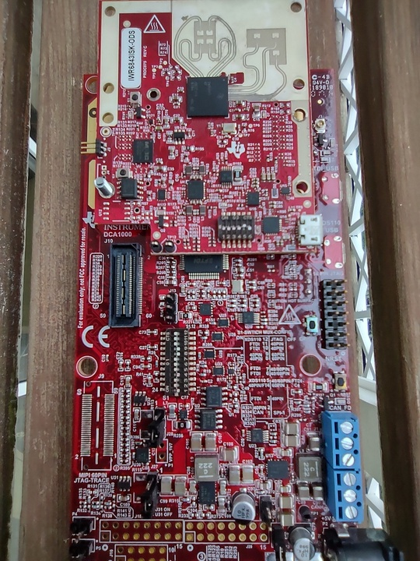

Step 7 : SET SOP Jumper for functional mode

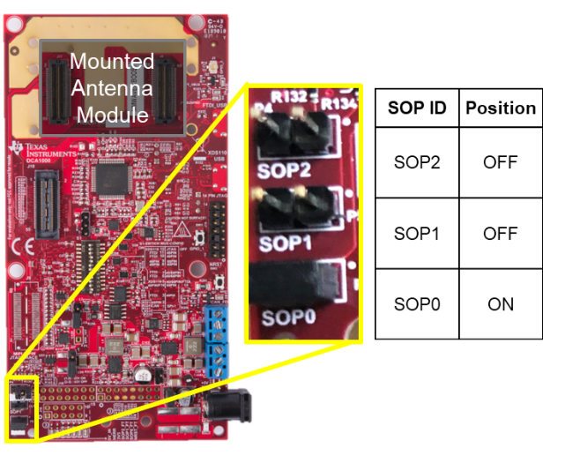

Step 8: APPLY the Power and Connect the USB CABLE on the ICBOOST and click on RESET on the ICBOOST

Step 9: Select com port and connecting to the board.