Step 1: : First Power off the board Disconnect the ISK-IDS and ICBOOSt Board

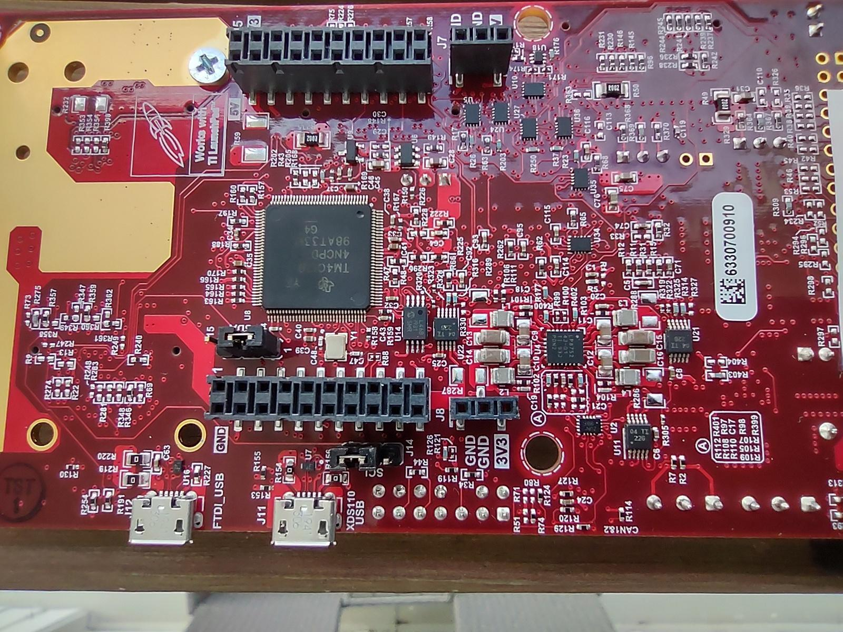

Step 2: ISK ODS Board Config As Flash

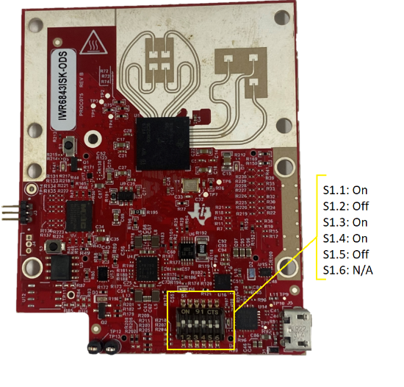

Step 3: Connect the USB cable and Attach To Desktop and click on Reset

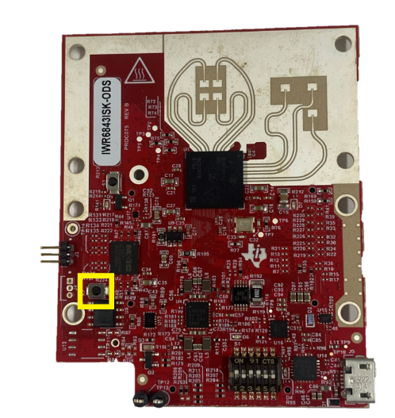

Step 4: after configuration Flash theBinary



Step 5: Now Disconnect USB of ISK-ODS Board and set DIP SWITCH Config.

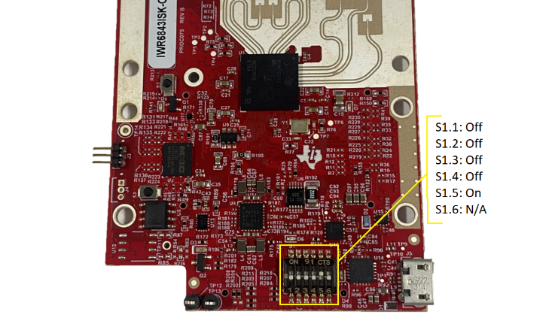

Step 6: ICBOOSt Board Set below config

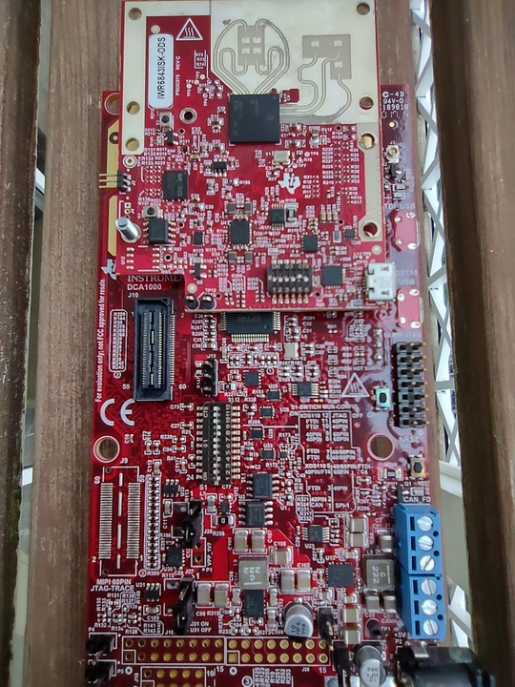

SW4 should be flipped to the left

Step 7: APPLY the Power and Connect the USB CABLE on the ICBOOST and click on RESET on the ICBOOST

Step 8: follow the CCS debug guide in the radar toolbox to import the out_of_box_6843_ods project into CCS, build, and then debug the program.

<https://dev.ti.com/tirex/explore/node?a=1AslXXD__1.10.00.13&node=A__AKZl2I1OiS5ssBNGpidsCQ__radar_toolbox__1AslXXD__1.10.00.13>