Step 1: : First Power off the board Disconnect the ISK-IDS and ICBOOSt Board

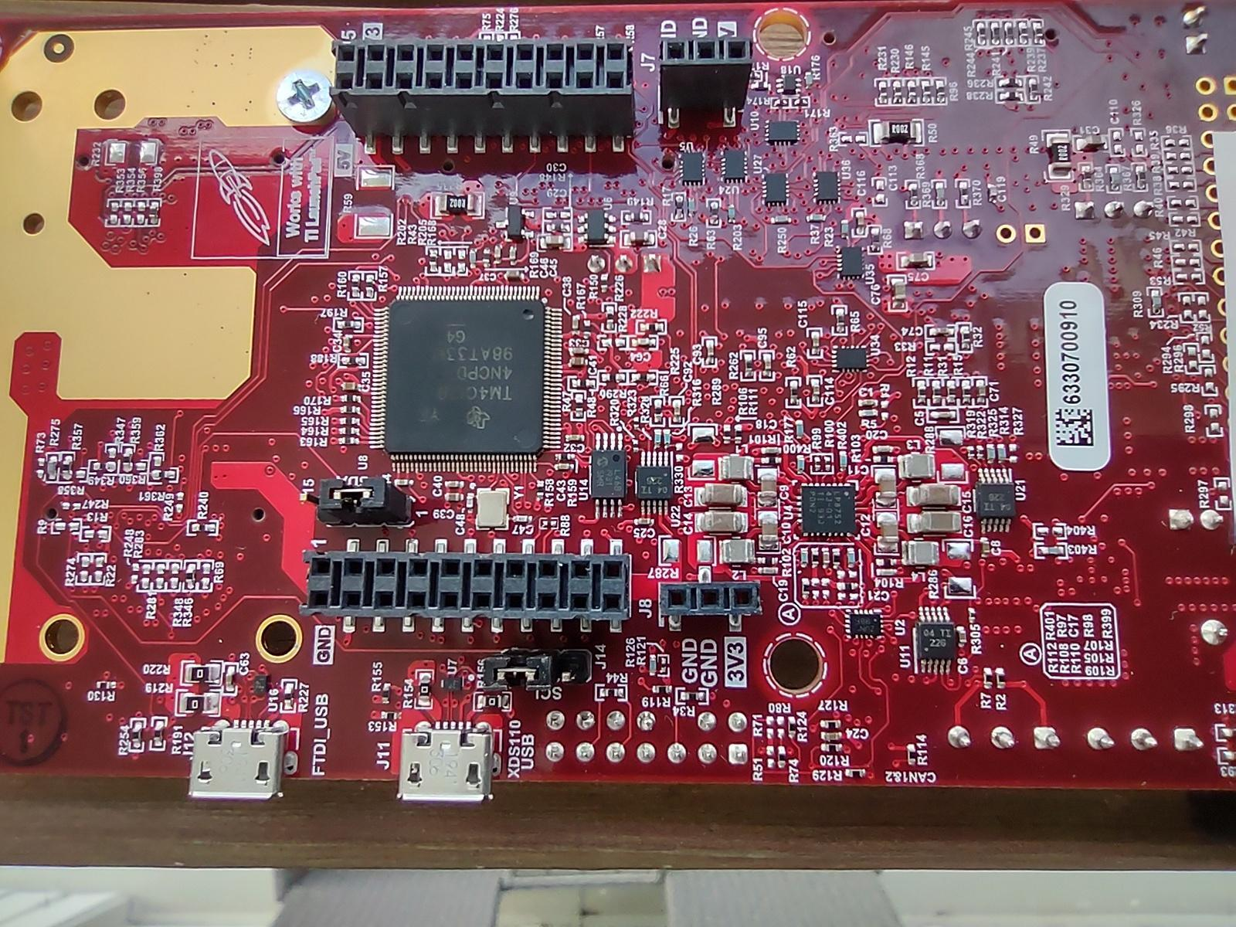
Step 2: ISK ODS Board Config As Flash
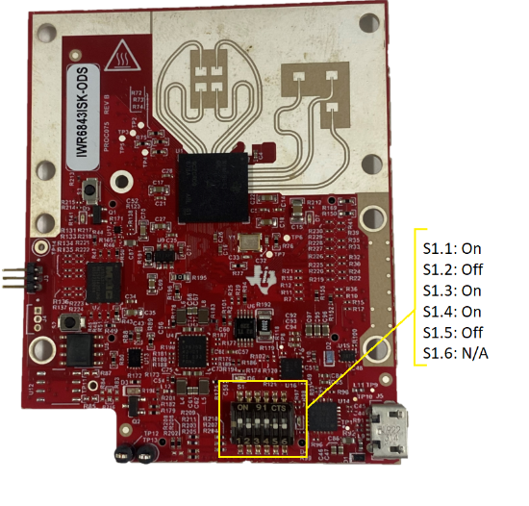

Step 3: Connect the USB cable and Attach To Desktop and click on Reset
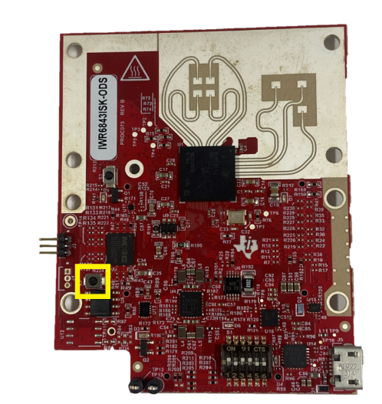

Step 4: after configuration Flash theBinary

Step 5: Now Disconnect USB of ISK-ODS Board and set DIP SWITCH Config.
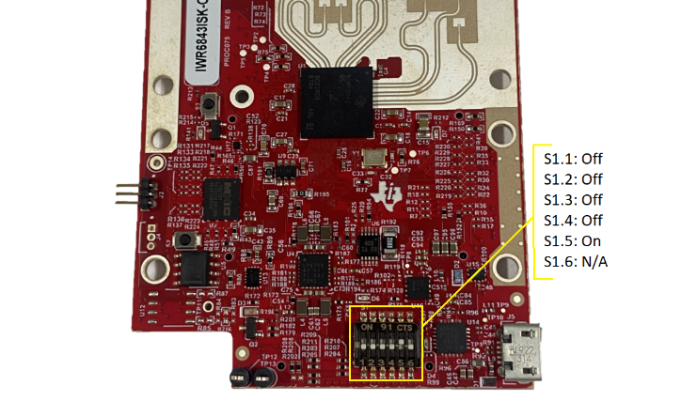

Step 6: ICBOOSt Board Set below config
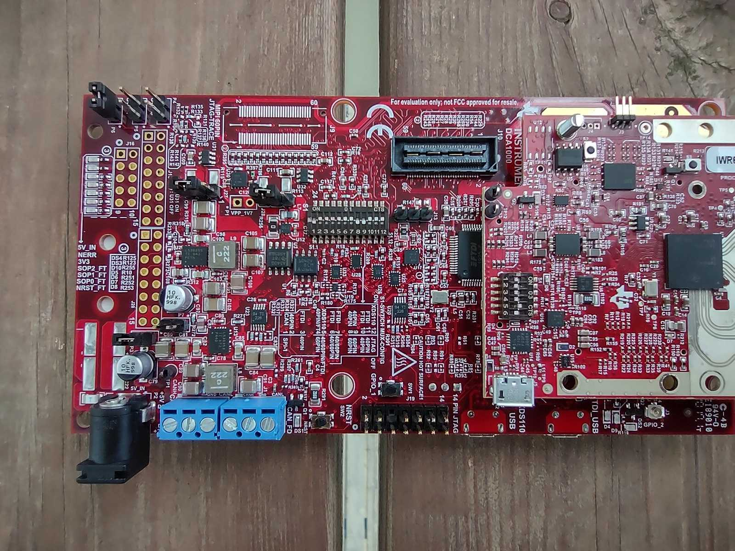

Step 7 : SET SOP Jumper for flashing mode
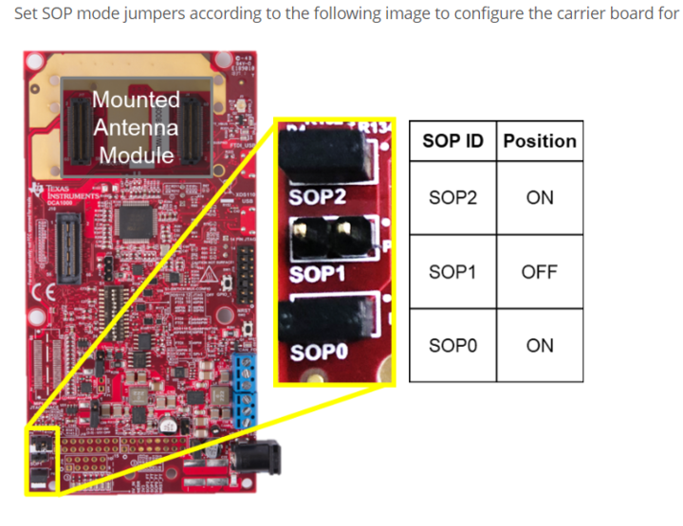

Step 8: APPLY the Power and Connect the USB CABLE on the ICBOOST and click on RESET on the ICBOOST

Step 9: Select com port and connect to the board. And try to flash the Out of the BOX Prebuilt binary