- Sensor classification
A total of 65 sensors were classified based on purchased date, and Group 3 was sub-classified based on the assembly method
Classification | NIST-ID | Number of sensors | Assembly Method
Group 1 | xx-xx-7a-9f-09-1f | 4 | Manual
Group 2 | xx-xx-fc-70-08-2e | 50 | SMT
Group 3-1 | xx-xx-a5-73-11-3e | 5 | Manual
Group 3-2 | xx-xx-a5-73-11-3e | 6 | SMT
Table 1
- "XX" in NIST-ID: means don't-care
- Group 3 was included to investigate the assembly method based on the results in "Table 2".
- Group 1: purchased samples for development purposes (Mauser)
- See "Figure 5" for Group 2 and Group 3

- Repeatability and Deviation check
As shown in "Table 2" below, there is a deviation from the specifications, showing an overall positive error. Notably, Group 2 shows a higher error than the other groups.

Category | Error
 | 30%RH | 60%RH | 90 %RH
Group 1 | 3.9 | 2.5 | 4.5
Group 2 | 2.8 | 3.7 | 8.0
Group 3-1 | 1.7 | 1.6 | 4.3
Group 3-2 | 1.1 | 0.6 | 3.3
Table 2
- The table was created by calculating the maximum values.
- Deviation = Acquired value of group sensor – Acquired value of reference sensor.
  - Reference sensor: Vaisala, HMP155 (output type: RS-485) (certified for calibration by the Korea Meteorological Institute (KMI))
As shown in "Figure 1" below, the sensors tested during the same period show small errors among them and stable output.

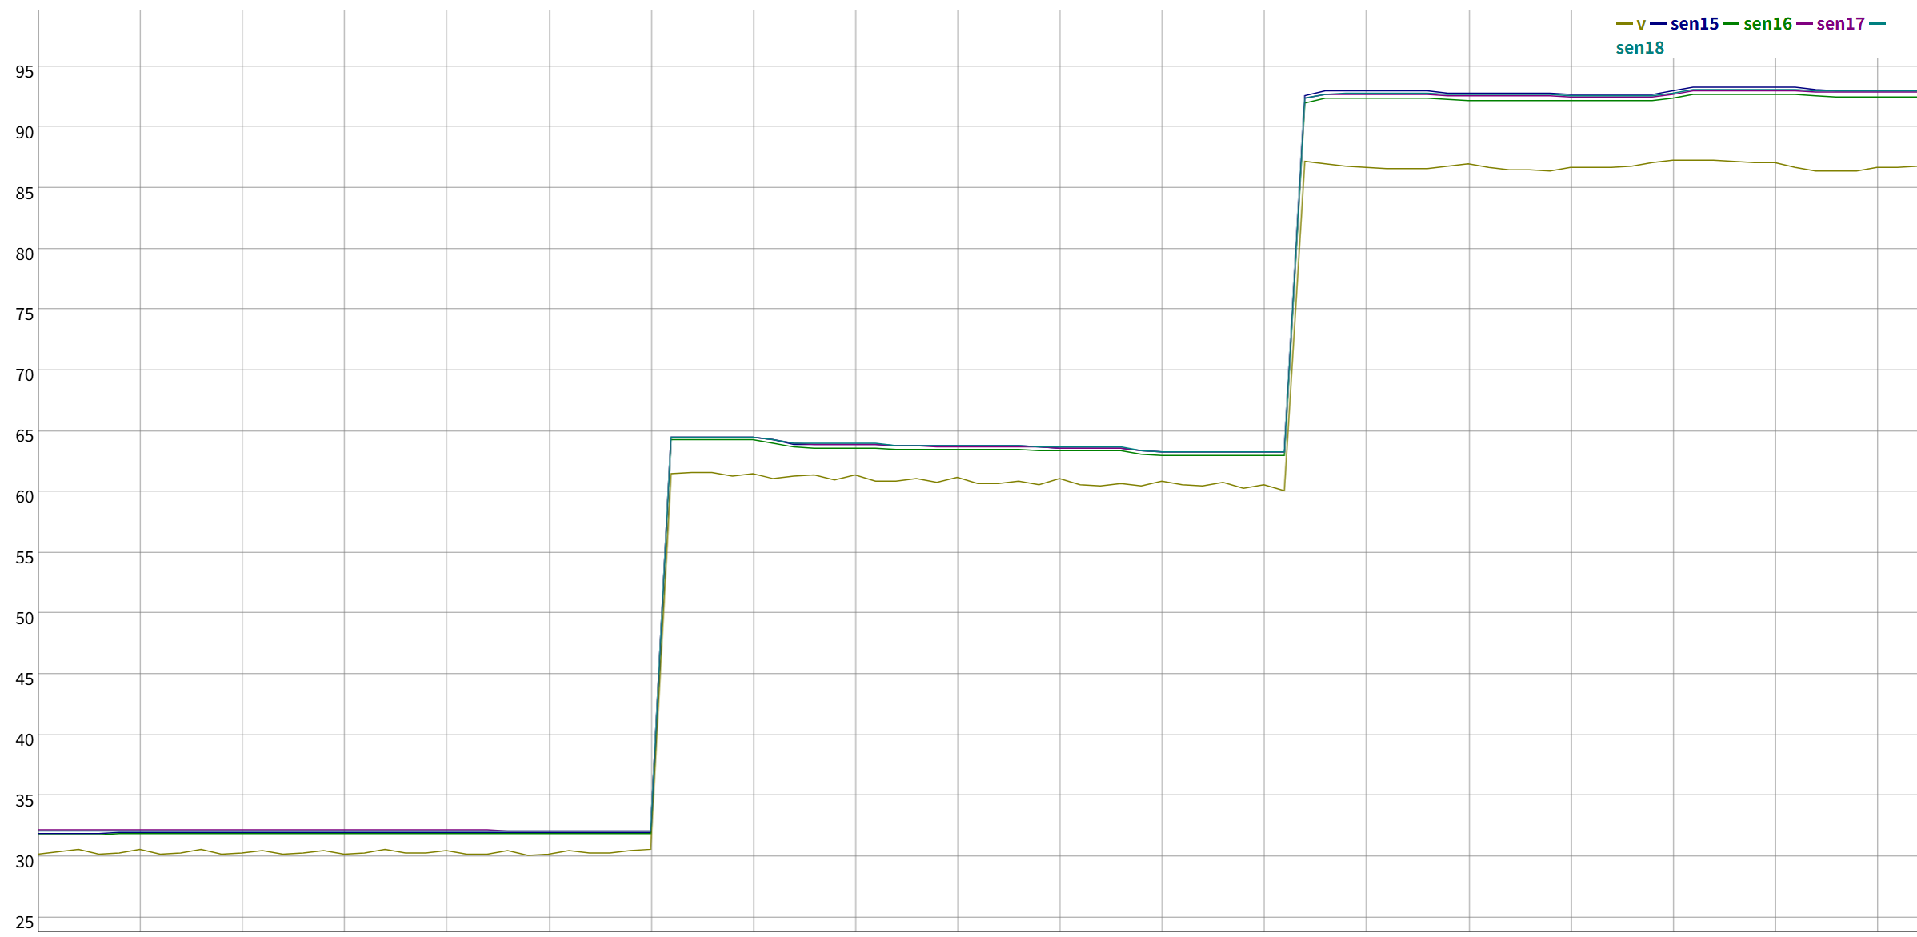
Figure 1 (Measurement results of Sensor 15 ~ Sensor 18 of Group 2)
- V : Reference sensor (HMP155), sen : HDC3022

- TEST Process
Inside the chamber (ESPEC CORP, SH-662), the sensors were installed with the same orientation and height from the floor as the reference sensor, as shown in "Figure 2". Data was then acquired via serial communication (Reference sensor: RS-485, HDC3022: RS-232).
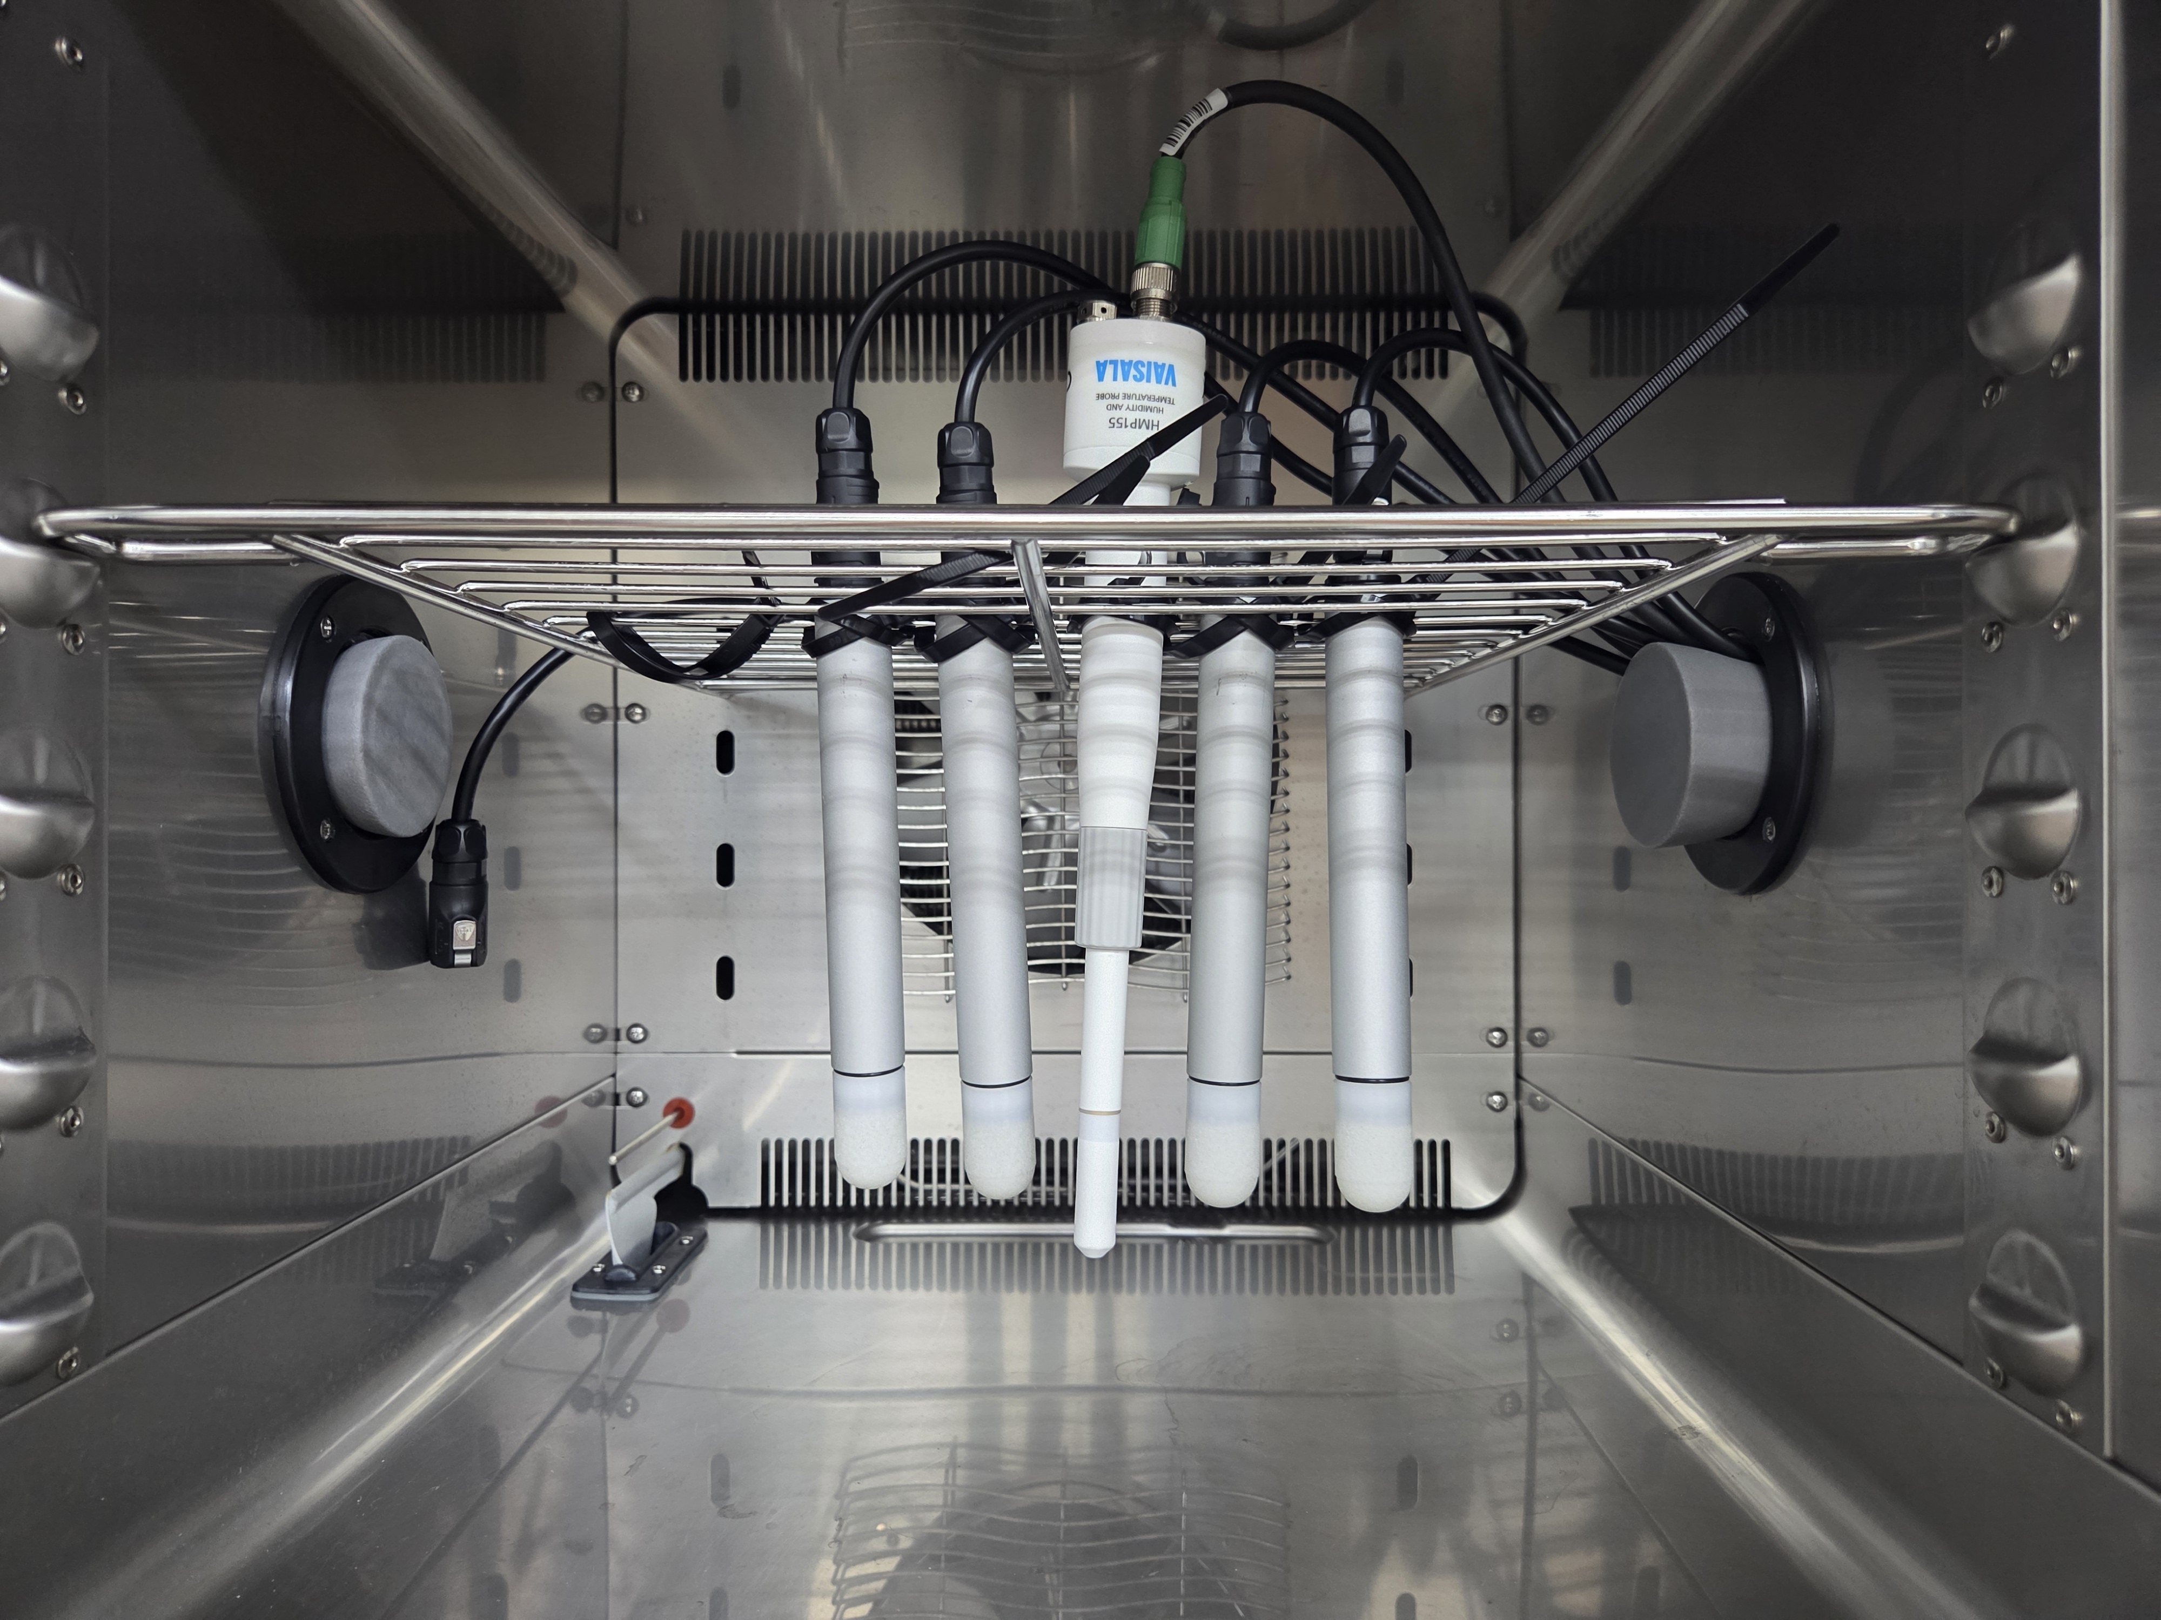 | 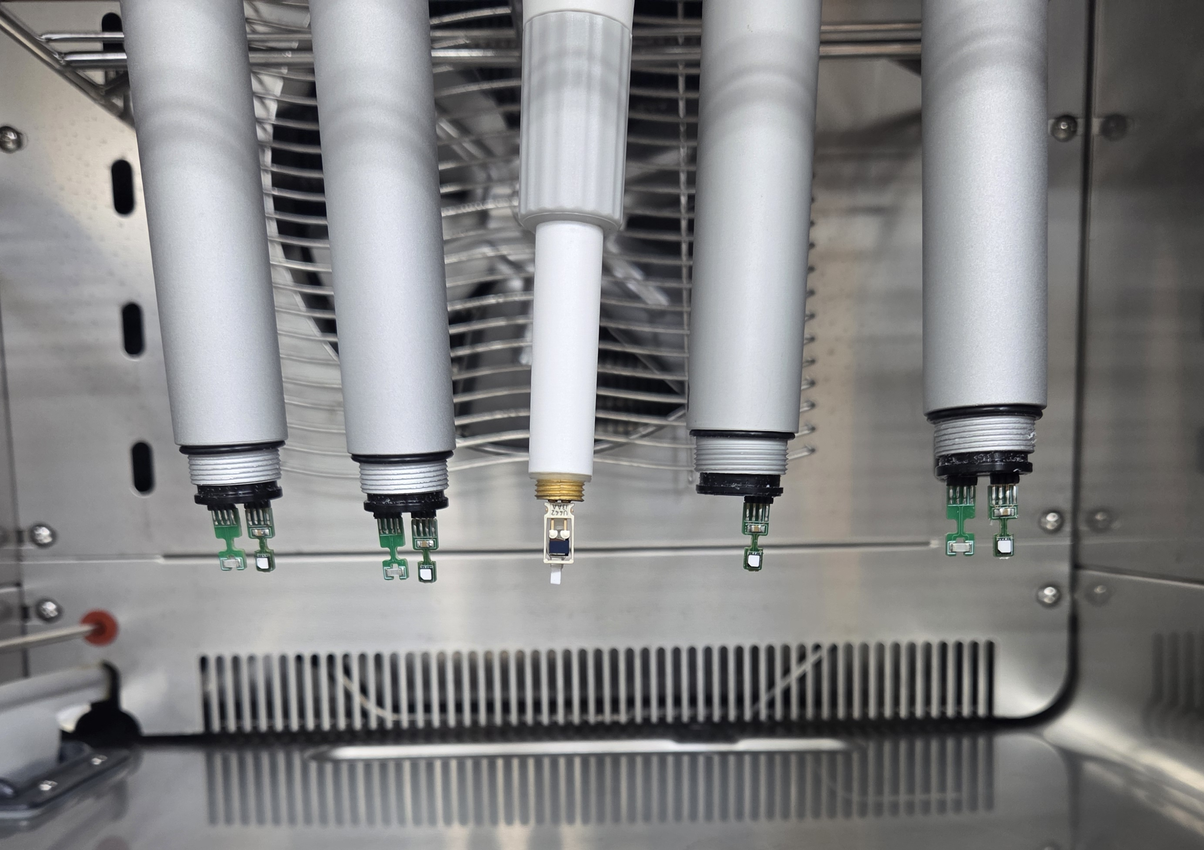
Figure 2
The temperature was fixed at 30 degrees Celsius, and measurements were taken at three points (30 %RH, 60 %RH, 90 %RH). As shown in "Figure 3" below, data was acquired for over 25 minutes for each RH set point to ensure a stable humidity level within the chamber.
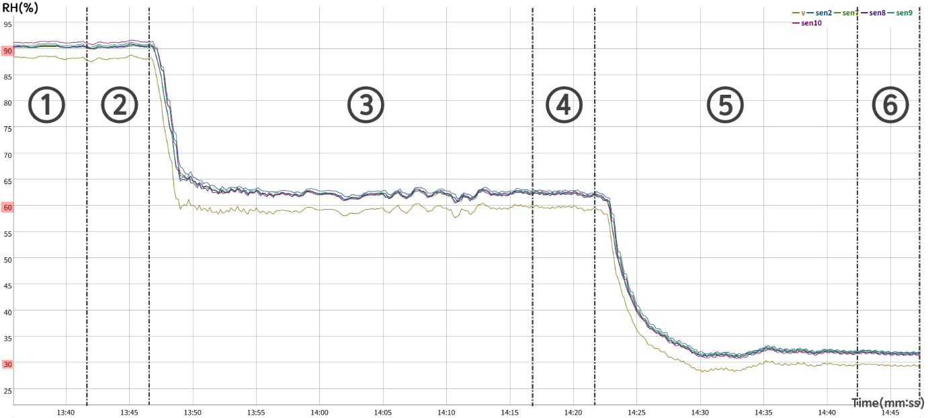
Figure 3
- Stabilization Period (①, ③, ⑤, approx. 20 minutes): Waiting time for RH stabilization.
- Measurement Period (②, ④, ⑥, approx. 5 minutes): Time for acquiring stable RH data.
- Sampling period: 10 seconds

- Sensor Configuration
The test was conducted by assembling the sensor as shown in "Figure 4" below. (Bypass capacitor: 100uF).
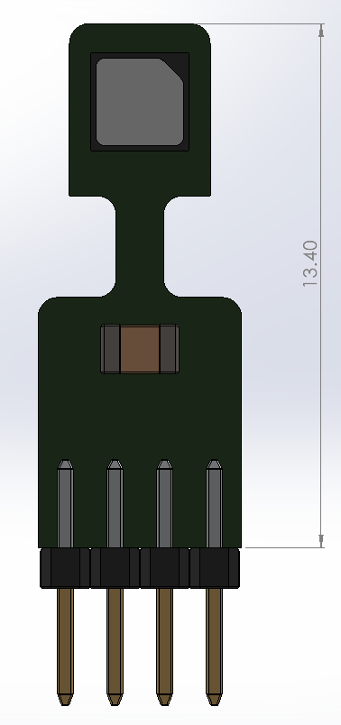 | 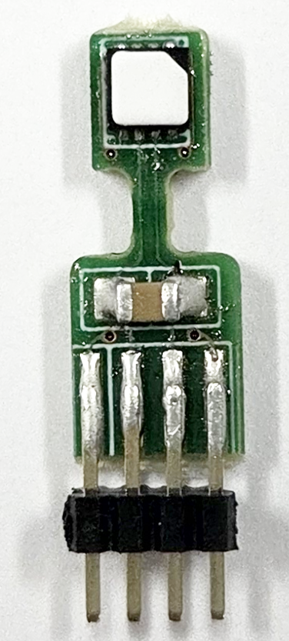
3D model | Assembled
Figure 4
- Sensor Storage
The sensors were stored in ESD-safe bags, which we believe were properly handled and packaged by our authorized distributor.
After purchasing the sensors, they were immediately used for mass production, and we have no record of any inappropriate storage or prolonged idle time.
To our knowledge, the storage conditions were stable and fully compliant with recommended handling practices throughout.

Group | Picture
Group 2 | 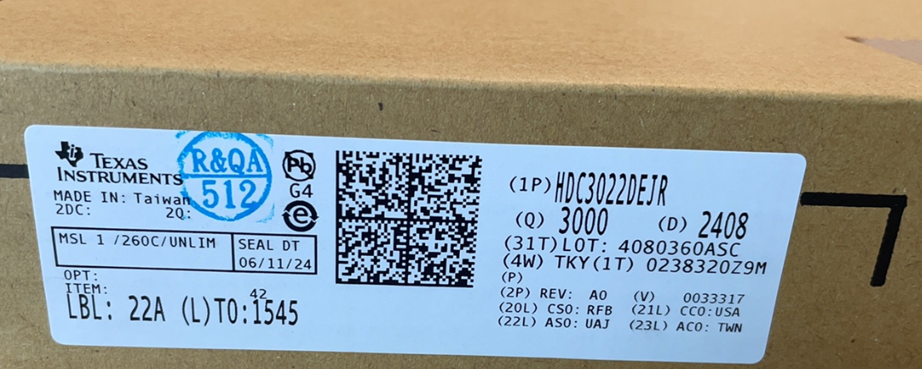
Group 3 | 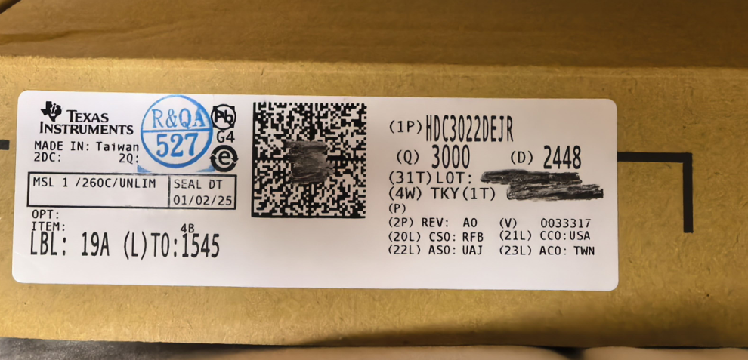
Figure 5

- Sensor assembly
"Figure 6" below shows the reflow profile during SMT operation.
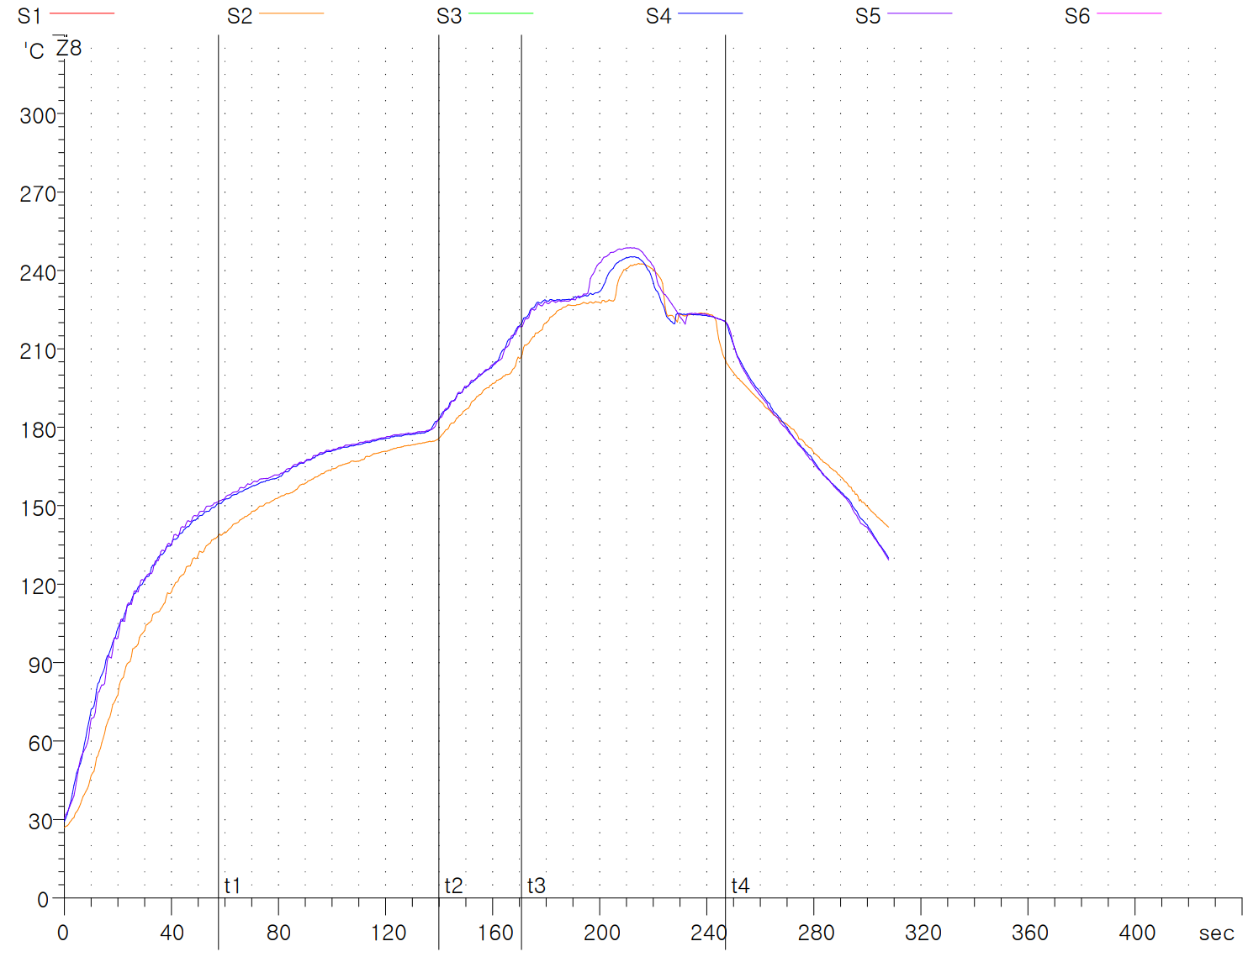
Figure 6
The cleaners and solder paste used during assembly are shown in "Figure 7"
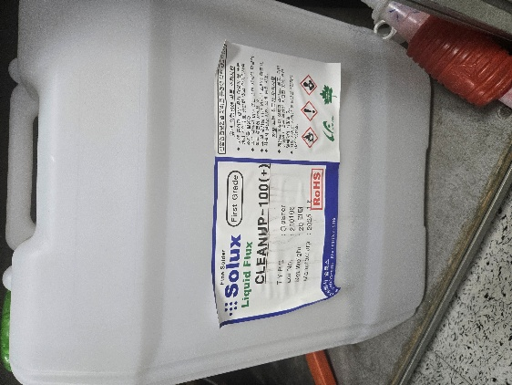 | 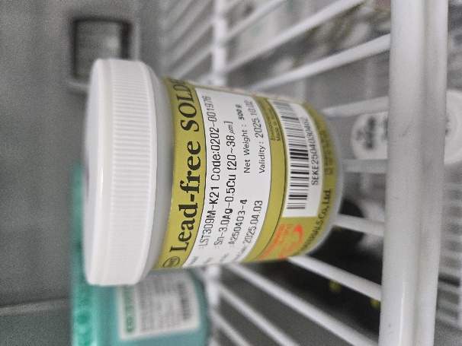
Board cleaner  (Solux CLEANUP-100(+)) | Solder paste  (BNF MATERIALS LST309M-K21)
Figure 7
- Additional information
- NIST-ID and Sensor Deviation by Humidity (.xlsx)
- Humidity/Temperature Sensor Deviation Comparison Graph (.html)

