**Question on IWR6843AOP CW mode raw data captured by mmWave studio**

Q1: There is unexpected data inside the raw data. Is these data insert by mmWave studio?

Q2: There is dataTransSize setting in ADCBuf_control call in mmwave SDK, but we can't find such setting in mmWave studio.

typedef struct MMWave_ContModeCfg_t  
{  
/**  
* @brief Continuous mode configuration  
*/  
rlContModeCfg_t cfg;

/**  
* @brief Sample count: This refers to the number of samples per  
* channel.  
*/  
uint16_t dataTransSize;  
}MMWave_ContModeCfg;

**Test setup:**

* xWR6843AOPEVM RevG+DAC1000EVM. EVMs are facing to the ceil.

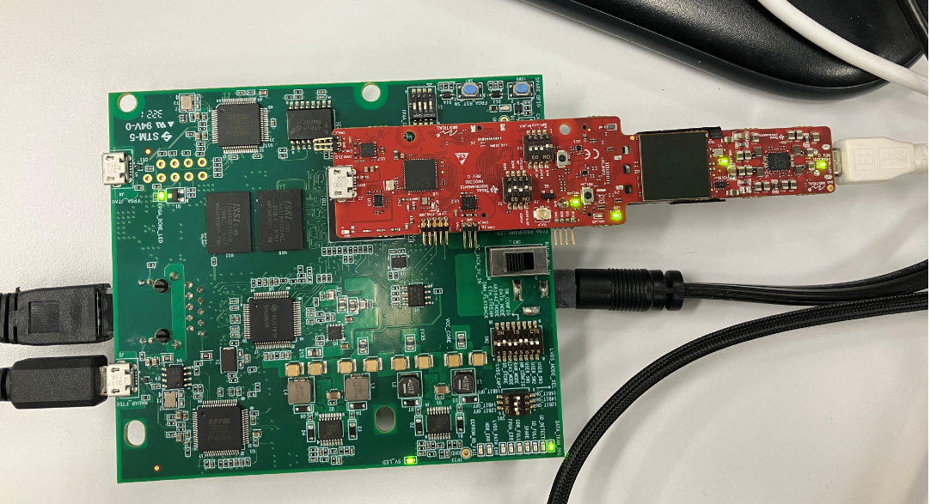

* mmWave studio 2.1.1.0

**Flow to get ADC data**

1. Connect the boards to PC with usb cable and eth cable. Power on the DCA1000EVM.
2. Click below 1 and 2.

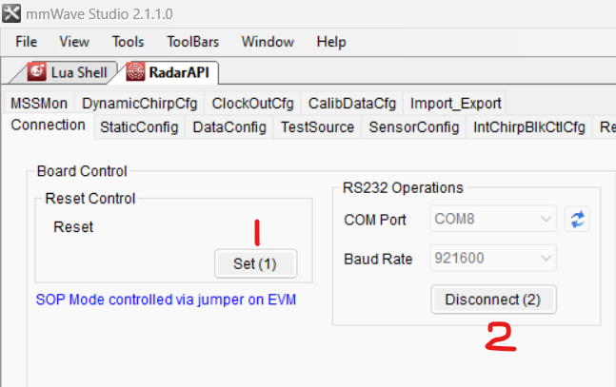

1. Run below LUA.



1. After LUA runs successfully, click below button from 1 to 4.

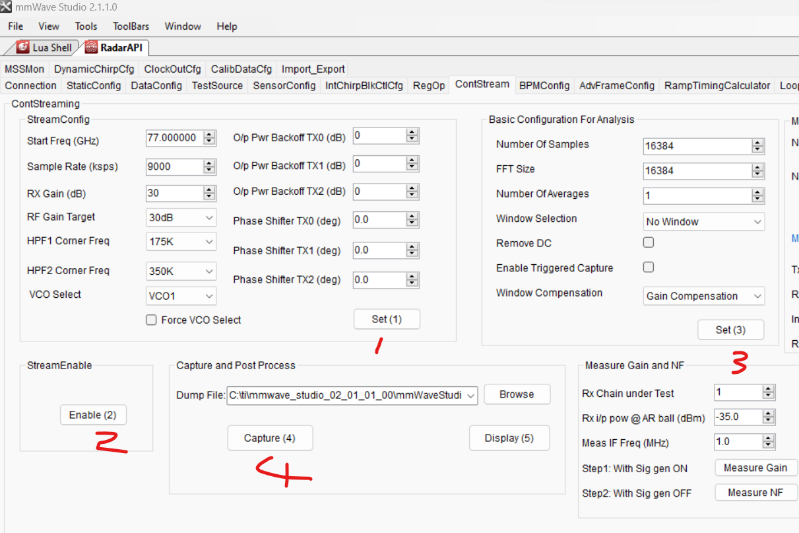

1. Click button 4 and 2 to stop data capture.

**ADC data display**

I used below matlab script to display the raw data.



1. Below is the result got by the ADC data with 16K setting for no. of samples and FFT size

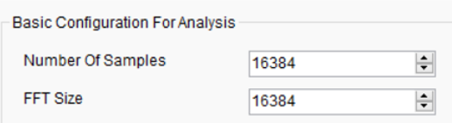

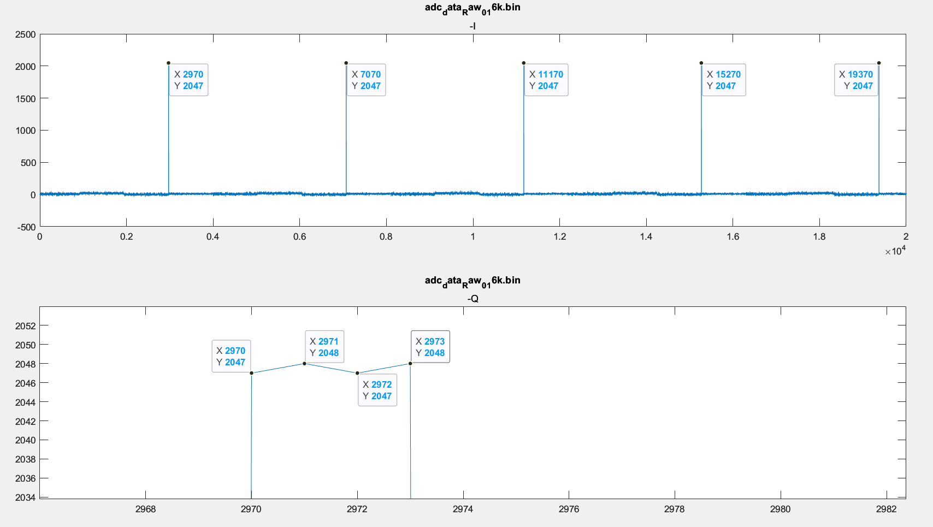

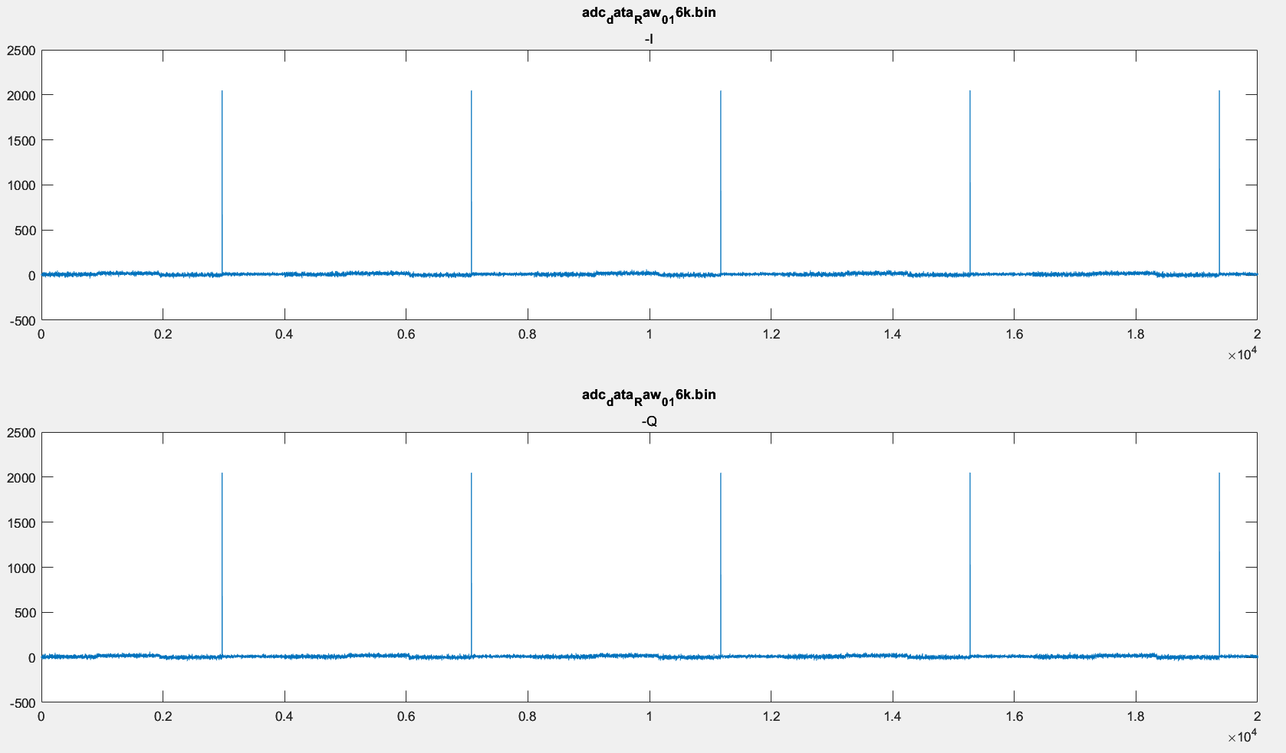



1. Below is the result got by the ADC data with 4K setting for no. of samples and FFT size.

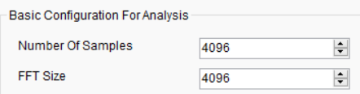

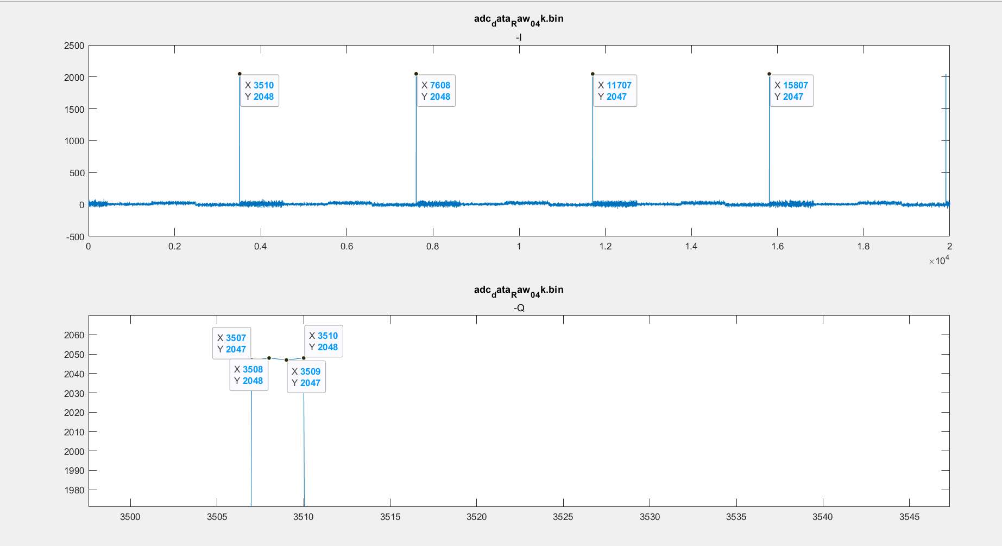

1. Below is the result got by the ADC data with 1K setting for no. of samples and FFT size

