20 pin connectors of IC boost (J5, J6) and mmwavepoeevm (J9, J10) is directly connectable hence by comparing it you will be able to understand which signal of the 6843AoP needs to be connected to which pin of J9&J10 connectors. Please refer to the to the attached snapshots below. For example, RS232TX from AWR6843AoP EVM should be connected to J9.5 of MMWAVEPOEEVM.  
  
 I would recommend to check schematic of AWR6843AoP EVM, mmWave IC Boost and MMWAVEPOEEVM to understand how the power and signals are routed from **6843AoP device ->60 PIN HD Connector of AWR6843AoP EVM(J2)-> HD connector of IC boost(J4)->BP/LP connector of IC boost(J5,J6)-> J9,J10 connector of MMWAVEPOEEVM-> MSP432.**  
  
**ICBOOST Connector**  
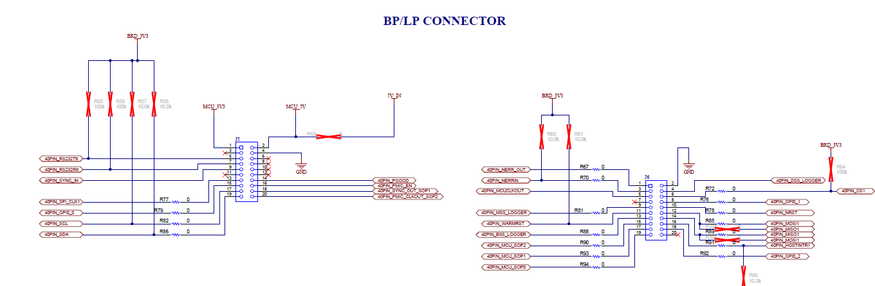  
**MMWAVEPOEEVM**  
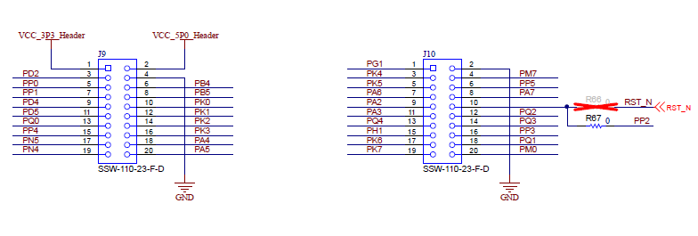  
   
 Choice of 6843AoP’s signals which you need to connect to MMWAVEPOEEVM is completely depends on your application and requirements. For sending configurations to the 6843AoP device connect RS232TX/RX. You can consider connecting MSS_Logger since in our demos output is streamed through MSS_logger. Connect SPI if you want to send API/commands (e.g. - mmWave Studio) or higher rate data transfer. If needed, you can connect I2C, BSS_Logger/DSS_Logger, NERROR, GPIOs, PMIC controls, Warmreset etc. according to your requirements.

**How to Power Up**  
  
Please connect GND pins of MMWAVEPOEEVM(J9.4) to GND of your PCB to ensure common GND between the boards  
  
If you are looking to power up your PCB through MMWAVEPOEEVM then please consider connecting J9.2(VCC_5P0_Header) to the primary input of the Load switch witch will eventually become input of PMIC in AWR6843AoP board(5V_HD_IN as per AWR6843AoP EVM).  
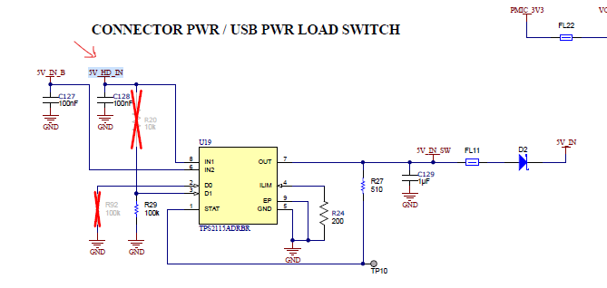  
 Additionally, there is blue wiring required in the MMWAVEPOEEVM which is marked by “Red arrow” in the below image to support powering up the PCB through MMWAVEPOEEVM.  
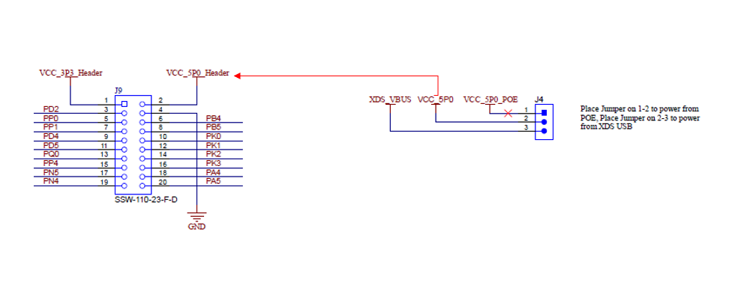  
As a provision, J9.1(VCC_3p3_Header) can be connected to 3v3 of 6843AoP board (VCC_BA_3V3 according to AWR6843AoP EVM) with 0ohm resistance(Make it as DNP by default) in the path.  
  
  
nReset and SOP control also can be given from MMWAVEPOEEVM as per your requirement. If you are considering nReset I would recommend to connect J10.10 to 3rd pin of SN74LVC1G11DSFR (AWR6843AoP EVM).  
  
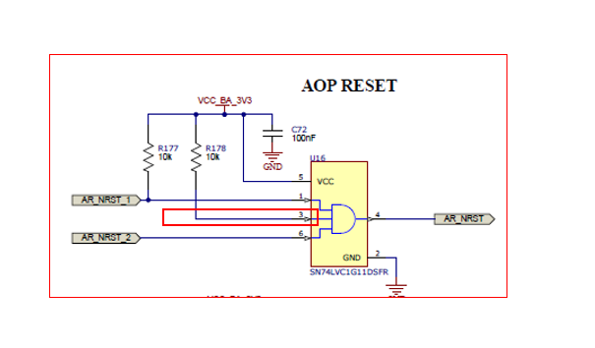  
  
These are my suggestions. Please also refer to the schematic of IC Boost, MMWAVEPOEEVM and AWR6843AoPEVM for understanding how the signal and power routed between the boards. As I mentioned we only have hardware support and we don’t have any software solution for this. Customer has to take care the software implementation on their own.