**Question 1: Can you confirm which SSD disk is mounted on the single board? Is it possible to try a different SSD?**

**reply: The single board is mounted with the original SSD disk along with the board, and there is no other SSD replacement attempt currently.**

**Question 2: can you please probe the CSI2 signals when you are sending the data to confirm if you see the CSI2 lanes toggling to indicate the data is being transferred?**

**reply:We consulted the data as shown in Figure 1. I don't know if you mentioned four FPGA. If so, the FPGA indicator does not come on when transmitting the data.**

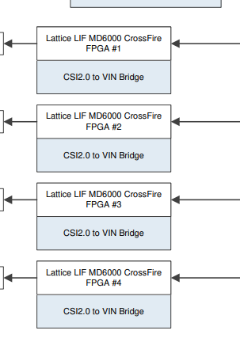

图1 FPGA和CSI2

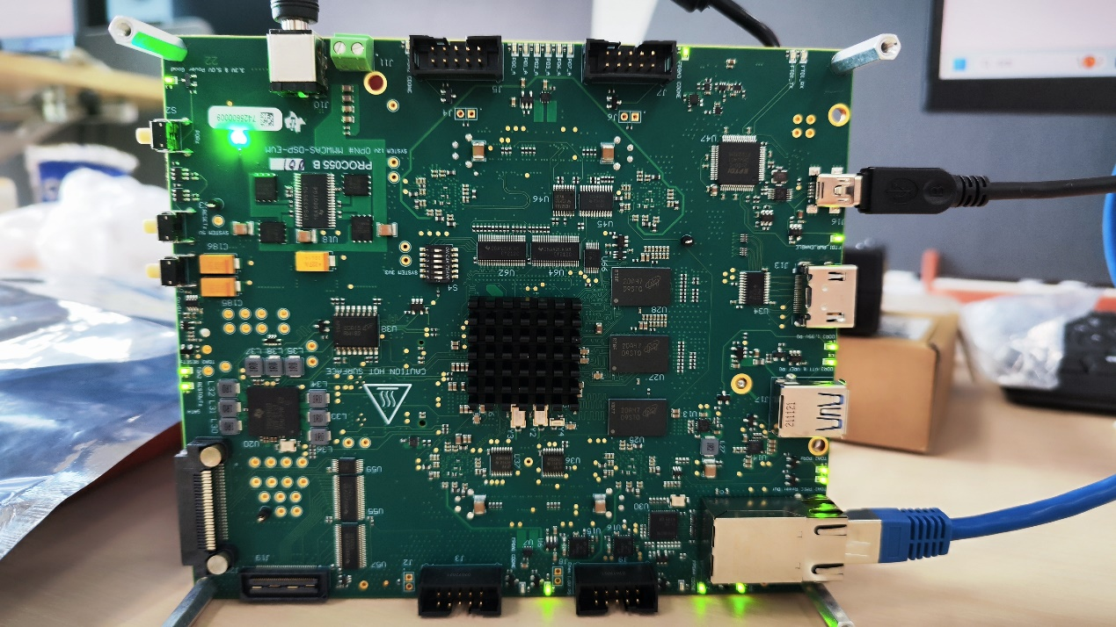

Figure 2. Operating status of the radar board

As shown in Figure 2, only FPGA 3 is on while the other three FPGA indicators are transmitted.