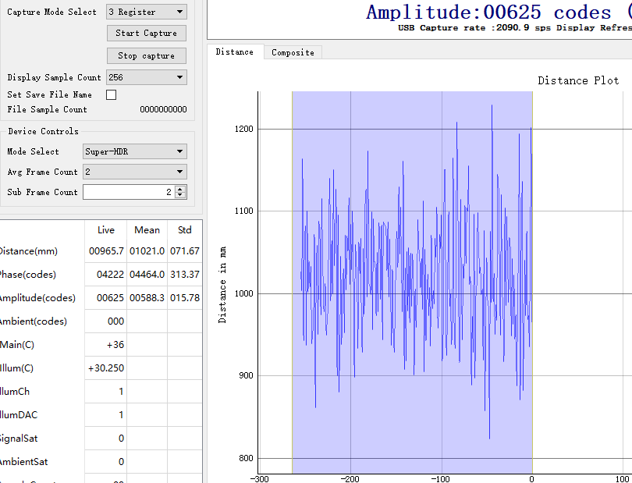

Hi Engineer,

The ranging chip evaluation module OPT3101EVM, in the actual test process, found that the module's ranging accuracy is significantly different from the official description, as shown above:

In the SUPER-HDR mode, the measured distance divergence at 1m under 2Ksps and 10% standard reflective surface is greater than 300mm. (The test method uses the OPT3101EVM evaluation version to face the 10% standard reflective surface vertically and drag the reflective surface to 1m. The distance measured by the upper computer curve to observe the distance divergence) and the official software OPT3101-System-Estimator gives the following accuracy:

The accuracy of the distance measurement at 1m is 30! Is the method of my measurement wrong or is the understanding of official information incorrect?

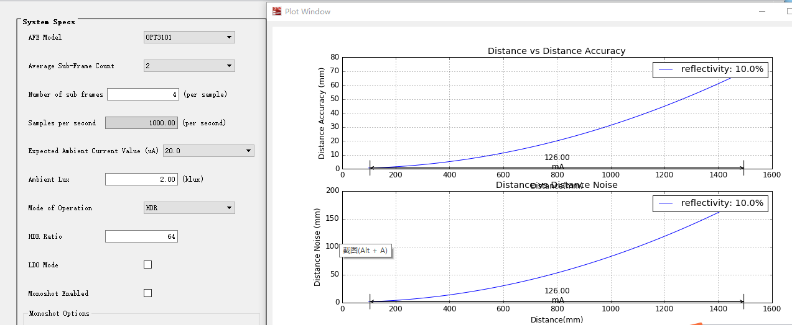

In addition, if I want to apply OPT3101 to scanning laser ranging, considering its ranging accuracy and sampling frequency, under the condition of constructing optical components to ensure good transmission and reception efficiency, for the object with 10% reflectivity, What’s the upper limit of the range speed and accuracy?

Thanks.