Hi Team,

I would like to understand if ability of the device to provide communication signal.

Sending you example of signals that we would like to produce, need to know if this device can work in such mode to provide it. I’m talking about sending (without listening) sequence of frequencies and PWM. See below:

|  |  |  |
| --- | --- | --- |
| Bit Duration [msec] | DC%/ Freq | |
| 10 | 2.35% | 40.8 kHz |
| 10 | 18.70% | 42.55 kHz |
| 10 | 44.42% | 44.44 kHz |
| 10 | 9.18% | 41.667 kHz |
| 10 | 32.90% | 43.47 kHz |
| 10 | 18.41% | 37.035 kHz |
| 10 | 8.93% | 38.462 kHz |
| 10 | 3.63% | 40 kHz |
| 10 | 15.73% | 37.74 kHz |
| 10 | 5.60% | 39.216 kHz |
| 10 | 2.35% | 40.8 kHz |
| 10 | 18.70% | 42.55 kHz |

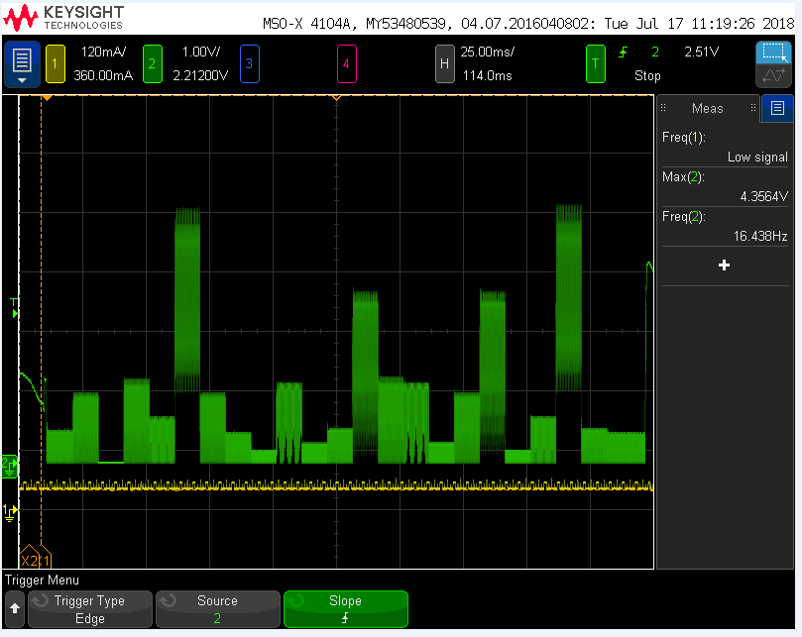

Thanks,

Shlomi