Contents

1. Comparison of TMC1133 CT input and output current: 1

1.1 150KHz/+/-8A: 2

1.2 150KHz/+/-12A: 3

1.3 150KHz/+/-14A: 3

1.4 150KHz/+/-18A: 3

1.5 250KHz/+/-8A: 4

1.6 250KHz/+/-10A: 4

1.7 250KHz/+/-16A: 4

1.8 350KHz/+/-8A: 4

1.9 Observation table: 5

# 1. Comparison of TMC1133 CT input and output current:

**Setup:**

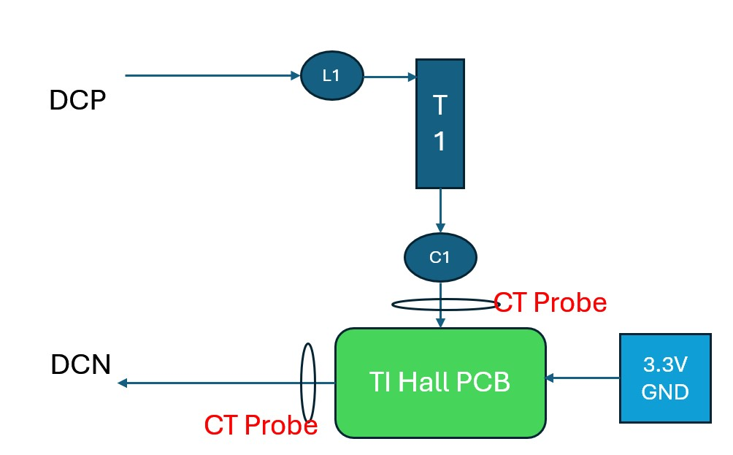

Measured input at Entry and exit side as mentioned in above setup, waveforms shown below side by side.

Yellow: Current probe (PMCS1133 input)-50mv/A, Pink : Pig tail (PMCS1133 output)-25mV/A

## 1.1 150KHz/+/-8A:

## 1.2 150KHz/+/-12A:

## 1.3 150KHz/+/-14A:

## 1.4 150KHz/+/-18A:

## 1.5 250KHz/+/-8A:

## 1.6 250KHz/+/-10A:

## 1.7 250KHz/+/-16A:

## 1.8 350KHz/+/-8A:

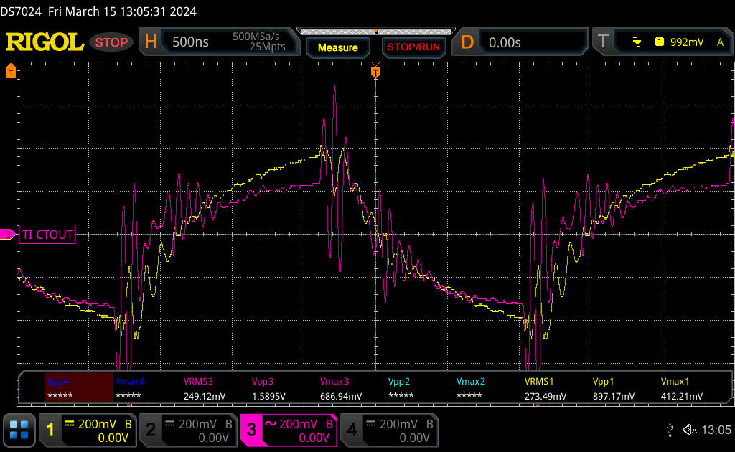

## 1.9 Observation table:

