Qst：
1、IWR1443：Using lvds lanes to transmit ADC rawdata
Our project is to use iwr1443 to transmit rawdata to fpga board which isn't DCA1000EVM, we want to develop our own FPGA board. However, i have some problem when i start the project.

I have already read the following invitation:
https://e2e.ti.com/support/sensors-group/sensors/f/sensors-forum/885225/awr1843-need-help-to-send-a-mount-of-data-through-lvds-when-using-mrr-demo-or-mmw-demo?tisearch=e2e-sitesearch&keymatch=iwr1843%252525252520lvds#

I think there are three ways to achieve this function. The first method is to use the mmwdemo_transferLVDSUserData function in OOB demo to do so, but the function’s annotation indicates it’s not verified. Besides, is there a more detailed explanation about this function?
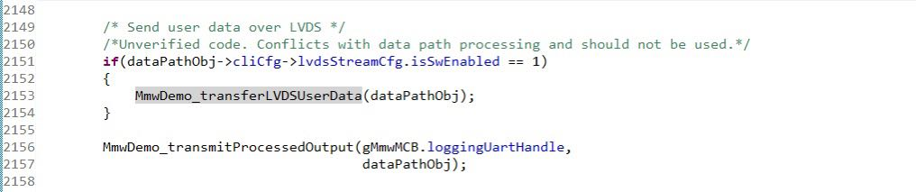

The second method is to use the lvds section in mmw demo. I plan to implement it according to the instructions in the document, but currently mmw demo does not seem to support iwr1443. I don't know if it is workful when we just use LVDS part.
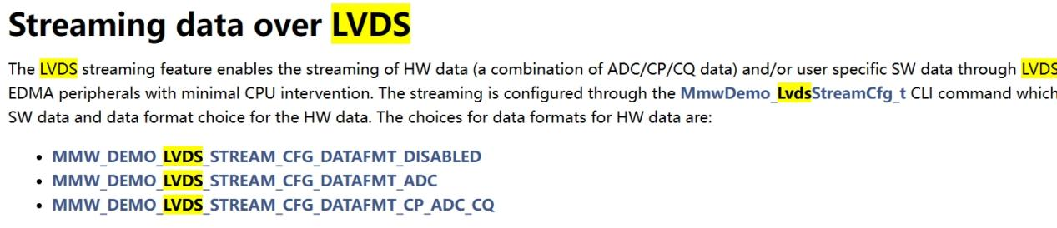

The third method is to use mems _Capture demo in SDK2.1 . This demo only transmit data for one frame at a time

- If there are other better ways to meet the requirements of our project, it would also be very helpful to us.

Best regards.

