**Questions in Snoa949 [Power Reduction Techniques for the Multichannel LDCs in Inductive Sensing Applications]**  2020.06.11

Expressions not found in the LDC1612 SPEC sheet appear in this snoa949.

t N = t S + t C + t SD + t RB

It is tN or tRB.

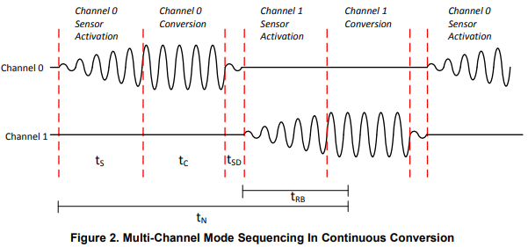

The data readback time (tRB) comes out for the first time on page 3 of snoa949. Is it necessary to read data at this timing (immediately after t SD)? If so, what is the trigger to start the readback?

Also, I'm not sure what the relationship between duty cycle and sampling rate is in this article. I don't know what the duty cycle is because I don't have a diagram.

I was reading the data with I2C at a proper timing apart from sampling. Is it the wrong way to read data?

Also, this document doesn't quite know when to enter sleep mode. Will it be done during sampling? It looks like a very complicated program.

Could you tell me?

Best regards