[AWR1843AOP] SPI MCAL Problem Report

Date: ’24.07.02
Written by Beomjin Kim (PHA)

Contents
[AWR1843AOP] SPI MCAL Problem Report 1
1. Configuration 3
2. Code compilation 8
3. Code Flow and CCS Capture 10
4. Conclusion. 11

Topic: Spi_SyncTransmit(SpiDriver_0.seqCfg[0].seqId) API Function fail.
When I try to use function Spi_SyncTransmit API, JobResult and Sequence Result return fail.
I’m trying to use functional API that provided by SPI module, which I can use to control peripherals.
The chip I want to control is TCAN-14689-Q1. To do so, I configured MCAL SPI module, finished SPI_Init(), and completed Spi_SetupEB.
When I write image to Customer board and start it, even result return E_OK, jobResult and seqResult return SPI_JOB_FAILED and SPI_SEQ_FAILED.
For more description, please read below.

Configuration
The chip that I want to control by using SPI module is TCAN-1469-q1, which is released by TI.
Port module was set like picture below, and before SPI_Init(), Port_Init() was executed.
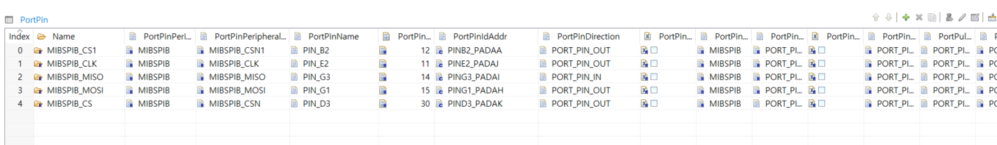

Here are some configurations for SPI that I configured to control TCAN-1469-q1.
  - SpiDriver0
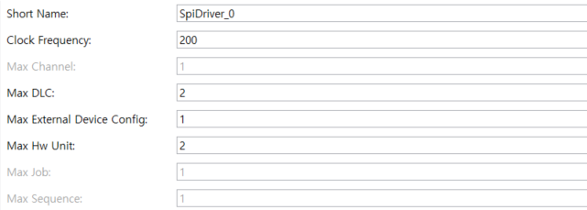

  - Channels
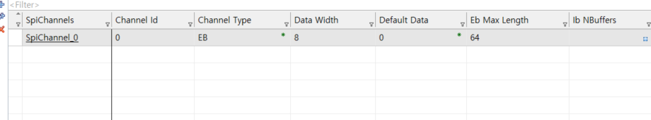
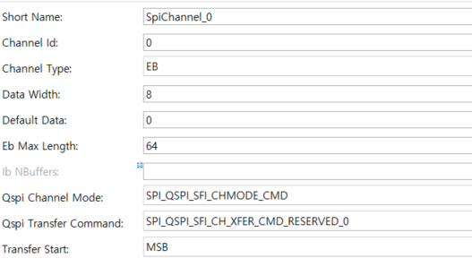
  - ExternalDevices
- Because usage of SPI in customer board is MIBSPIB, Hwunit was configured as MIBSPI2.
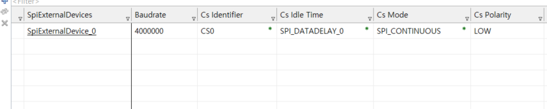
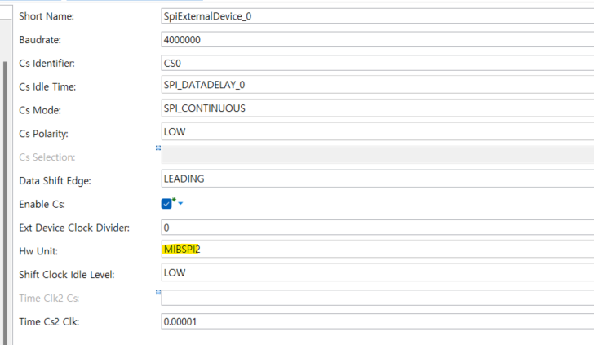
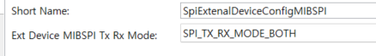
- In addition, because I can’t remove configuration for QSPI in here, I configured it as picture below.
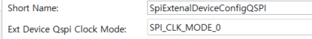
  - HwUnitConfigs
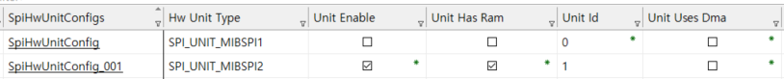
  - Jobs
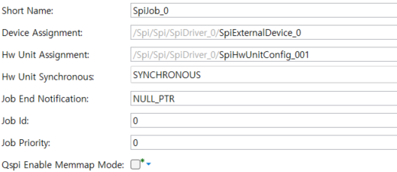
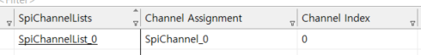
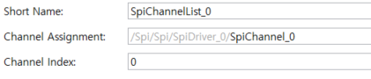
  - Sequences
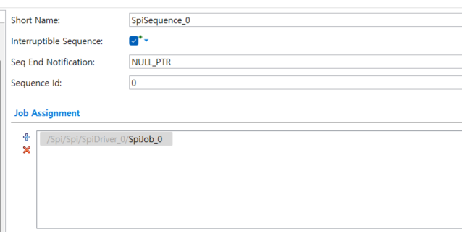

  - General
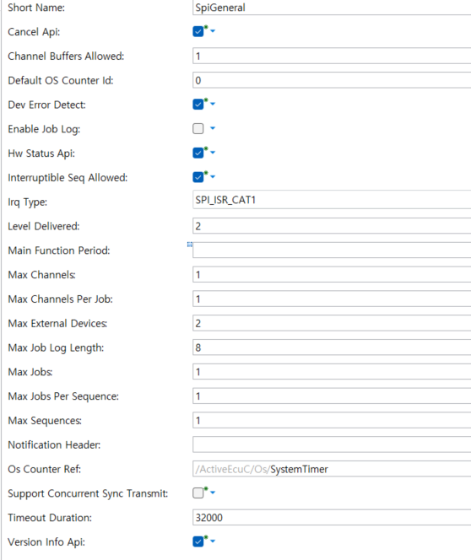
  - HwUnitEnableds
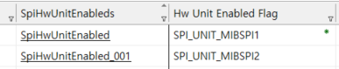
  - PublishedInformation
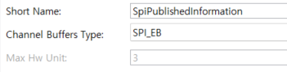

Code compilation
AS I use DAVINCI, the tool for configuration and integration of BSW module, which Vector provided,
I generated it in DAVINCI, compiled through make file and initialized SPI module through BSWM module.
- Initialization
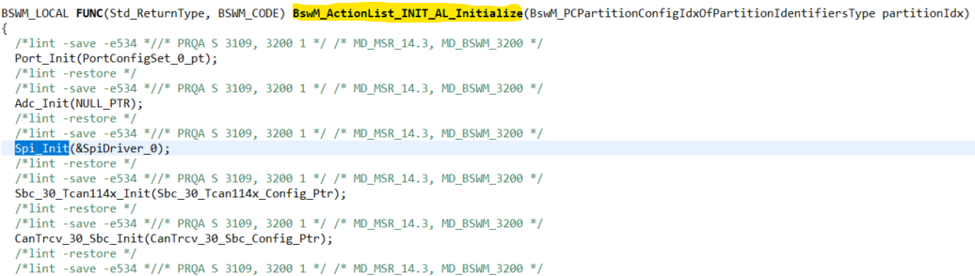
Spi module is initialized after Port Init.
As platform initialized and AUTOSAR OS operates, SWC(Software component) that I designed runs for every 1ms and I designed it like the picture below.
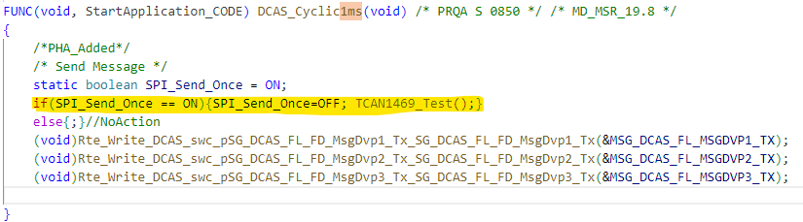
Runnable DCAS_Cyclic1ms(void) is triggered every 1ms and my test function is triggered only one time.
The contents for TCAN1469_Test() is designed picture like below.

- TCAN1469_Test()
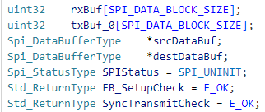
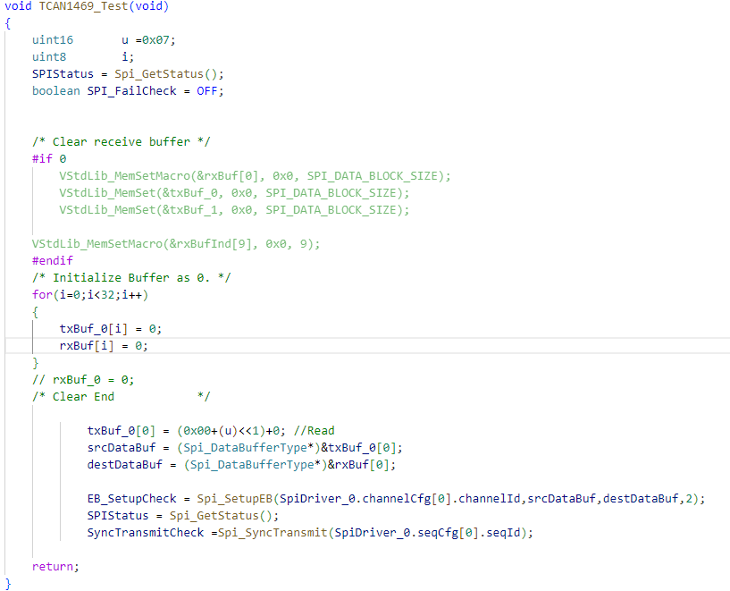
Tx Buffer was set to read Register’s value which is related with the information, described in picture below.
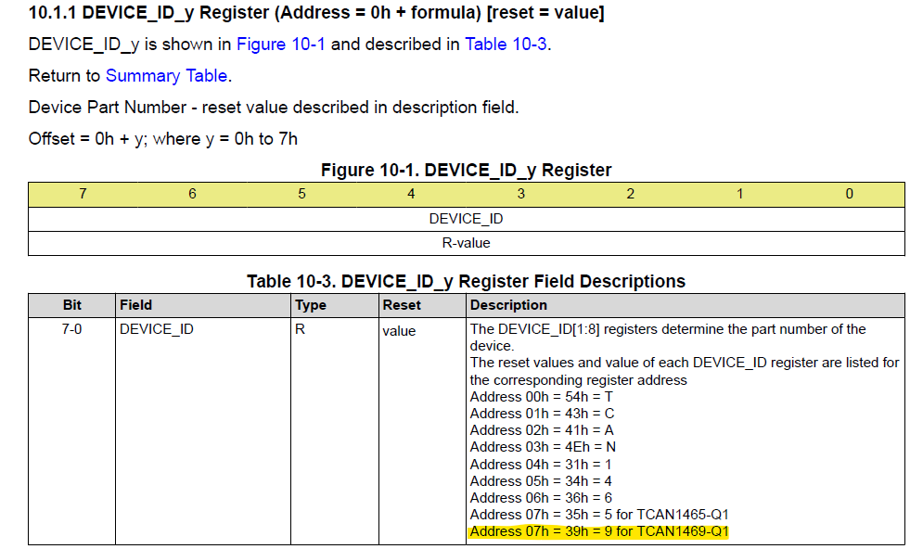
(TCAN-1469-Q1 Datasheet content related to register.)
I expected the result of this function is to return 0x39 in destDataBuf.
As I referenced in topic, Spi_SyncTransmit(SpiDriver_0.seqCfg[0].seqId) doesn’t work properly.

Code Flow and CCS Capture
In here, I’d like to talk about main topic for this report. I inserted breakpoint like the picture below.
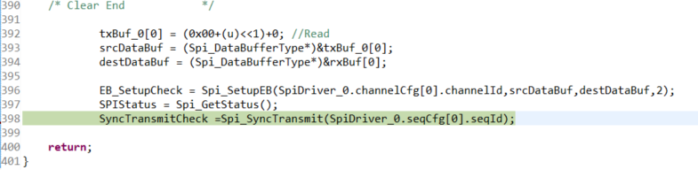
In this API, there’s no problem to proceed the code to next break point, which is shown below.
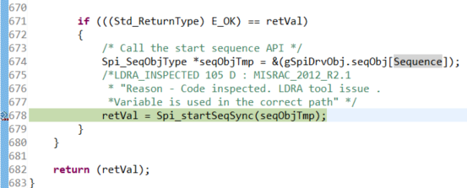

After this break point, the function Spi_ScheduleAllJobsSyncTransmit() is executed.
Finally, the problem point reached in this function. The point is in picture below.
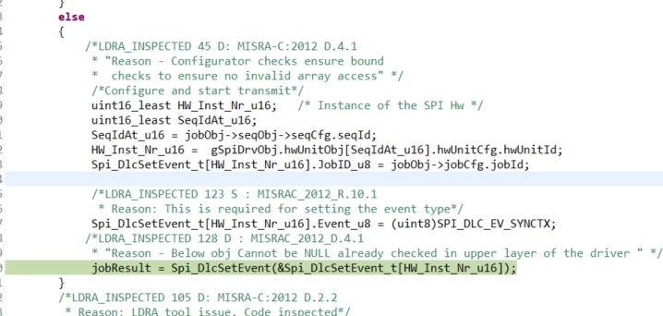
In here, jobResult is returned fail and because of this, seqResult is returned fail too.

Conclusion.
To debug this error, I need TI’s help. Indeed, I need TI’s FAE to make this module work, to operate TCAN1469-q1, as there’s little time to work with in developing period.
Please confirm it and reply me back. Thank you.

