**Setup**

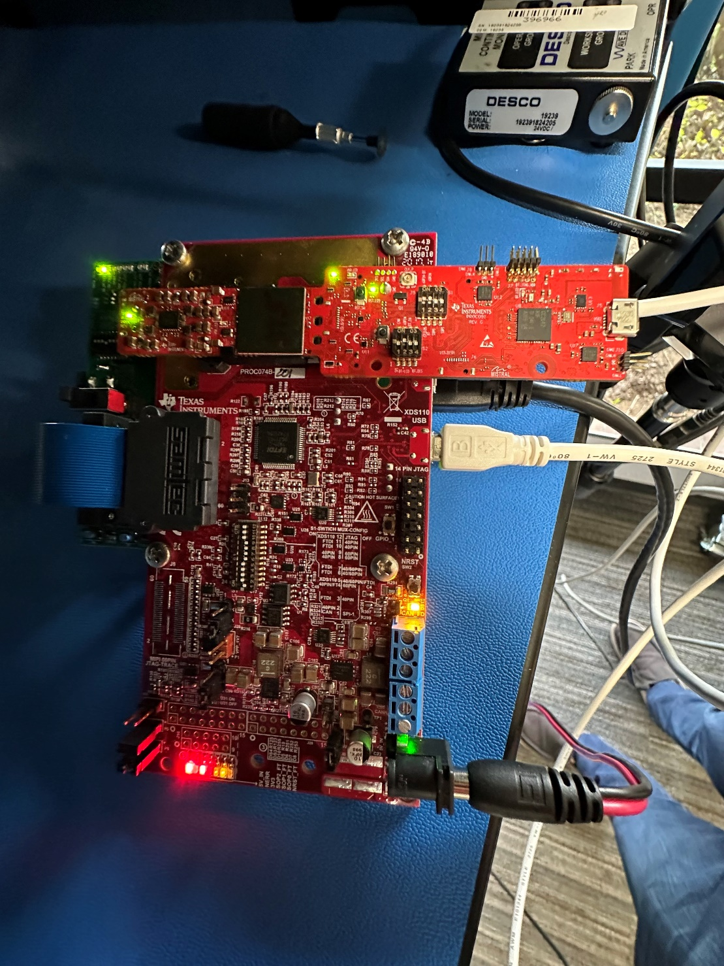

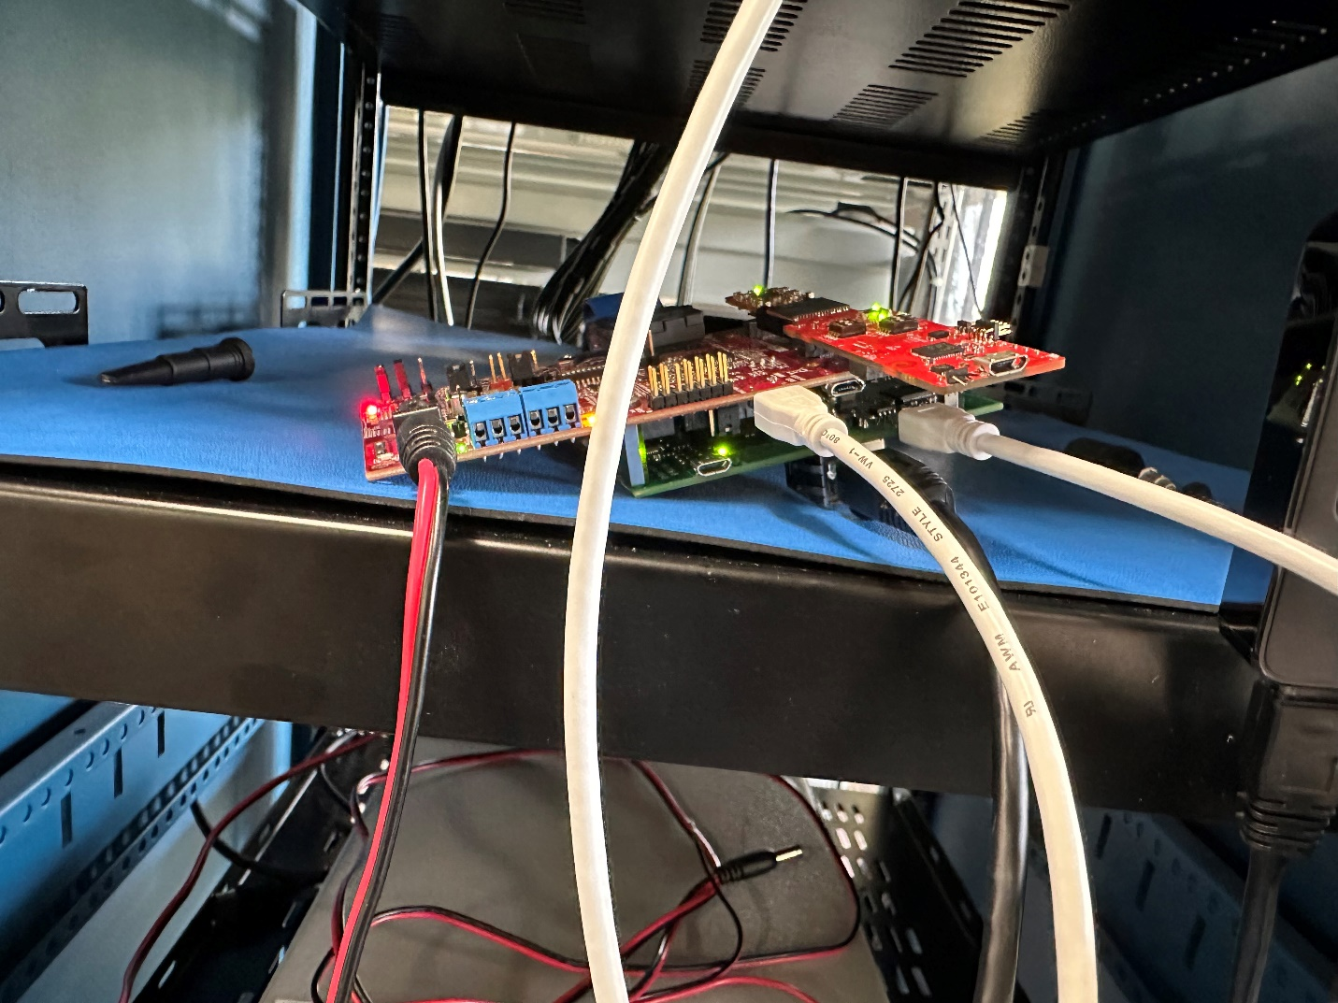

**Connections :-   
IC boost :- DC Jack , xds110_usb  
DCA100- Ethernet cable, Radar_FTDI  
Connect 60 pin connectors of IC boost and DCA1000 using samtec cable(As mentioned in the image).**

**Switch Settings  
6843AoP EVM**

**S3 -off**

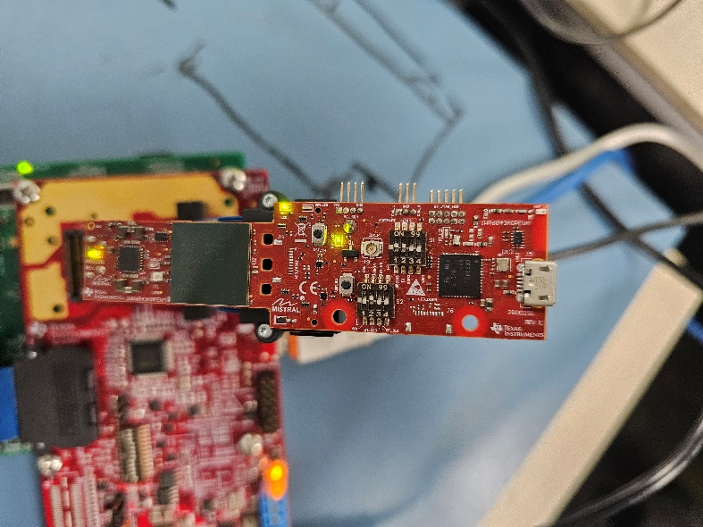

**DCA1000  
Connections : Ethernet cable, Radar_FTDI usb  
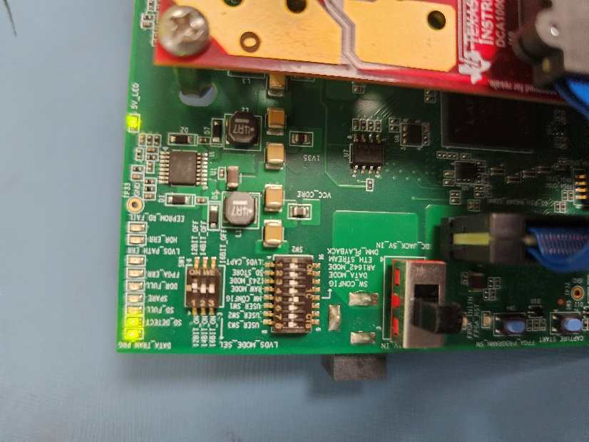**

**IC BOOST  
Connections: DC Jack, XDS110_USB  
Put it in sop2 (Bottom left corner Jumpers)**

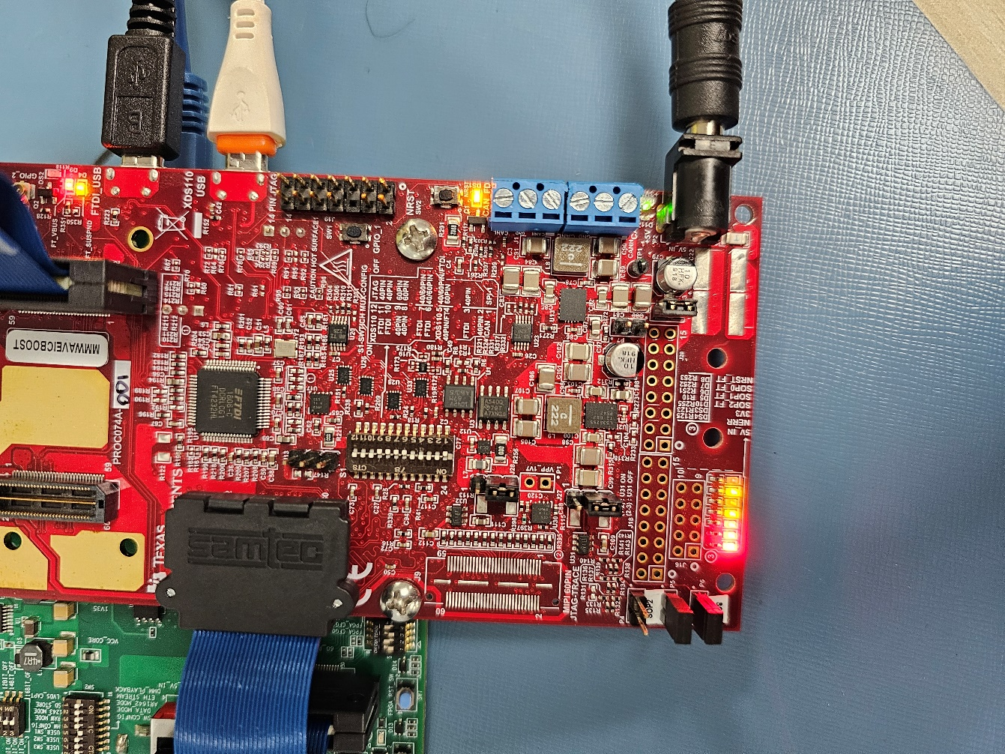S1.1 -OFF  
S1.2 -ON  
S1.3 -ON  
S1.4 -ON   
S1.5 -ON   
S1.6 -OFF   
S1.7 -OFF   
S1.8 -OFF   
S1.9 -OFF   
S1.10 - ON   
S1.11 - ON  
S1.1 2- ON