**Summary of IWRL6432 Issues**

**Scenario 1:**

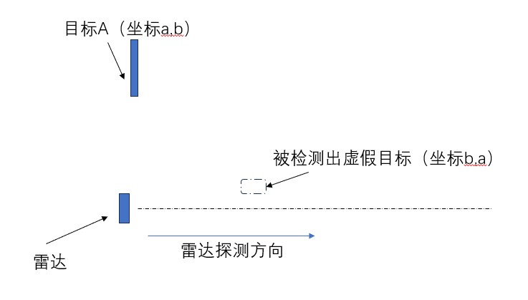

Detected virtual target (b,a)

Radar detection direction

Radar

Target A (a,b)

**As shown in the figure, target A is located at a large angle position x=a, y=b on the left side of the radar; A false target will be detected in front of the radar, and its coordinates are x=b, y=a;**

**Scenario 2:**

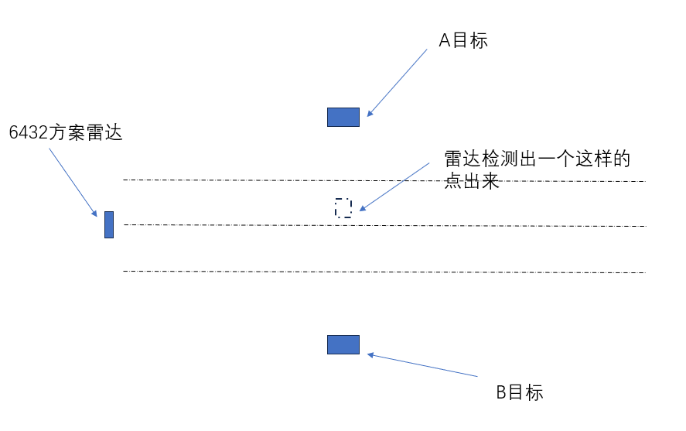

Radar detection point

Target B

Target A

6432 Radar solution

**As shown in the above figure, our IWRL6432 scheme currently encounters a problem where A and B targets are placed on the left and right sides of the radar, and the distance between A and B targets is greater than the resolution; The radar will detect a point between target A and target B; This point is virtually generated.**

**The parameter configuration is as follows:**

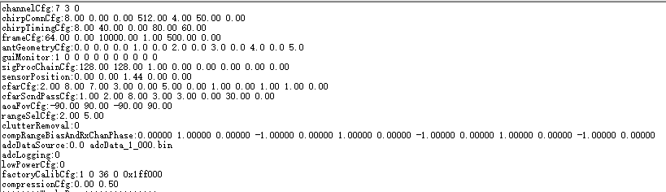

**The antenna layout is**

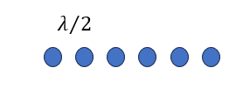

**The SDK used is this one**

**MMWAVE_L_SDK_05_04_00_01\examples\mmw_demo\mmwave_demo**