**1. Poor channel consistency**

Test validation data

Ant0, rangeIdx, 40,  Peak:3604480

Ant1, rangeIdx, 40,  Peak:3368747

Ant2, rangeIdx, 40,  Peak:3649074

Ant3, rangeIdx, 40,  Peak:3668723

Ant4, rangeIdx, 40,  Peak:11605129

Ant5, rangeIdx, 40,  Peak:10876686

Ant6, rangeIdx, 40,  Peak:10877114

Ant7, rangeIdx, 40,  Peak:12422133

Ant8, rangeIdx, 40,  Peak:2111054

Ant9, rangeIdx, 40,  Peak:1935204

Ant10, rangeIdx, 40, Peak:2005571

Ant11, rangeIdx, 40, Peak:2064230

Ant12, rangeIdx, 40, Peak:12299337

Ant13, rangeIdx, 40, Peak:11553028

Ant14, rangeIdx, 40, Peak:11533816

Ant15, rangeIdx, 40, Peak:13173580

Ant16, rangeIdx, 40, Peak:3864963

Ant17, rangeIdx, 40, Peak:3656136

Ant18, rangeIdx, 40, Peak:3815440

Ant19, rangeIdx, 40, Peak:3869474

Ant20, rangeIdx, 40, Peak:11436110

Ant21, rangeIdx, 40, Peak:10957794

Ant22, rangeIdx, 40, Peak:11226479

Ant23, rangeIdx, 40, Peak:12505704

Ant24, rangeIdx, 40, Peak:4120712

Ant25, rangeIdx, 40, Peak:3900505

Ant26, rangeIdx, 40, Peak:4106992

Ant27, rangeIdx, 40, Peak:4097992

Ant28, rangeIdx, 40, Peak:11794391

Ant29, rangeIdx, 40, Peak:11353524

Ant30, rangeIdx, 40, Peak:11757801

Ant31, rangeIdx, 40, Peak:13028205

Ant32, rangeIdx, 40, Peak:882296

Ant33, rangeIdx, 39, Peak:852178

Ant34, rangeIdx, 39, Peak:734775

Ant35, rangeIdx, 40, Peak:762578

Ant36, rangeIdx, 40, Peak:11435192

Ant37, rangeIdx, 40, Peak:11089599

Ant38, rangeIdx, 40, Peak:11382838

Ant39, rangeIdx, 40, Peak:12612975

Ant40, rangeIdx, 40, Peak:2075206

Ant41, rangeIdx, 40, Peak:1910437

Ant42, rangeIdx, 40, Peak:2054106

Ant43, rangeIdx, 40, Peak:2031399

Ant44, rangeIdx, 40, Peak:11962197

Ant45, rangeIdx, 40, Peak:11199297

Ant46, rangeIdx, 40, Peak:11779530

Ant47, rangeIdx, 40, Peak:13387894

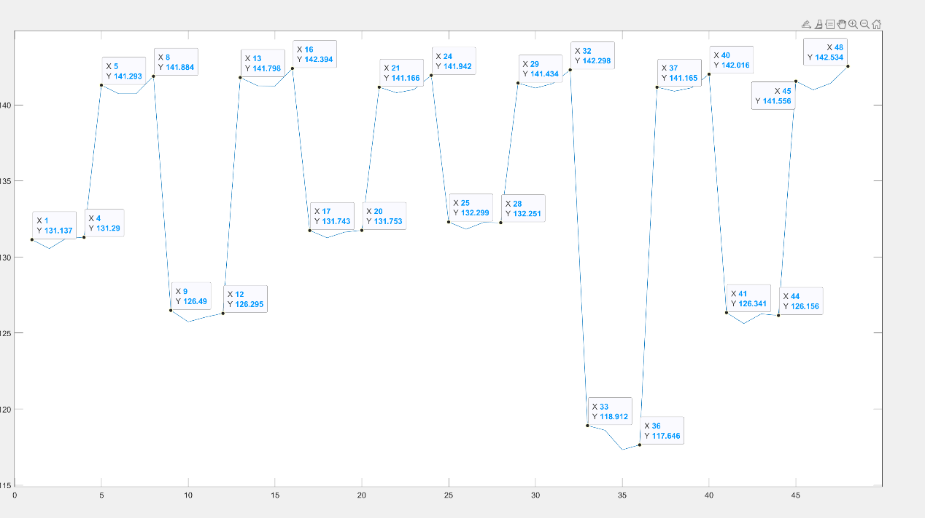

What could be the cause of poor consistency channel?

**2. False alarm point**

When testing and verifying with dual IC firmware, there is a false alarm point at position 229

When using single-IC firmware, there is no false alarm point

**Additionally, I noticed on the forum that others also share this point**

What is the probable cause of this false alarm point?