As you suggested. Now we are following the out of the box demo.

Second suggestion

-> we have tried with the uniflash 8.1.1. software ,try to upload the binary but no luck

Error image is older andI see the same error from day 1. When I connect ICBOOST

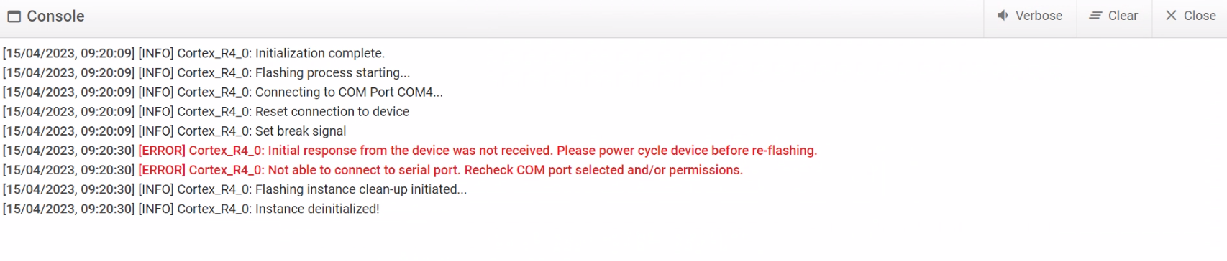

-> we tried to flash the out of the box precompiled binary (C:\ti\radar_toolbox_1_00_00_26\source\ti\examples\Out_Of_Box_Demo\prebuilt_binaries/out_of_box_6843_ods.bin)

As you asked for steps Below steps i’m following

**Steps 1:** remove the ICBOOST with IWR6843 ISK-ODS board

**Step 2 :**  IWR6843 ISK-ODS set in Flashing mode

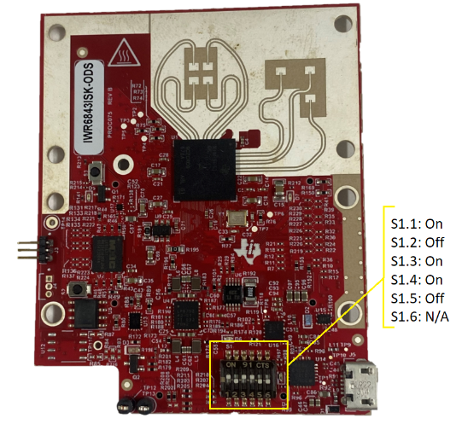

**Step 3 :** Connect the Board to Desktop over USB Cable.

**Step 4 :** Open the **UNIFLASH 8.1.1**

**Step 5 :** Select the **IWR6843**

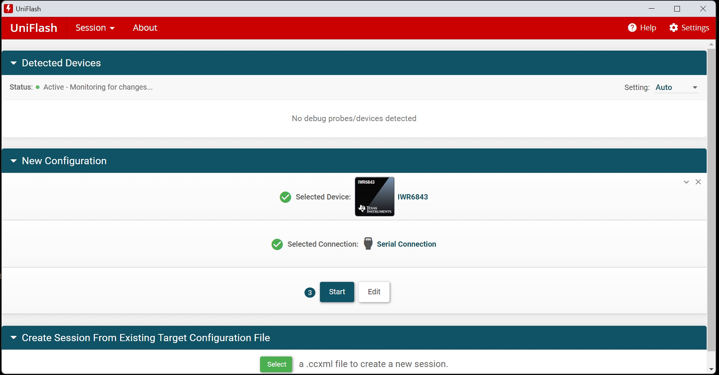

**Step 6:** Path For CCS Debug binary C:\ti\mmwave_sdk_03_06_00_00-LTS\packages\ti\utils\ccsdebug/xwr68xx_ccsdebug.bin

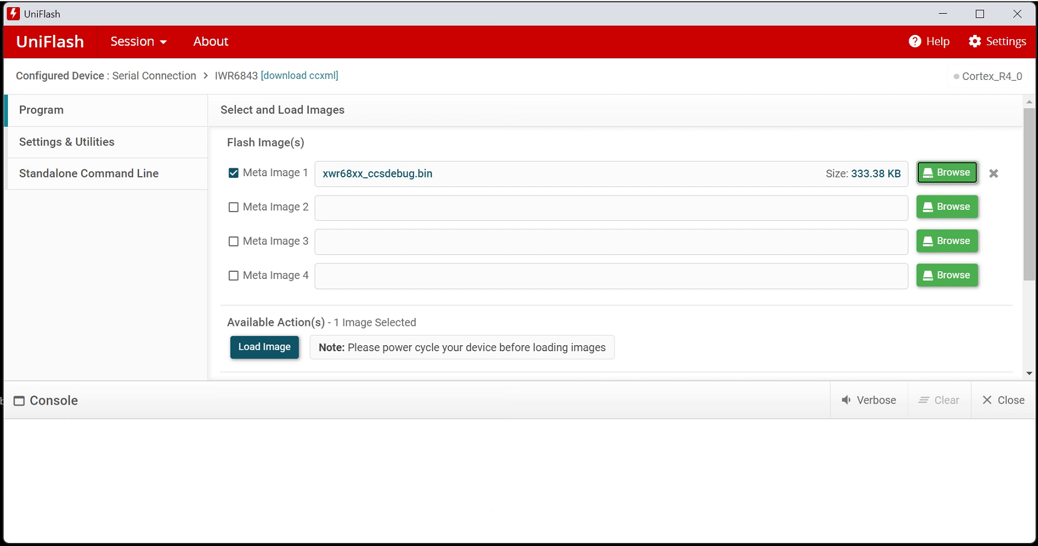

**Step 7:** Select COM Port (Enhanced Serial Port) on UNIFLASH

**Step 8:** Click on the Load Image

**Step 9 :** Few Seconds Binary Will be uploaded

**Step 10 :** Remove the USB Cable

**Step 11 :** ISK-ODS Board Config as Radar Board

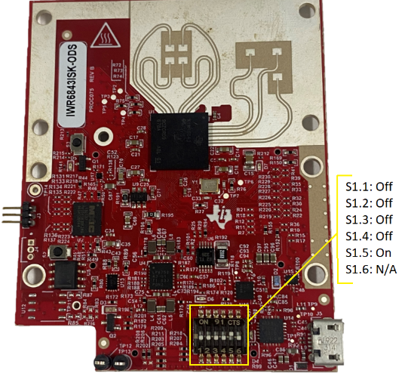

Step 12 : ICBOOST DIP Switch Config as Below Shown image.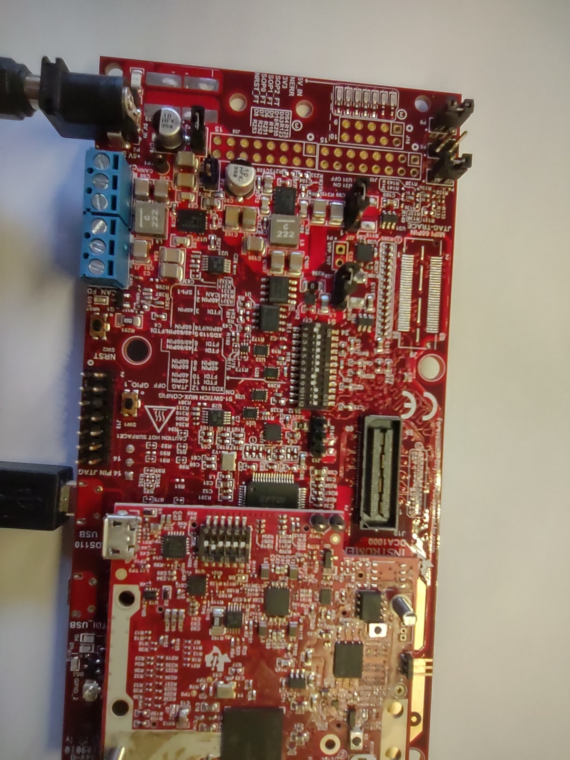

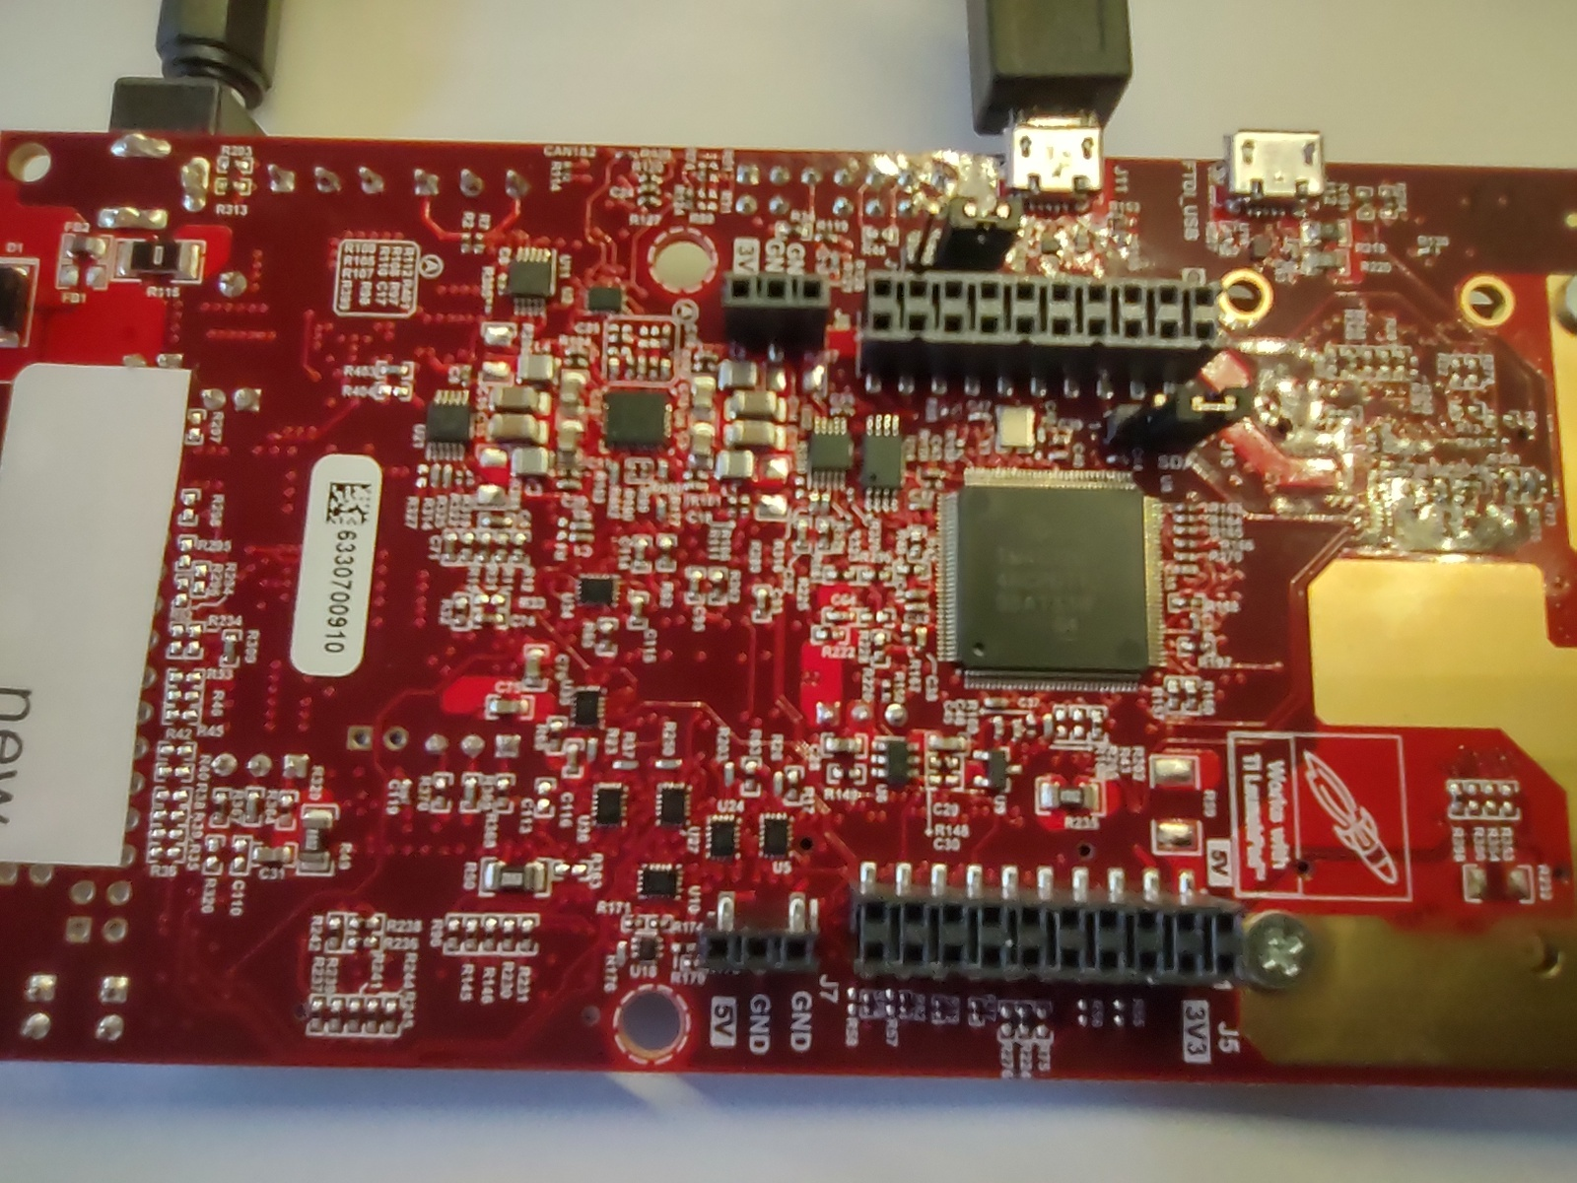

Step 13 : SOP Jumper Set To Flashing mode

Step 14 : connect the ISK-ODS Board On ICBOOST

Step 15 : Now Connect USB and Apply The 5V-3A Power

Step 16 : Click on The Reset button on the ICBOOST

Step 17 : now open the CCS Studio

Step18 : Go to Resource manager and select the out_of_box_6843_ODS

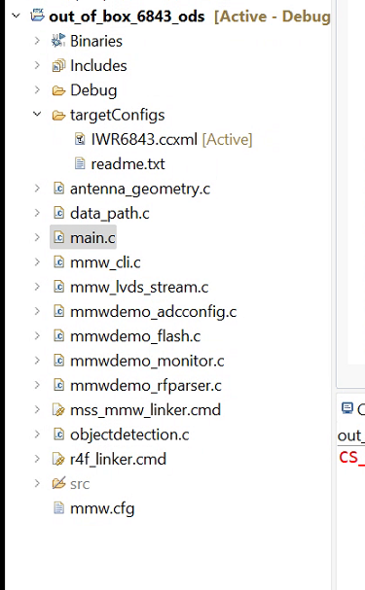

Step 19 : Click on Rebuild

Step 20 : after Compile successfully .xer4f and .bin file generated

Step 21 : Click on the Debug Icon .

In our case Step 21 is get failed so now we closed the CCS Studio and Try To Flash using UNIFLASH.

Step 1 : Select the **IWR6843**

Step 2 : Select the **out_of_the_box_6843/debug/*.xer4f** or .bin (we tried one by one)

Step 3 : Select COM Port **(Application/user UART)**

Step 4 : Click on Load image.

I See some observation can you please confirm CASE 2 is valid behavior or not

Case 1 : When We Connect ICBOOST+ISK-ODS in that Case Device Manager shows the Two COM Port, One is application and other is auxiliary Data port.

Case 2 : When We Connect only the ICBOOST in that Case Device Manager is not showing the COM Port ? is valid behavior