1. Install TPS GUI
2. TPS8804 EVM Setup:
3. Switch S1 Position 4
4. Short J2
5. Set J6 at AGND for getting I2C address as 0x3F
6. Use a USB cable to connect the USB2ANY adapter to a computer with the TPS880x GUI installed.

Ensure the detection of USB2ANY adapter in PC connected as “MSP430-based HID Device” as below in “Settings” window:

1. Open the TPS880x GUI and verify the USB2ANY adapter is recognized

**Actual Messages at bottom of the TPS GUI:**

1. Connecting to TI Cloud Agent …
2. Connecting to target…
3. MSP430-based HID Device waiting for data…
4. Hardware not connected. Failed to connect.

**Expected:**



1. Set up of Power Supply to EVM
   1. Set the voltage at Power Supply 5V
   2. Connect the Power Supply to EVM across VCC(TP3) and PGND(TP19)

Getting voltage at VMCU (TP27): 3.26V

1. Select TPS8804 and click “Explore TPS8804

Expected Window:

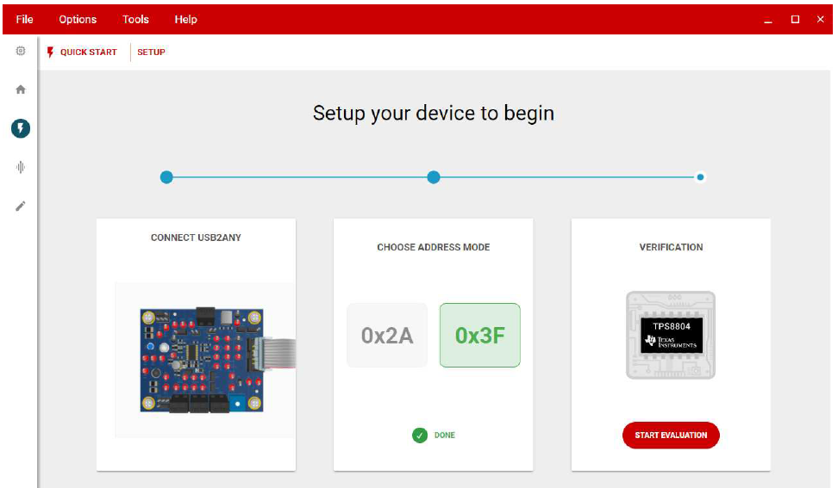

Actual Window:

