After replacing power supply to 12 V , 2.5 Amper

Trying to flash default.cfg

***First Step***

C:\ti\mmwave_mcuplus_sdk_04_07_00_01\mcu_plus_sdk_awr2x44p_10_00_00_07\tools\boot\sbl_prebuilt\awr2x44p-evm>setenv.bat

-----------------------------------------------

mmWave Build Environment Configured

-----------------------------------------------

Second step

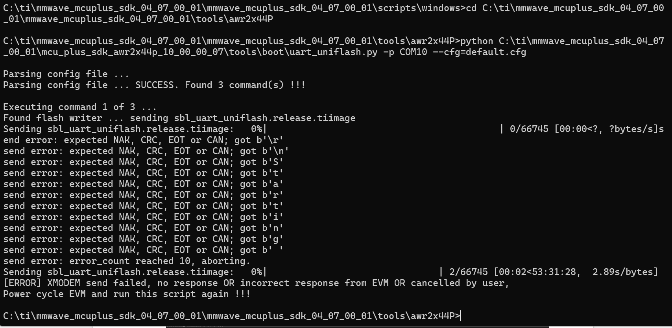

Trying to falsh default_sbl_null.cfg

***First Step***

C:\ti\mmwave_mcuplus_sdk_04_07_00_01\mcu_plus_sdk_awr2x44p_10_00_00_07\tools\boot\sbl_prebuilt\awr2x44p-evm>setenv.bat

'setenv.bat' is not recognized as an internal or external command,

operable program or batch file.

C:\ti\mmwave_mcuplus_sdk_04_07_00_01\mcu_plus_sdk_awr2x44p_10_00_00_07\tools\boot\sbl_prebuilt\awr2x44p-evm>cd C:\ti\mmwave_mcuplus_sdk_04_07_00_01\mmwave_mcuplus_sdk_04_07_00_01\scripts\windows

C:\ti\mmwave_mcuplus_sdk_04_07_00_01\mmwave_mcuplus_sdk_04_07_00_01\scripts\windows>setenv.bat

C:\ti\mmwave_mcuplus_sdk_04_07_00_01\mmwave_mcuplus_sdk_04_07_00_01\scripts\windows>set MMWAVE_SDK_DEVICE=awr2x44P

C:\ti\mmwave_mcuplus_sdk_04_07_00_01\mmwave_mcuplus_sdk_04_07_00_01\scripts\windows>set DOWNLOAD_FROM_CCS=yes

C:\ti\mmwave_mcuplus_sdk_04_07_00_01\mmwave_mcuplus_sdk_04_07_00_01\scripts\windows>set MMWAVE_SDK_TOOLS_INSTALL_PATH=C:/ti/mmwave_mcuplus_sdk_04_07_00_01

C:\ti\mmwave_mcuplus_sdk_04_07_00_01\mmwave_mcuplus_sdk_04_07_00_01\scripts\windows>set MMWAVE_SDK_INSTALL_PATH=C:/ti/mmwave_mcuplus_sdk_04_07_00_01/mmwave_mcuplus_sdk_04_07_00_01

C:\ti\mmwave_mcuplus_sdk_04_07_00_01\mmwave_mcuplus_sdk_04_07_00_01\scripts\windows>set CCS_INSTALL_PATH=C:/ti/ccs1281

C:\ti\mmwave_mcuplus_sdk_04_07_00_01\mmwave_mcuplus_sdk_04_07_00_01\scripts\windows>set R5F_CLANG_INSTALL_PATH=C:/ti/ccs1281/ccs/tools/compiler/ti-cgt-armllvm_3.2.2.LTS

C:\ti\mmwave_mcuplus_sdk_04_07_00_01\mmwave_mcuplus_sdk_04_07_00_01\scripts\windows>set XDC_INSTALL_PATH=C:/ti/ccs1281/xdctools_3_62_01_16_core

C:\ti\mmwave_mcuplus_sdk_04_07_00_01\mmwave_mcuplus_sdk_04_07_00_01\scripts\windows>SET MCU_PLUS_AWR294X_INSTALL_PATH=C:/ti/mmwave_mcuplus_sdk_04_07_00_01/mcu_plus_sdk_awr294x_10_00_00_07

C:\ti\mmwave_mcuplus_sdk_04_07_00_01\mmwave_mcuplus_sdk_04_07_00_01\scripts\windows>SET MCU_PLUS_AWR2X44P_INSTALL_PATH=C:/ti/mmwave_mcuplus_sdk_04_07_00_01/mcu_plus_sdk_awr2x44p_10_00_00_07

C:\ti\mmwave_mcuplus_sdk_04_07_00_01\mmwave_mcuplus_sdk_04_07_00_01\scripts\windows>SET MCU_PLUS_AWR2544_INSTALL_PATH=C:/ti/mmwave_mcuplus_sdk_04_07_00_01/mcu_plus_sdk_awr2544_10_00_00_07

C:\ti\mmwave_mcuplus_sdk_04_07_00_01\mmwave_mcuplus_sdk_04_07_00_01\scripts\windows>SET SYSCONFIG_INSTALL_PATH=C:/ti/sysconfig_1.24.0

C:\ti\mmwave_mcuplus_sdk_04_07_00_01\mmwave_mcuplus_sdk_04_07_00_01\scripts\windows>set MMWAVE_AWR294X_DFP_INSTALL_PATH=C:/ti/mmwave_mcuplus_sdk_04_07_00_01/mmwave_dfp_02_04_17_00

C:\ti\mmwave_mcuplus_sdk_04_07_00_01\mmwave_mcuplus_sdk_04_07_00_01\scripts\windows>set AWR294X_RADARSS_IMAGE_BIN=C:/ti/mmwave_mcuplus_sdk_04_07_00_01/mmwave_dfp_02_04_17_00/firmware/radarss/xwr29xx_radarss_metarprc.bin

C:\ti\mmwave_mcuplus_sdk_04_07_00_01\mmwave_mcuplus_sdk_04_07_00_01\scripts\windows>set AWR2544_RADARSS_IMAGE_BIN=C:/ti/mmwave_mcuplus_sdk_04_07_00_01/mmwave_dfp_02_04_17_00/firmware/radarss/xwr25xx_radarss_metarprc.bin

C:\ti\mmwave_mcuplus_sdk_04_07_00_01\mmwave_mcuplus_sdk_04_07_00_01\scripts\windows>set AWR2X44P_RADARSS_IMAGE_BIN=C:/ti/mmwave_mcuplus_sdk_04_07_00_01/mmwave_dfp_02_04_17_00/firmware/radarss/xwr2x4xp_radarss_metarprc.bin

C:\ti\mmwave_mcuplus_sdk_04_07_00_01\mmwave_mcuplus_sdk_04_07_00_01\scripts\windows>set C66X_CODEGEN_INSTALL_PATH=C:/ti/ccs1281/ccs/tools/compiler/ti-cgt-c6000_8.3.12

C:\ti\mmwave_mcuplus_sdk_04_07_00_01\mmwave_mcuplus_sdk_04_07_00_01\scripts\windows>set C66x_DSPLIB_INSTALL_PATH=C:/ti/mmwave_mcuplus_sdk_04_07_00_01/dsplib_c66x_3_4_0_0

C:\ti\mmwave_mcuplus_sdk_04_07_00_01\mmwave_mcuplus_sdk_04_07_00_01\scripts\windows>set C66x_MATHLIB_INSTALL_PATH=C:/ti/mmwave_mcuplus_sdk_04_07_00_01/mathlib_c66x_3_1_2_1

C:\ti\mmwave_mcuplus_sdk_04_07_00_01\mmwave_mcuplus_sdk_04_07_00_01\scripts\windows>call checkenv.bat

-----------------------------------------------

mmWave Build Environment Configured

-----------------------------------------------

C:\ti\mmwave_mcuplus_sdk_04_07_00_01\mmwave_mcuplus_sdk_04_07_00_01\scripts\windows>

Second Step

