

**2.ソフトウェア使用方法**

**How to use the software**

ソフトウェア 「 PGA305EVM 」 を起動する

**Start the software "PGA305EVM"**

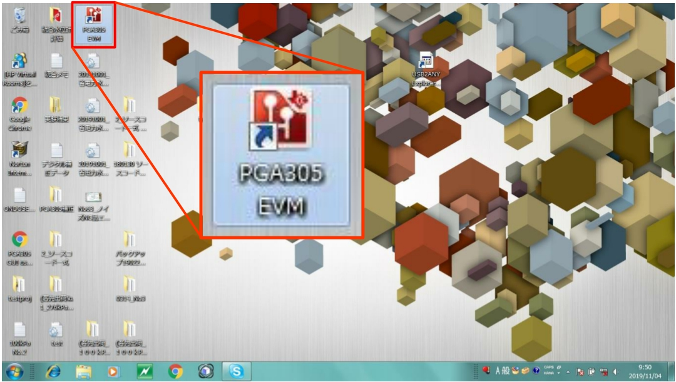

1



**2.ソフトウェア使用方法**

**How to use the software**

**1.Interface Setting**

起動後 「 ◆Interface Settings 」 の画面（下図）が表示される

画面右上 「 Interface Disconnected? 」 のチェックがついていればクリックしてチェックを外す画面左上の 「 I2C 」 をクリック

**If "Interface Disconnected?" Is checked at the top right of the screen, click it to uncheck it.**

**Click "I2C" at the top left of the screen**

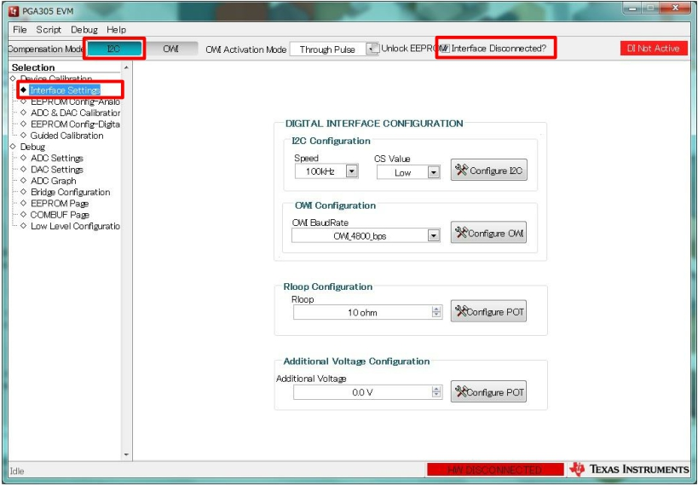

**2.ソフトウェア使用方法**

**1.Interface Setting**

画面左上 「 Compensation Mode 」 → 「 Digital Interface 」画面右上 「 DI Not Active 」 → 「 DI Active 」

画面右下 「 HW DISCONNECTED 」 → 「 HW CONNECTED 」 Confirm that it has changed and proceed to the next.

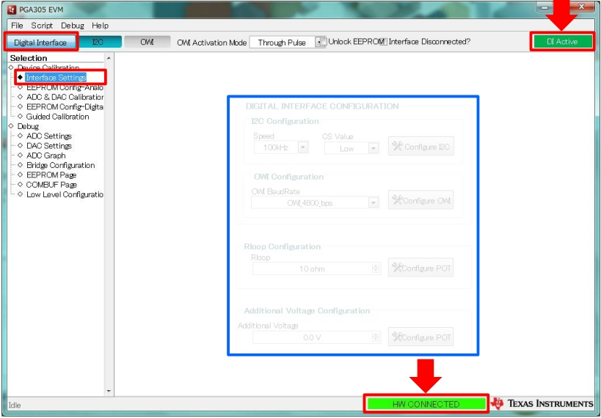

変更しない

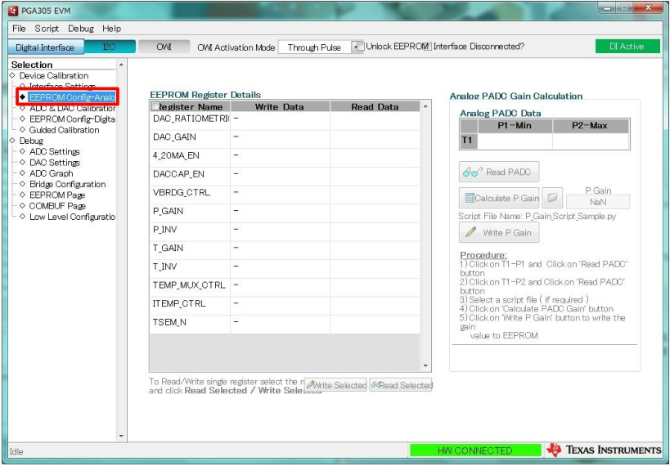

**2.** **How to use the software**

**2.EEPROM Config-Analog**

画面左 from「 ◇Device Calibration 」 select to「 ◆EEPROM Config-Analog 」

4

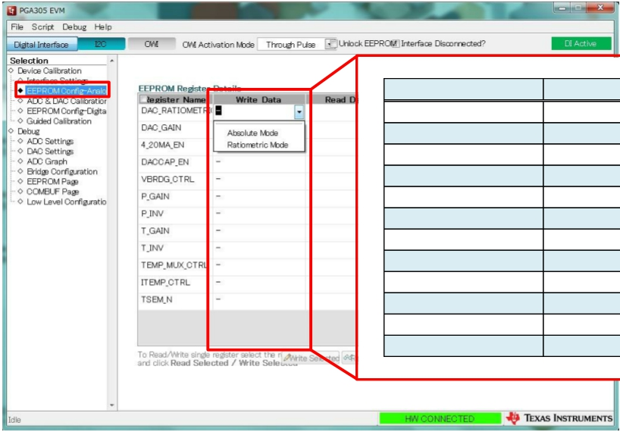

**2.** **How to use the software**

**2.EEPROM Config-Analog**

画面中央 「 EEPROM Register Details 」 の 「 Write Data 」 Click the field and select each item

項目 選択値

DAC_RATIO Absolute Mode

DAC_GAIN 4.00 V

4_20MA_EN No

DACCAP_EN Yes

VBRDG_CTRL 2.5 V

P_GAIN 40.00

P_INV No

T_GAIN 1.33

T_INV No

TEMP_MUX_CTRL VINTP-VINTN

ITEMP_CTRL OFF

TSEM_N Differential

5



**2. How to use the software**

**2.EEPROM Config-Analog**

After selecting each item, check the "Register Name" field and make all items selected.

With all items selected, click "Write Selected" at the bottom center of the screen to write.

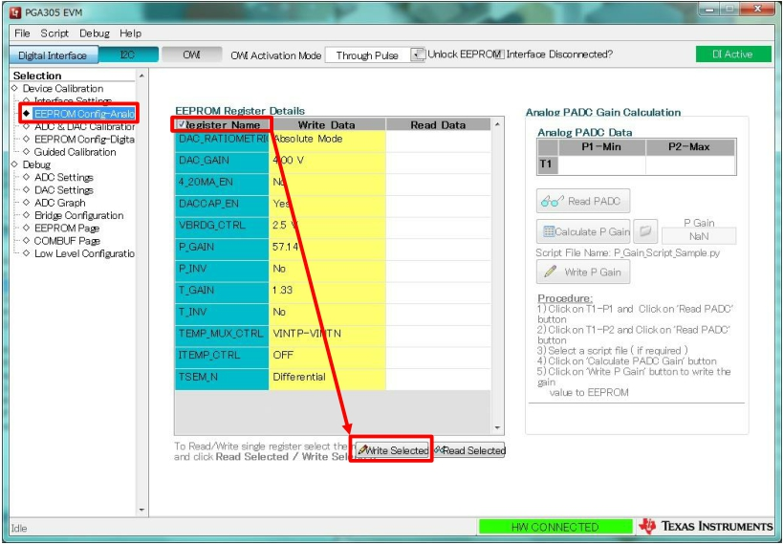

6



**2. How to use the software**

**2.EEPROM Config-Analog**

After writing, turn off the power of the product → Power on

After turning on the power, click "I2C" to communicate with the connected water level gauge.

Check the "Register Name" field and click "Read Selected"

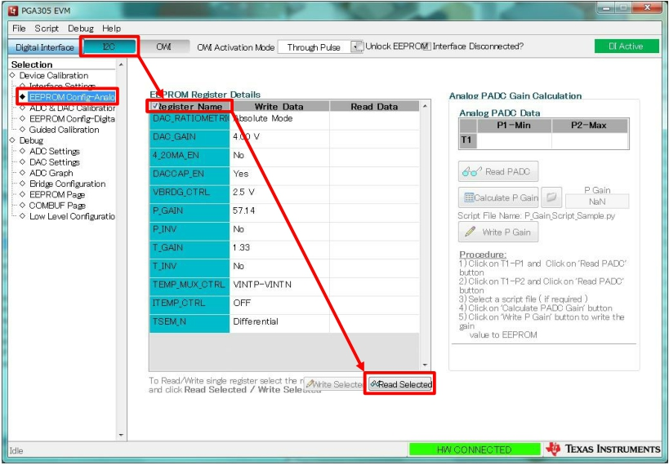

7

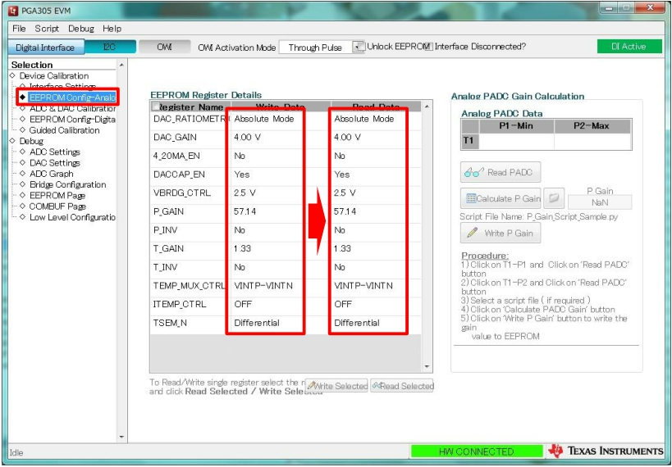

**2. How to use the software**

**2.EEPROM Config-Analog**

After confirming that "Write Data" and "Read Data" are the same as shown in the figure below,

proceed to the next step.

8



**2. How to use the software**

**3.ADC & DAC Calibration**

From "◇ Device Calibration" on the left side of the screen,

Select "◆ ADC & DAC Calibration"

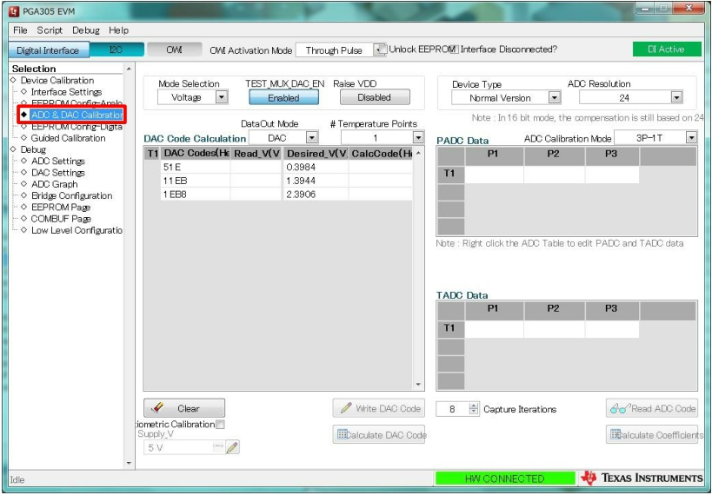

9

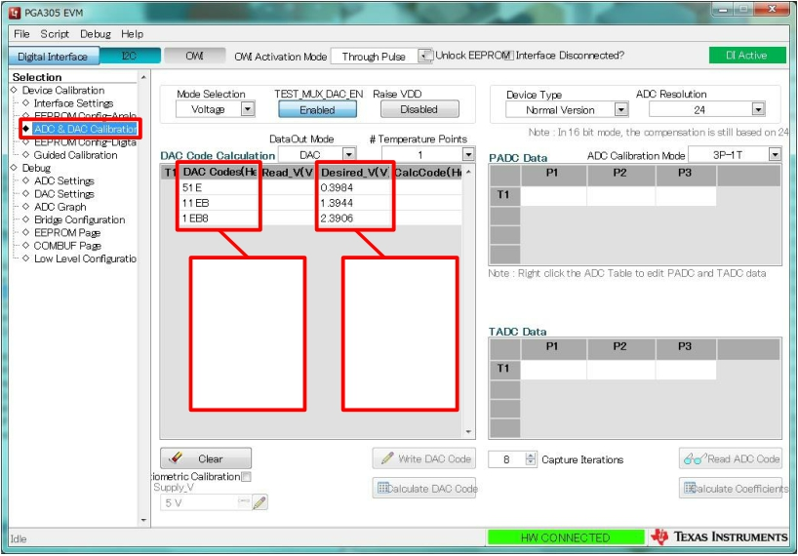

**2. How to use the software**

**3.ADC & DAC Calibration**

Enter "DAC Codes" in the column from top to bottom　"51E" "11EB" "1EB8"「 DAC Codes 」

Enter "DAC Codes" in the column from top to bottom,Enter "0.4000", "1.4000", "2.4000"

51E 11EB 1EB8

0.4000 1.4000 2.4000

10



**2. How to use the software**

**3.ADC & DAC Calibration**

Click "DAC Code" under "DAC Code Calculation"

Click "Write DAC Code" when the frame color changes to blue.

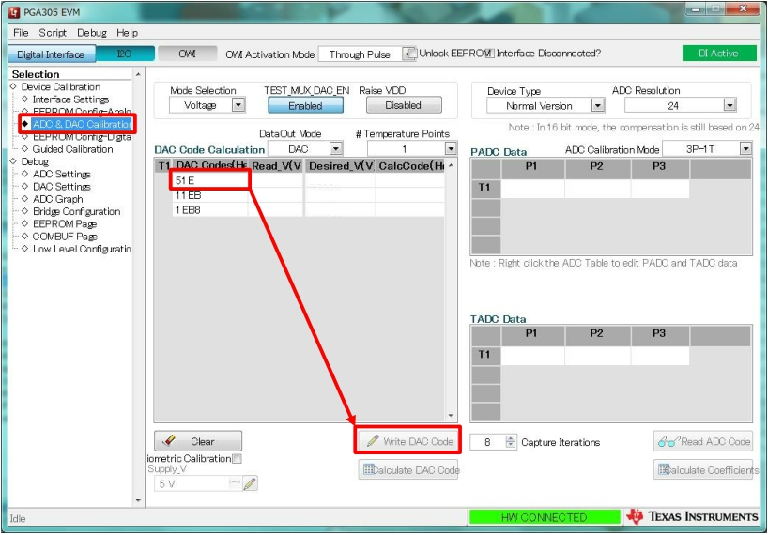

0.4000

1.4000 2.4000

11



**2. How to use the software**

**3.ADC & DAC Calibration**

　　　　Check the value displayed on the multimeter measuring the output voltage of the product.

Operate in the same way for each column (51E, 11EB, 1EB8) of "DAC Code" and check the value.

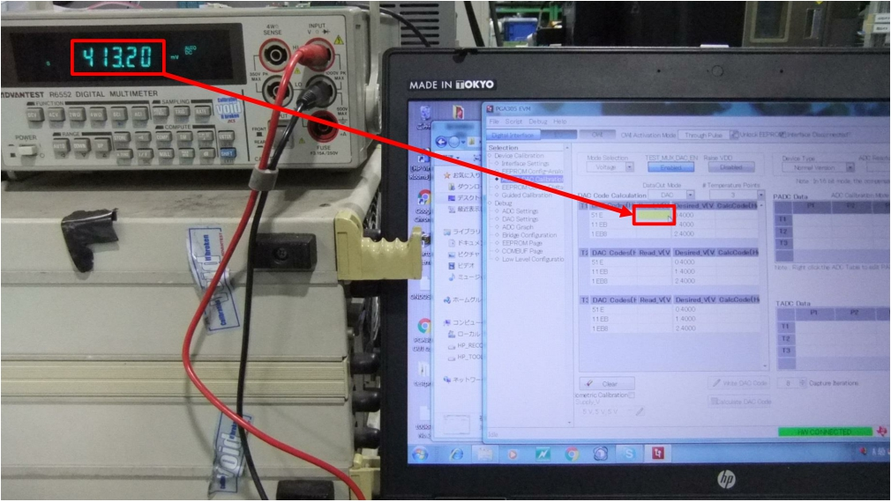

**mV**

**0.4132 V**

12