Step 1 : First Power off the board

Step :2 please check is the same sequence in on IBOOST

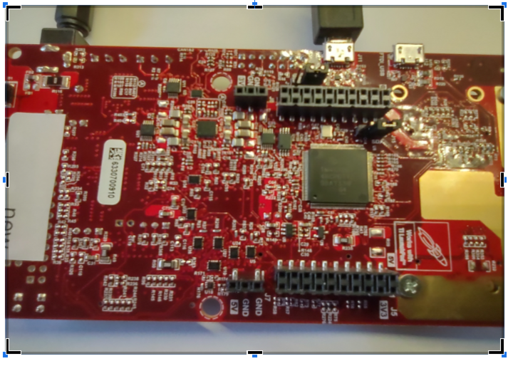

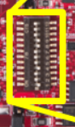

step 3 : Check ISK board switch

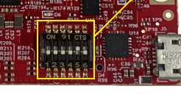

Step 4 : remove the jumper

SOP2 Jumper OPEN

SOP1 Jumper OPEN

SOP0 Jumper CLOSE (edited)

Step 5: Connect the USB AND Power supply and turn on Board

step 6: Do not turn off board

Set SOP Jumper

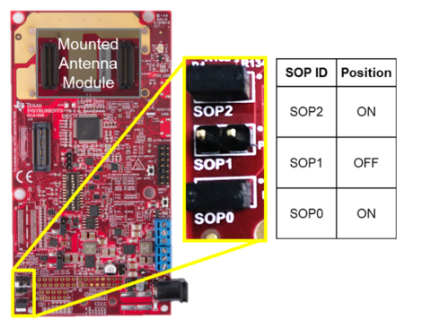

Step 7: Press the Reset for activate flash mode

