I use mmWave Studio with AWR1642 and DCA1000

StaticConfig Tab

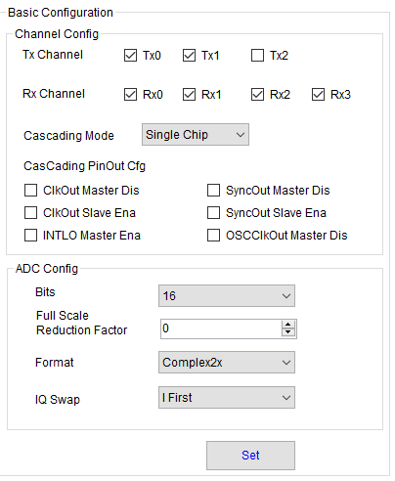

SensorConfig Tab:

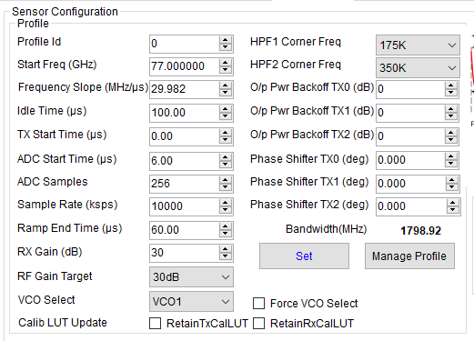

PostProc:

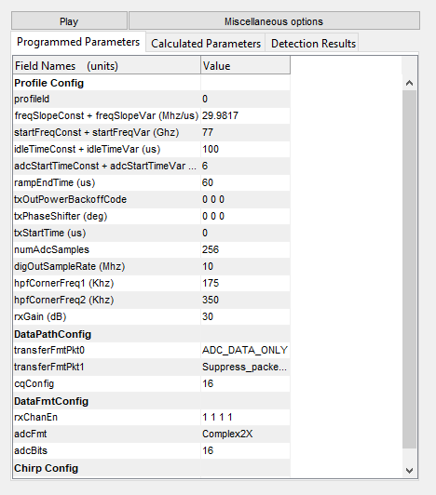

digOutSampleRate (Mhz) 10

adcFmt Complex2X

I got the correct target measurement as expected and no error message at all…

Claudio