Minolta readings are
x:0.2903 y:0.6079.
u’: 0.1195 v’:0.5632
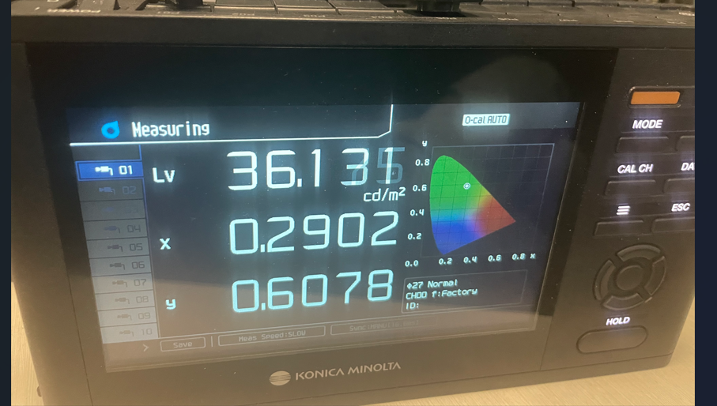

opt4048 ti evm is u’:0.160 v’:0.562
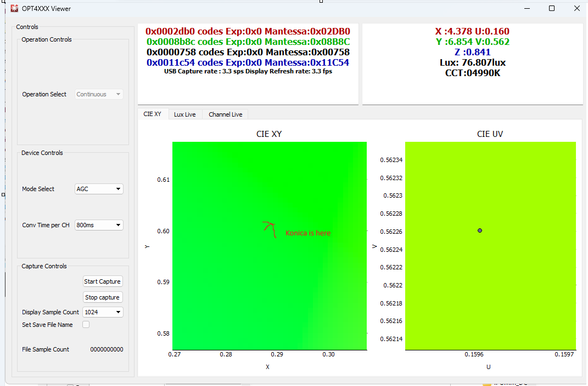

Sparkfun
