First, we need to purchase a batch of millimeter wave radars for high-speed ranging

Suppose we have the following working scenario, A1 and B1 move relative to each other, the rendezvous time is 0.6ms, and another rendezvous will be completed after 18ms.

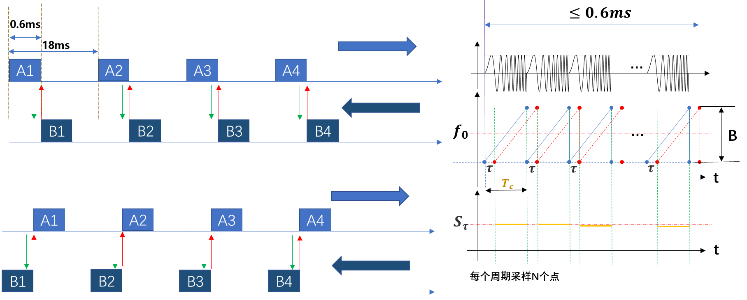

Therefore, we need to complete the transmission and reception of radar signal within 0.6ms, and the transmission, processing and calculation of the whole data within 18ms.

If we can reduce the numbers of chirps, the total chirps time can limited within 0.6ms, but I’m not sure the total frame period time can limited within 18ms.

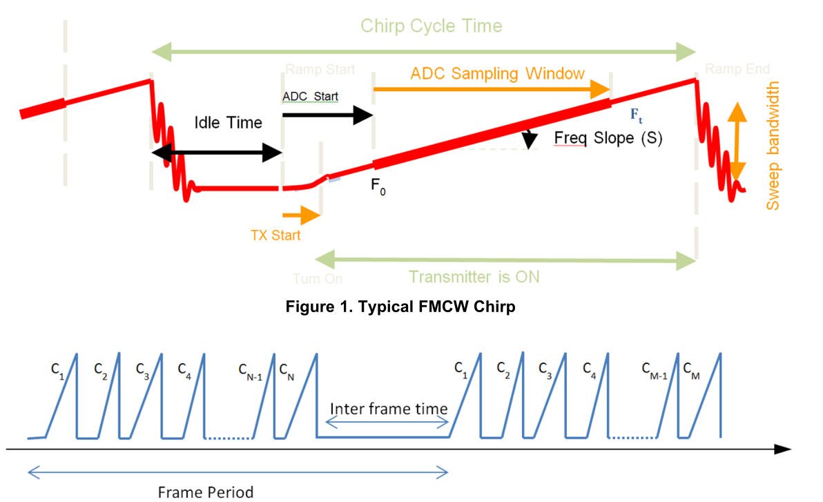

If these are ok, please give me a choose, we will purchase some product.

If the DCA1000EVM can meet our requirements?

