Target application : Gas tank level detection with IOT module.
Test condition :
- EVM : default setting
- Piezo transducer : BSU-P7-1000B-W200 : BESTAR ELECTRONICS 1MHz 2mm thickness 7mm diameter
Test result
- The TOF value change variation is just 0.00xx usec. -> Seems Piezo didn’t work.
- Left PGA gain 9dB, Right PGA gain 15dB -> If I increase the PGA gain then the COMPIN in value changed but it seems a kind of noise.
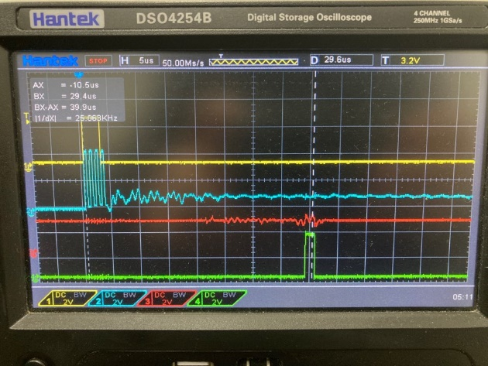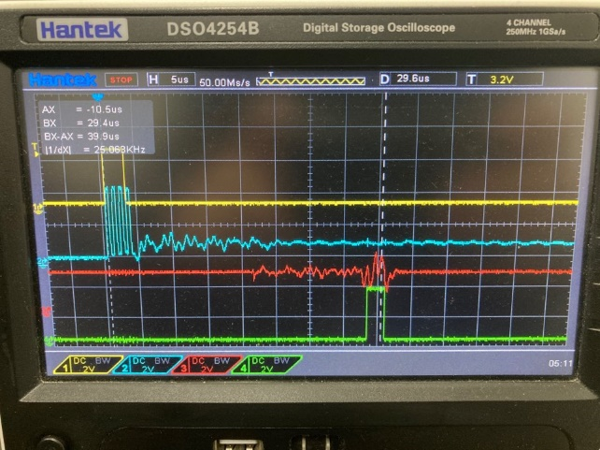
- If I increase the ECHO threshold value then no signal from COMPIN.
- I suspect the piezo sensor didn’t’ operate, so changed other units but the result was same.
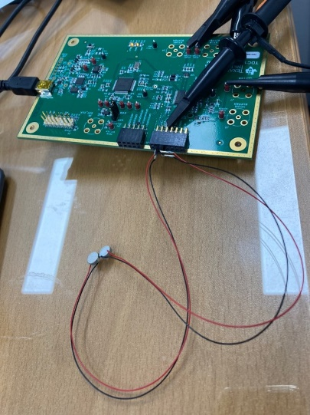
- So I disconnect 0 ohm resistors (R80 and R81) from EVM and connect transducers direct to TX1 and RX1 like below.
But the result was same. No signal from COMPIN. 