>Request detail

It had rust on it since I bought it.

This does not allow for precise measurements. Rust makes it useless.

I want to replace the antenna with a clean one.

>replacement qty, part#

2, AWR2944EVM

>outer box picture

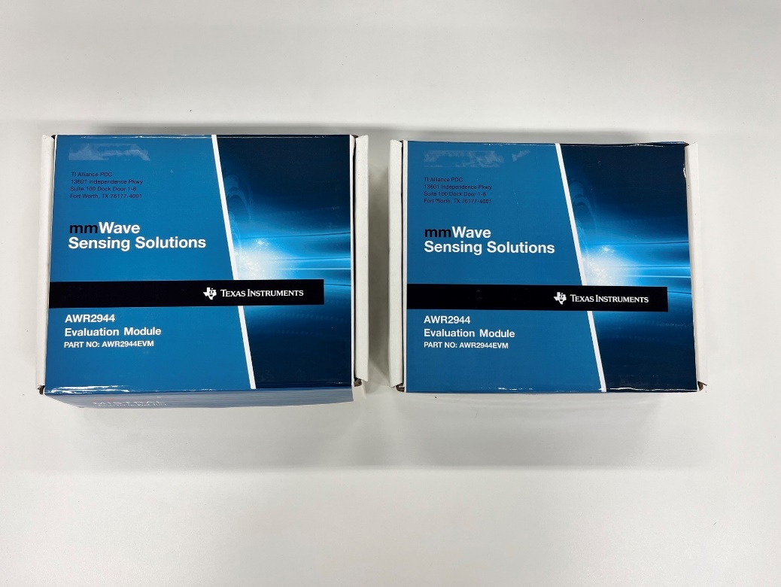

>inner box picture

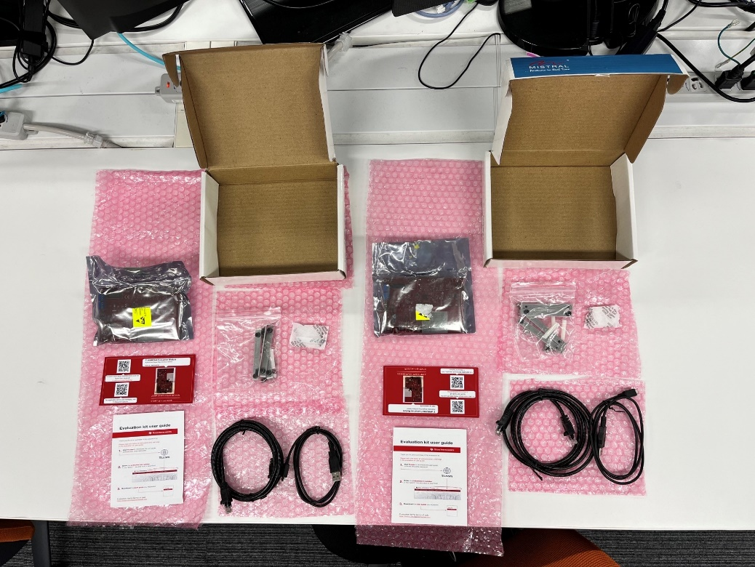

>shipment label picture

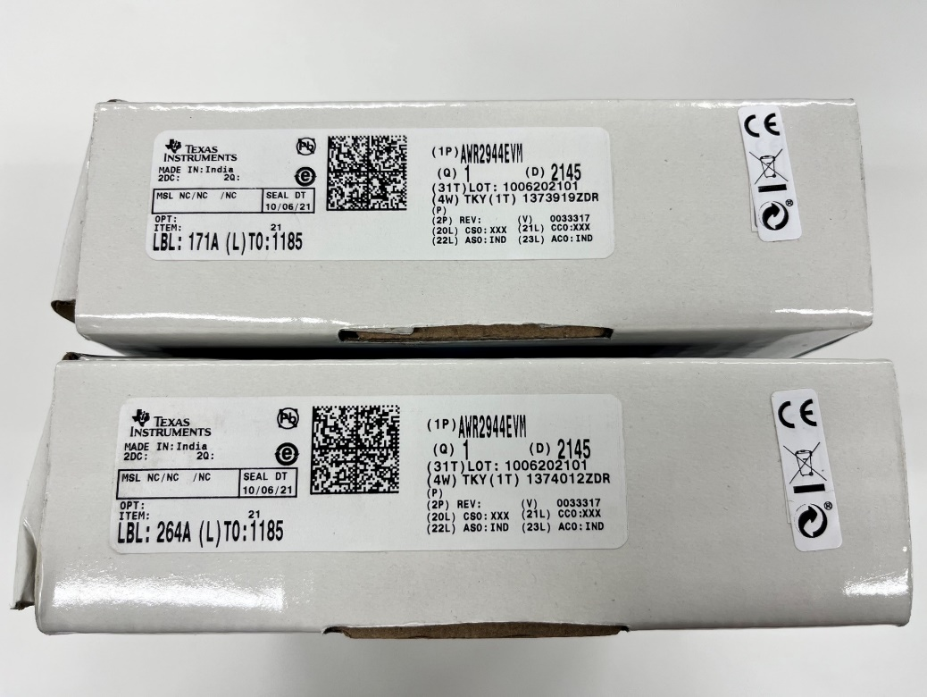

>customer request: replacement or refund

replacement

>picture of dirty products

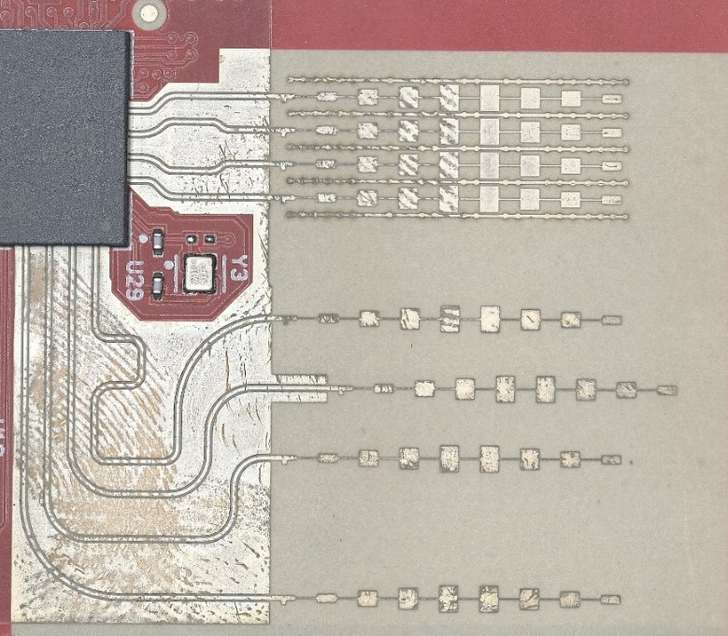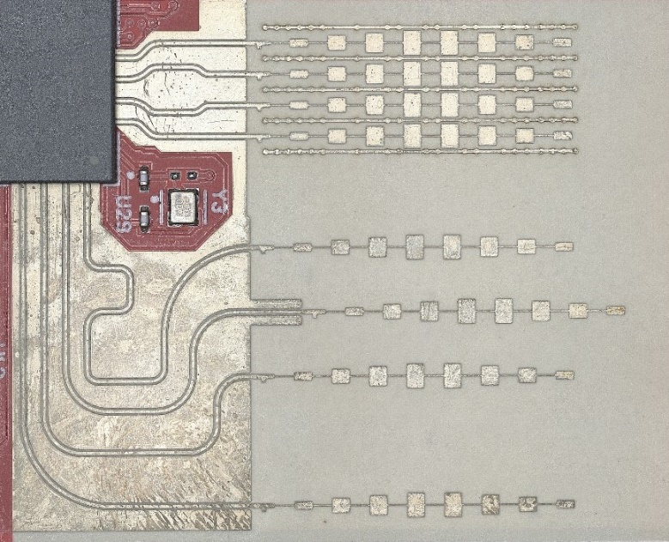

>e2e request detail and reply

