The output picture is following:
Picture for question 1:
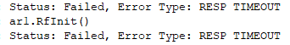
Picture for question 2:
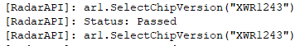
Picture for question 3:
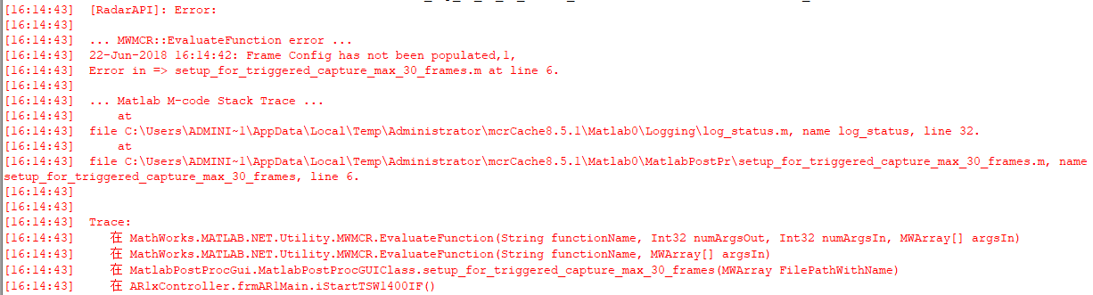
I pasted all of the output if necessary,as following:
