Bootloader UART Commands for xWRL6432 RBL

UART Protocol
The UART protocol involves a simple command-response flow. Host sends the command packet to XWR device and waits for the response from the device. Host can’t initiate another command before receiving the response of the previous command. Each command packet is immediately processed by the bootloader without any scheduling or processing in the background, and a valid response packet is sent. Each command has a known response packet associated with it and host application is responsible for validating the same.

Packet Format

Command packet format
The command packet consists of a sync pattern(0xAA) of 1 byte, 2 bytes to specify length of the packet, 1 byte of checksum for payload bytes and payload of max 252 remaining bytes.
Note - The length bytes are transmitted in big endian format with MSB byte transmitted followed by the LSB byte.
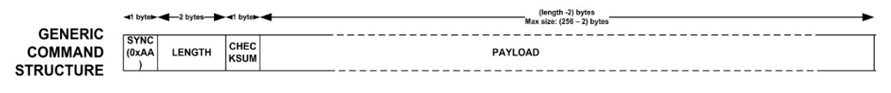

Response packet format
The response packet is same as the command packet except for that there is no sync byte for the response packet.
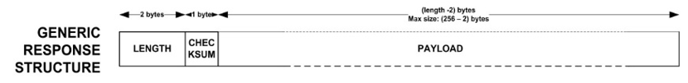

Supported Commands

Ping command
The ping command can be issued by the host for verifying the UART connection with XWR device.
Command Packet -
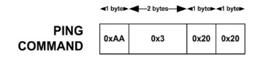

Response Packet – Ack response packet
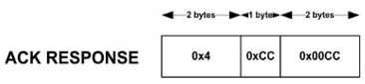

Get status command (execution status of last command)
The get status command can be issued by the host for getting the error code associated with the execution of previous command. This should be issued only after receiving the response of the previous command. For example, after receiving NACK response for a command, this command can be issued to determine the error information which resulted in the NACK response for the latest command.
Command Packet -
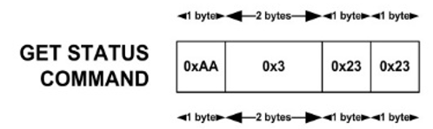
Response Packet –
LENGTH  (2 bytes) |  | CHKSUM  (1 byte) | PAYLOAD  (8 bytes)
0x00 (MSB) | 0x0A (LSB) | CHKSUM  (1 byte) | Error status  = 0 No error in execution of previous command  ≠ 0 Error code set by execution of previous command

Get version command
This command can be issued to get version information for the ROM bootloader.
Command Packet -
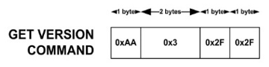
Response Packet –
LENGTH  (2 bytes) |  | CHKSUM  (1 byte) | PAYLOAD (12 bytes)
0x00 (MSB) | 0x0E (LSB) | CHKSUM  (1 byte) | ROM Version information  (4 bytes)  byte [0] = Build version  byte [1] = Minor version  byte [2] = Major version  byte [3] = ROM Gen version | Reserved  (8 bytes)

Open download command
This command is issued by the host to open a file download context for either serial flash download or SRAM download.
Command Packet –
SYNC  (1 byte) | LENGTH  (2 bytes) |  | CHKSUM  (1 byte) | PAYLOAD  (17 bytes)
0xAA | 0x00 (MSB) | 0x13 (LSB) | CHKSUM  (1 byte) | Opcode  (1 byte) | 0x21
 |  |  |  | FILE_SIZE  (4 bytes) | Size of image
 |  |  |  | STORAGE_TYPE  (4 bytes) | 0x2 = Serial flash  0x4 = SRAM  Others = Reserved
 |  |  |  | FILE_TYPE  (4 bytes) | Note – This field is read only if STORAGE_TYPE is serial flash  0x4: META_IMAGE1 (0KB offset)  0x5: META_IMAGE2 (512KB offset)  0x6: META_IMAGE3 (1024KB offset)  0x7: META_IMAGE4 (1536KB offset)  Others = Reserved
 |  |  |  | RESERVED  (4 bytes) | 0x0
Note – FILE_SIZE, STORAGE_TYPE and FILE_TYPE should be transmitted in big endian fashion similar to the length bytes of the protocol packets.
Response packet –
If there is no error in specified configuration ACK response is sent.
Else NACK response is sent –
LENGTH  (2 bytes) |  | CHKSUM  (1 byte)  0x33 | PAYLOAD  (2 bytes)
0x00 (MSB) | 0x4 (LSB) | CHKSUM  (1 byte)  0x33 | 0x0033

Send SFLASH download chunk command
This command is used to send the image chunks, 1…..n, after the “open download command” is issued.
Command packet -
SYNC  (1 byte) | LENGTH  (2 bytes) |  | CHKSUM  (1 byte) | PAYLOAD  Chunks 1…n-1: 240 + 1(for opcode) bytes  Chunk n: remaining bytes < 240 + 1(for opcode)
0xAA | 0x00 (MSB) | Chunks 1…n-1: 243 bytes (LSB)  Last chunk n: Remaining image bytes + 0x1 (for opcode) + 0x2 (for length bytes of protocol packet) | CHKSUM  (1 byte) | 0x24 (opcode) | Image data

Response packet –
If there is no error in specified configuration ACK response is sent.
Else NACK response is sent –
LENGTH  (2 bytes) |  | CHKSUM  (1 byte)  0x33 | PAYLOAD  (2 bytes)
0x00 (MSB) | 0x4 (LSB) | CHKSUM  (1 byte)  0x33 | 0x0033

Send SRAM download chunk command
This command is used to send the image chunks, 1…..n, after the “open download command” is issued.
Command packet -
SYNC  (1 byte) | LENGTH  (2 bytes) |  | CHKSUM  (1 byte) | PAYLOAD  Chunks 1…n-1: 240 + 1(for opcode) bytes  Chunk n: remaining bytes < 240 + 1(for opcode)
0xAA | 0x00 (MSB) | Chunks 1…n-1: 243 bytes (LSB)  Last chunk n: Remaining image bytes + 0x1 (for opcode) + 0x2 (for length bytes of protocol packet) | CHKSUM  (1 byte) | 0x26 (opcode) | Image data

Response packet –
If there is no error in specified configuration ACK response is sent.
Else NACK response is sent –
LENGTH  (2 bytes) |  | CHKSUM  (1 byte)  0x33 | PAYLOAD  (2 bytes)
0x00 (MSB) | 0x4 (LSB) | CHKSUM  (1 byte)  0x33 | 0x0033

Close download command (SFLASH)
This command is used to close the download context for SFLASH.
Command packet -
SYNC  (1 byte) | LENGTH  (2 bytes) |  | CHKSUM  (1 byte) | PAYLOAD  (5 bytes)
0xAA | 0x00 (MSB) | 0x7 (LSB) | CHKSUM  (1 byte) | Opcode  (1 byte) | 0x22
 |  |  |  | STORAGE_TYPE  (4 bytes) | 0x2 = Serial flash
Note – STORAGE_TYPE should be transmitted in big endian fashion similar to the length bytes of the protocol packets.
Response packet –
If there is no error in specified configuration ACK response is sent.
Else NACK response is sent –
LENGTH  (2 bytes) |  | CHKSUM  (1 byte)  0x33 | PAYLOAD  (2 bytes)
0x00 (MSB) | 0x4 (LSB) | CHKSUM  (1 byte)  0x33 | 0x0033

Close download command (SRAM)
This command is used to close the download context for SRAM.
Command packet -
SYNC  (1 byte) | LENGTH  (2 bytes) |  | CHKSUM  (1 byte) | PAYLOAD  (5 bytes)
0xAA | 0x00 (MSB) | 0x7 (LSB) | CHKSUM  (1 byte) | Opcode  (1 byte) | 0x22
 |  |  |  | STORAGE_TYPE  (4 bytes) | 0x4 = SRAM
Note – STORAGE_TYPE should be transmitted in big endian fashion similar to the length bytes of the protocol packets.
Response packet –
There are two response packets associated with this command.
Response packet #1 -
If there is no error in specified configuration ACK response is sent.
Else NACK response is sent –
LENGTH  (2 bytes) |  | CHKSUM  (1 byte)  0x33 | PAYLOAD  (2 bytes)
0x00 (MSB) | 0x4 (LSB) | CHKSUM  (1 byte)  0x33 | 0x0033
Response packet #2 –
Response Packet –
LENGTH  (2 bytes) |  | CHKSUM  (1 byte) | PAYLOAD  (8 bytes)
0x00 (MSB) | 0x0A (LSB) | CHKSUM  (1 byte) | Error status  = 0 No error in downloading and parsing of image  ≠ 0 Error code set by downloading and parsing of image

Error codes

Error Code Bits Definition (8 bytes) | Error Description
Bits [40:0] | Reserved
Bit 41 | UART invalid Target memory -  Occurs when  1) SRAM storage type command used in SOP Device management  2) SFLASH storage type command used in SOP Functional mode
Bit 42 | UART download incomplete occurs when not full chunks received
Bit 43 | UART SFLASH download CRC mismatch – Occurs when calculated CRC not match with the expected CRC in flashing
Bits [44:63] | Reserved

Flashing Sequence
The flash programming sequence is as depicted below. The initial handshake starts with a UART break issued by the external host. This is followed by the command sequence as below.
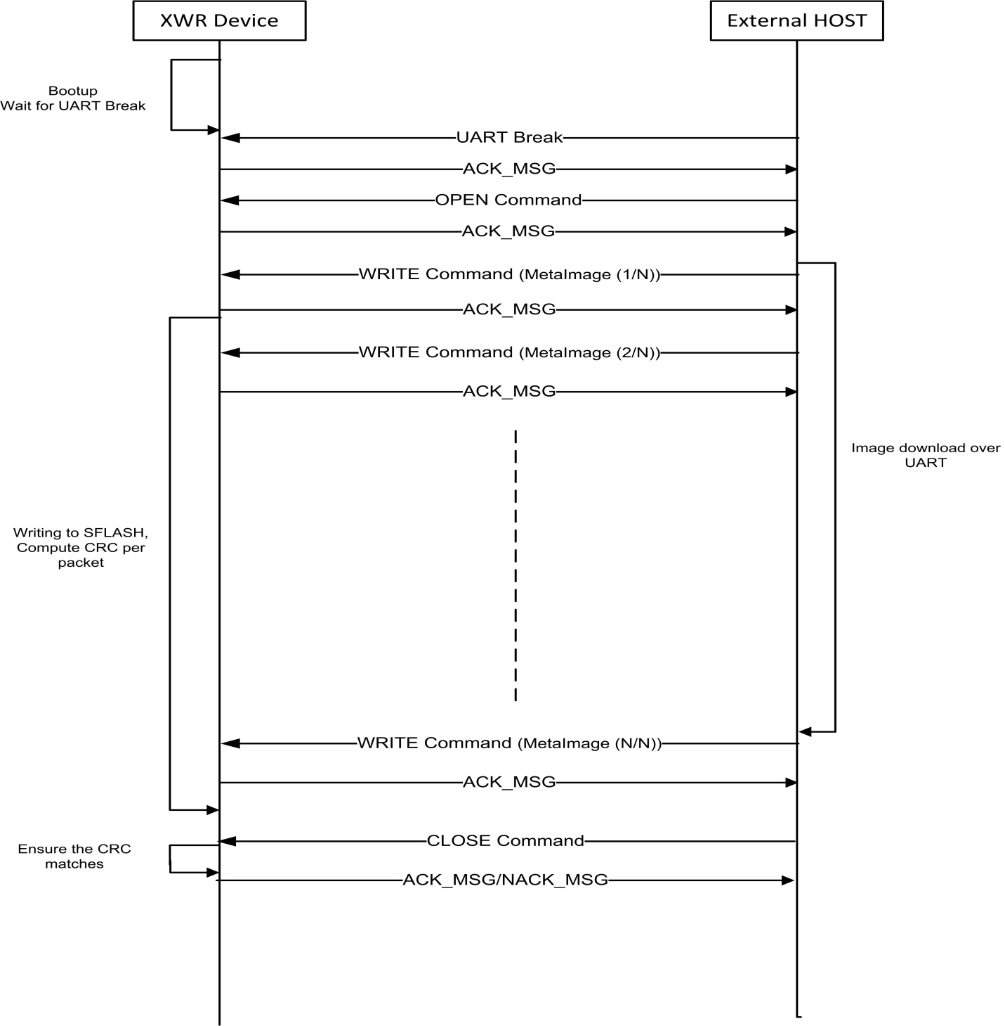
Figure 4-2 – Flashing Sequence
Booting over UART:
The bootloading over the UART also follows the same sequence as above (except that WRITE command – 0x26 and response of close command is different – refer to the supported commands for clarity). The META IMAGE received over the UART is interpreted and loaded to the appropriate memories.

