Technical Questions.

- Can we use API endpoints below to create the actual part subscription alert? We want to use the below link for phase 1 (In Phase II – We will create automation in our IT department).

- We have documented the below steps to our procurement team to create the actual part subscription

- Navigate to https://api-portal.ti.com/inventory-subscription-push-api#/InventorySubscriptions/upsertSubscription
- Authorize.
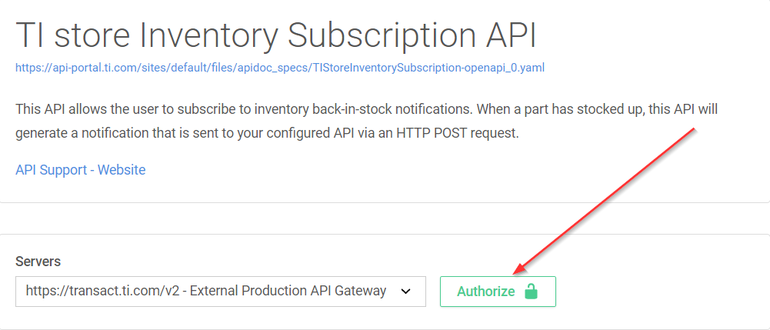
- Validate Authorization.
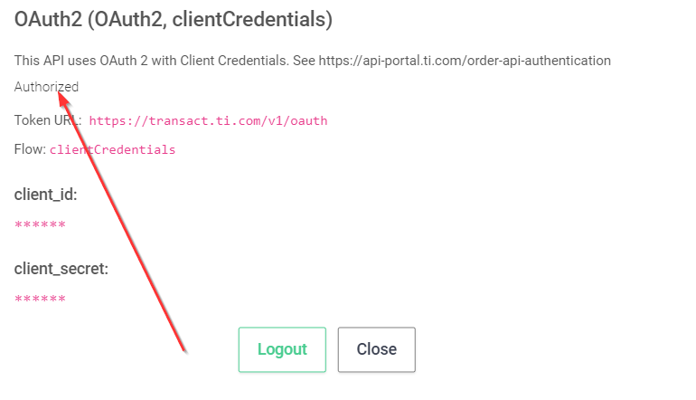

- Navigate to subscription API.
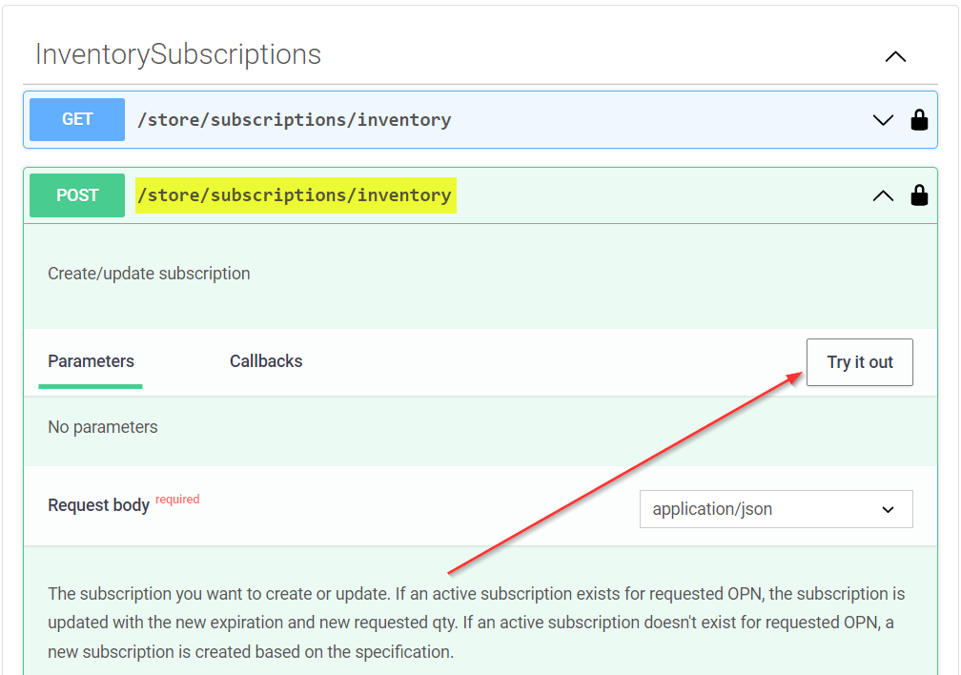

- Execute the api.
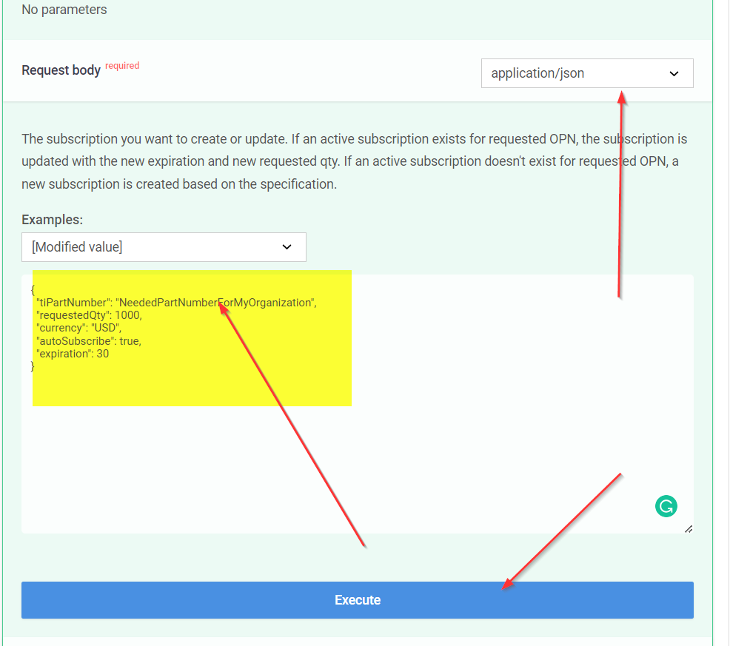

And check the response message.

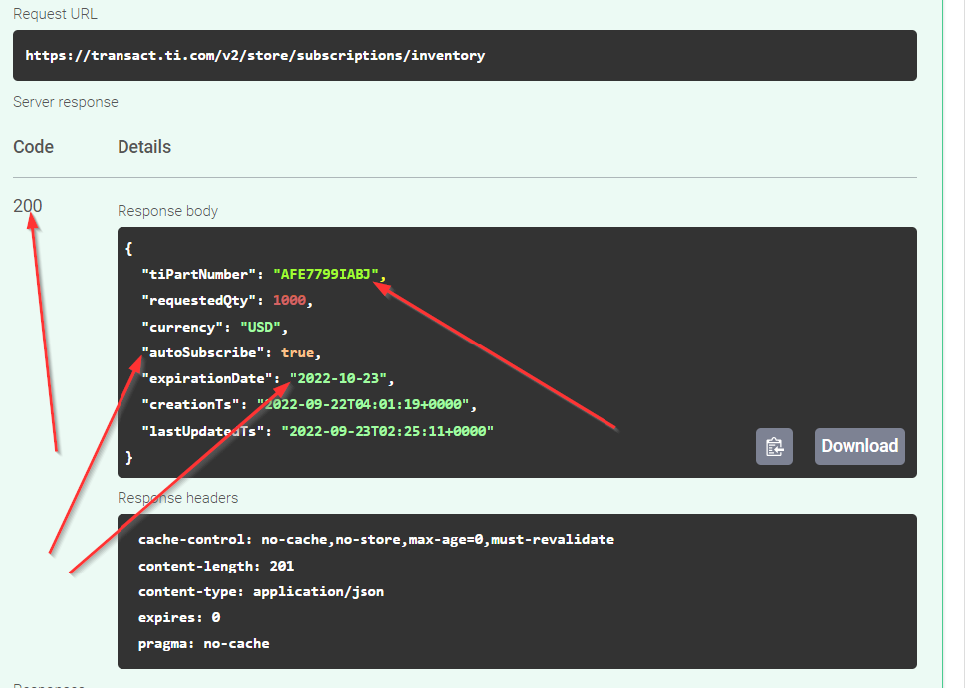

Question: Can we use this process to create the Alert for a given part(for an actual part, not a test part) via TI API?

Note: Our IT teams are also working on the IT automation to invoke these APIs from the Ciena applications, but until that time, we want to use the short-term solution as attached.

