Hi Team
I have two question for TUSB6250
1 : I have this file “TUSB6250_Firmware Programmer Users Guide”
Could you provide this tool ? [ I have v00.00.02.00.562AD403.Default.hex ]
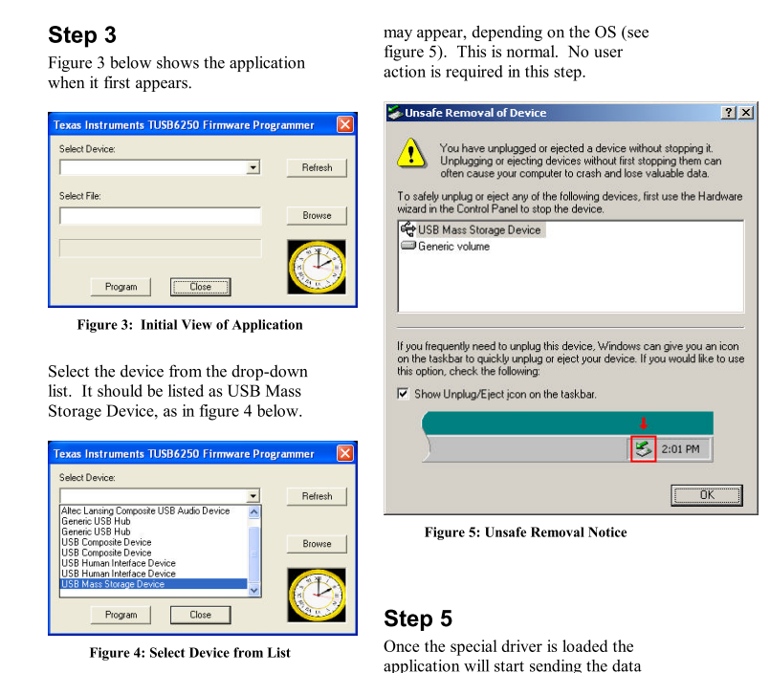
2: I have check TI TUSB6250 Bootcode Application Note
Web : http://www.ti.com/lit/an/slla126/slla126.pdf
Page 38 – 45 have 3 sample code
The files are 3 sample code.
I have use TI Header.exe to transform for CFG to BIN file. We want use TUSB6250 EEPROM Burner for programmer EERPOM.
BTW , I have some issue for those.

Commend : ex : header.exe 6250a.cfg 6250a.bin –v But have some Error
For 6250A.CFG
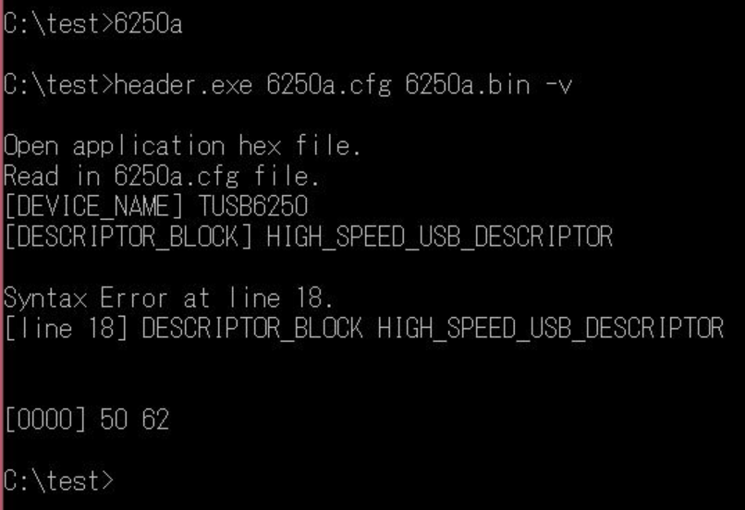
For 6250b
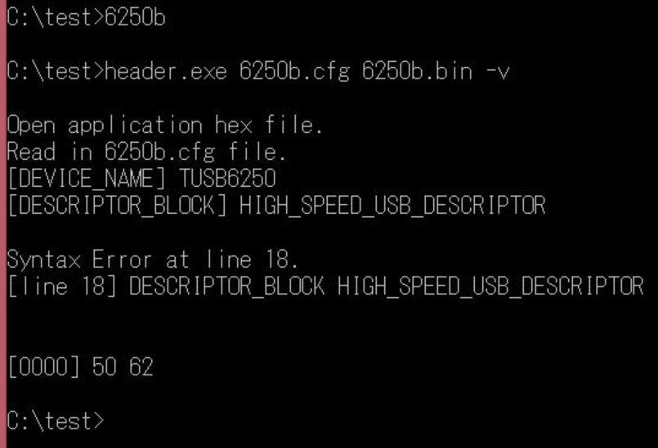

For 6250C
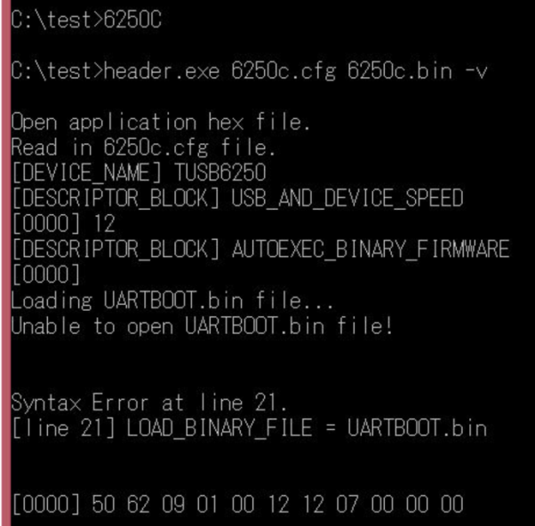
Could you provide correct CFG file for USB Mass Storage Device application ?

