15H ➔ 10 (Pre-emphasis +10%)

Pre-emphasis ok but Swing fail

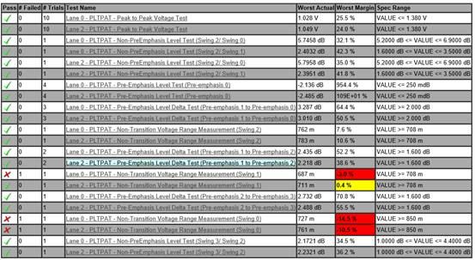

15H ➔ 14 (Pre-emphasis +10% and High TMDS output swing) 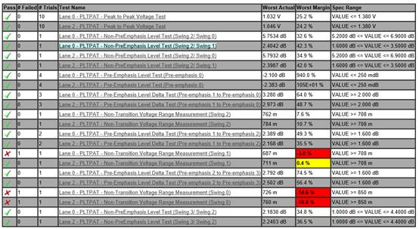

修改 15H ➔ 0E(High TMDS output swing)

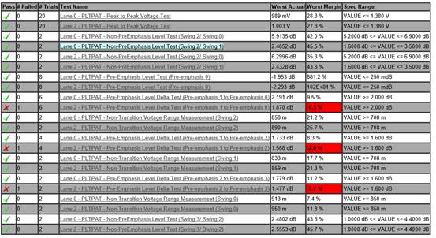

15H ➔ 00 (Pre-emphasis - 10% )  ➔ Pre-emphasis fail