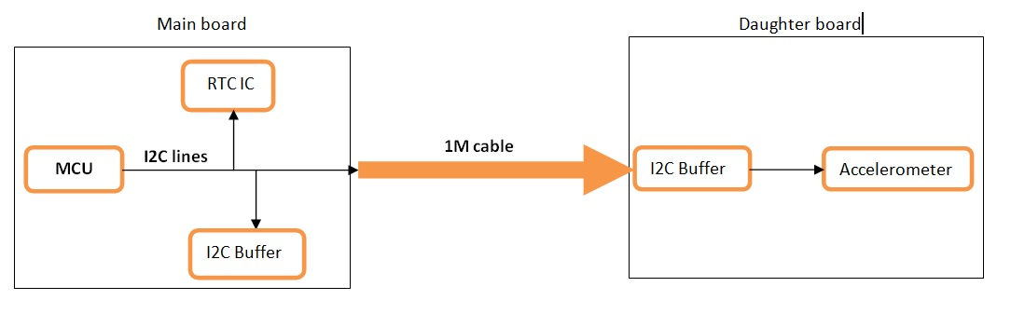

**Working board_Inclinometer NOT Working board_Inclinometer**

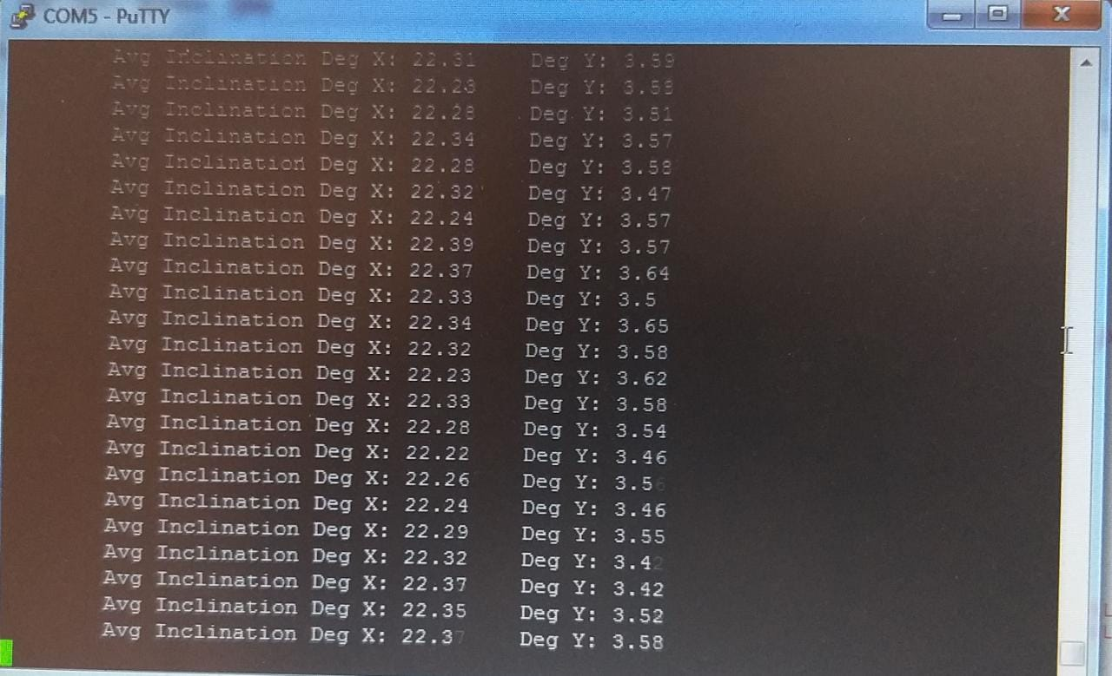 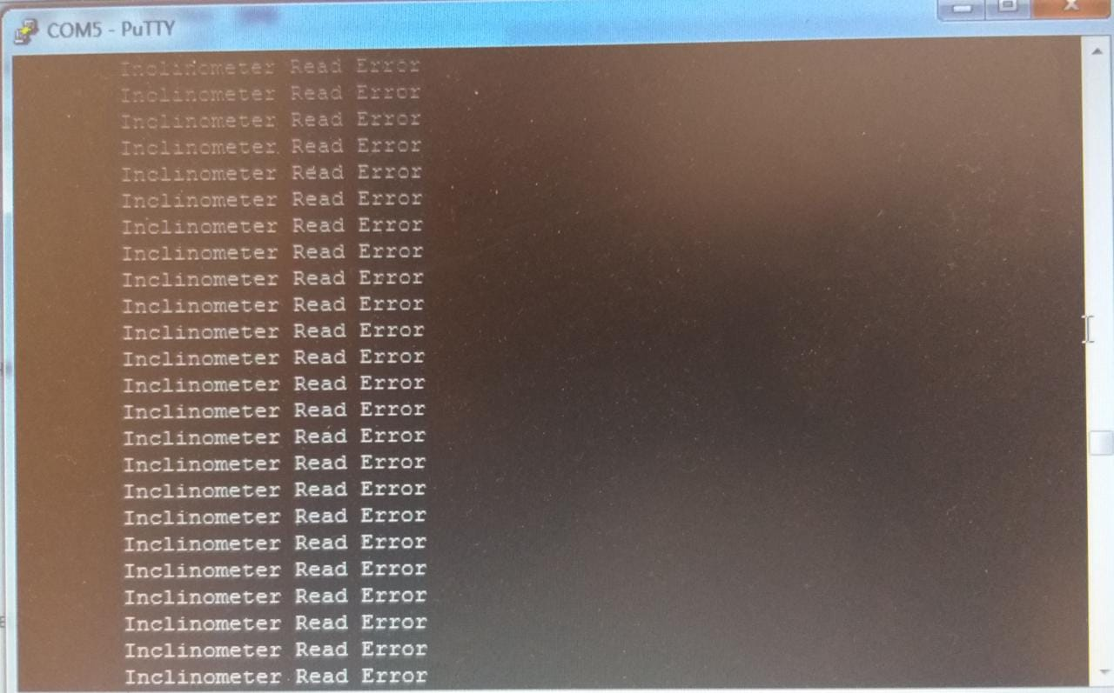

**Working board_RTC IC NOT Working board_RTC IC**

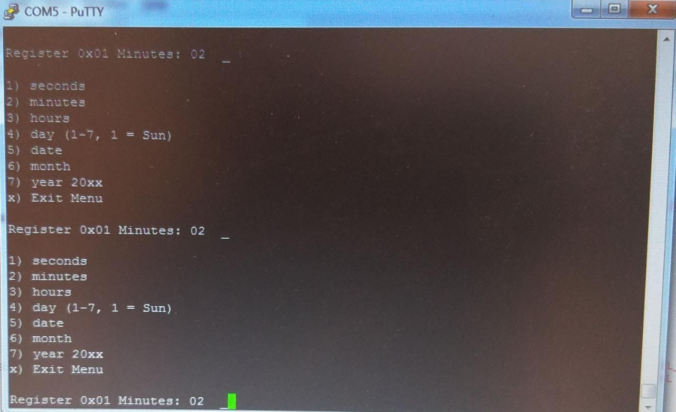 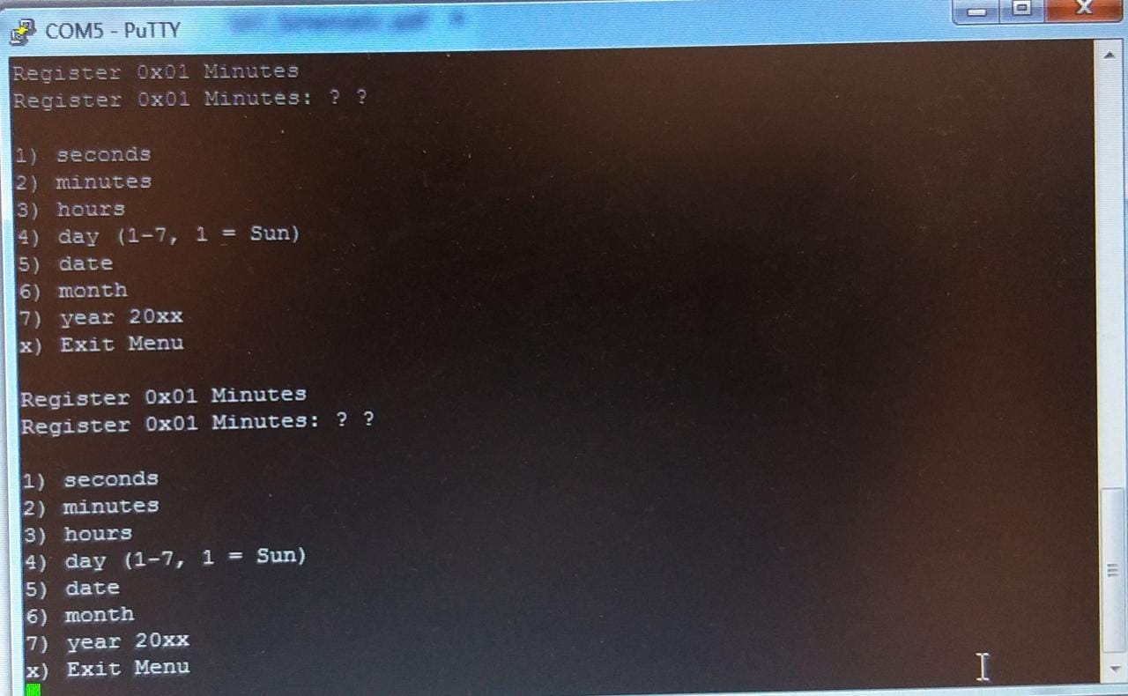

1. **SDA_U10, Working board, 3.3v**

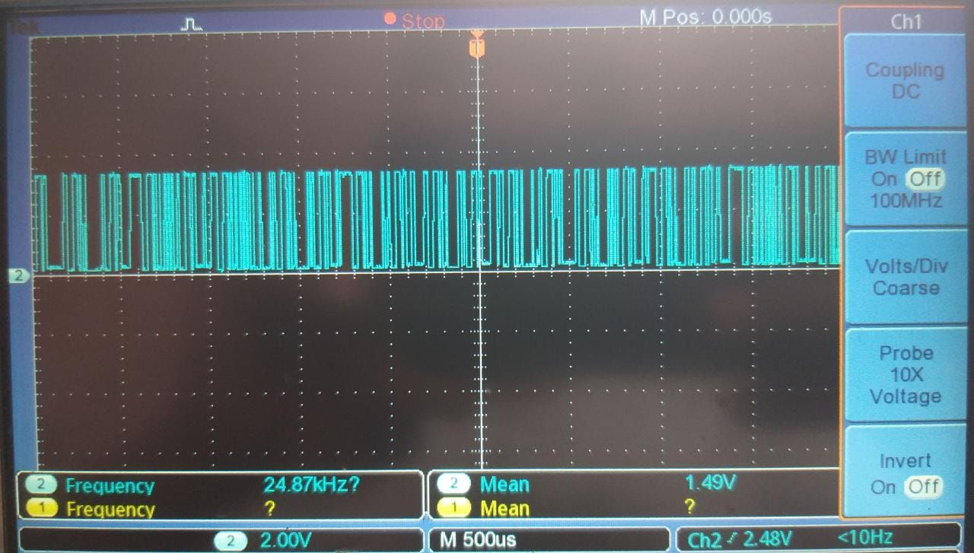

1. **SDA_U10, NOT Working board, 3.3v**

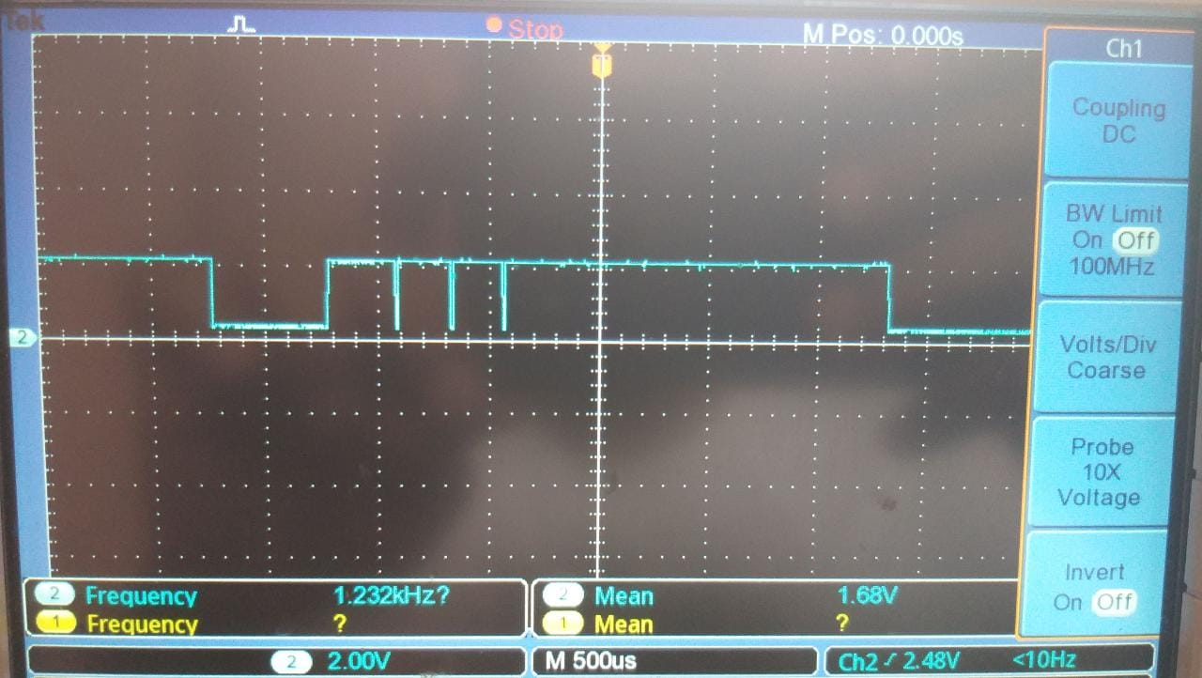

1. **SCL_U10, Working board, 3.3v**

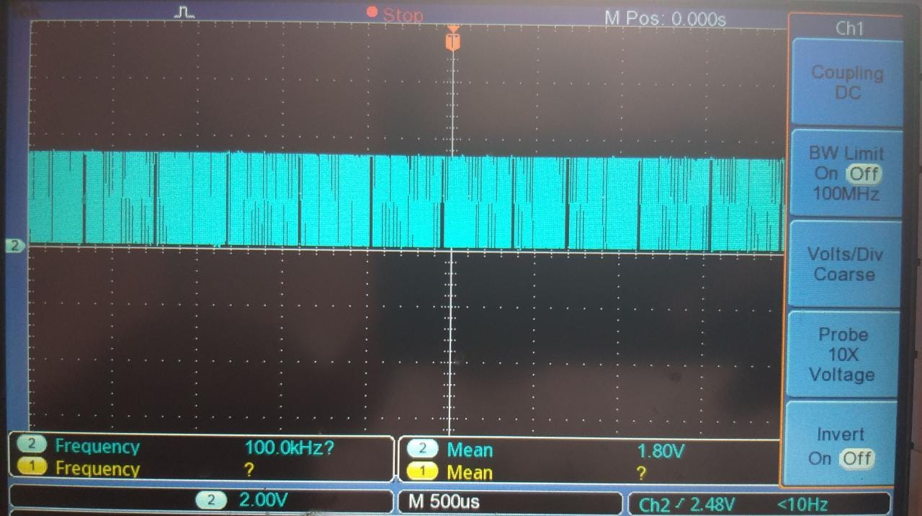

1. **SCL_U10, NOT Working board, 3.3v**

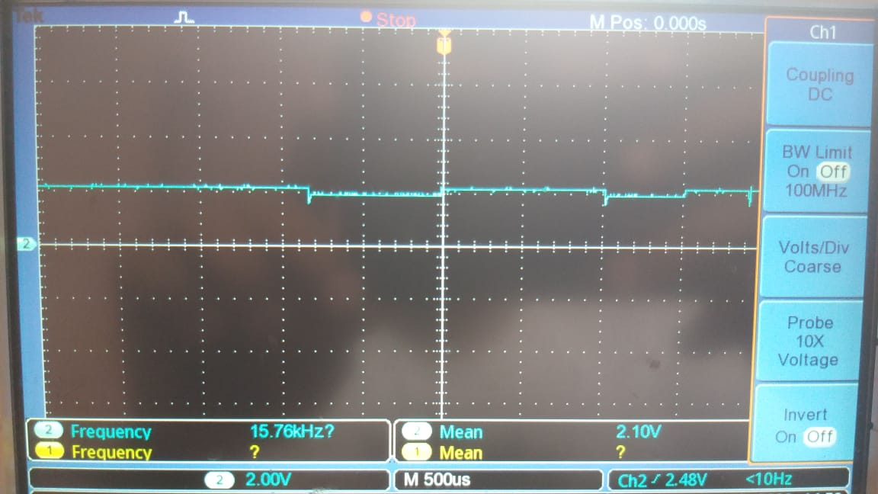

1. **SDA_U17, Working board, 3.3v**

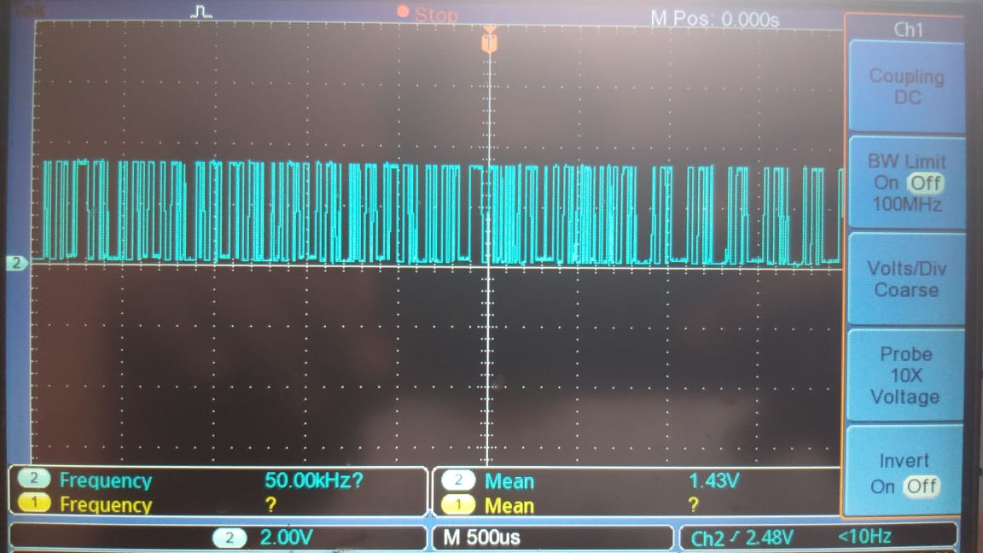

1. **SDA_U17, NOT Working board, 3.3v**

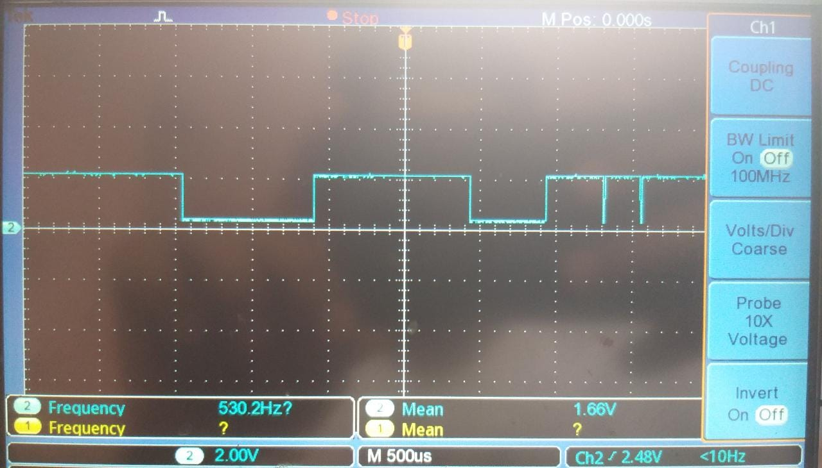

1. **SCL_U10, Working board, 3.3v**



1. **SCL_U10, NOT Working board, 3.3v**
2. **LX_U17, Working board, 3.3v**

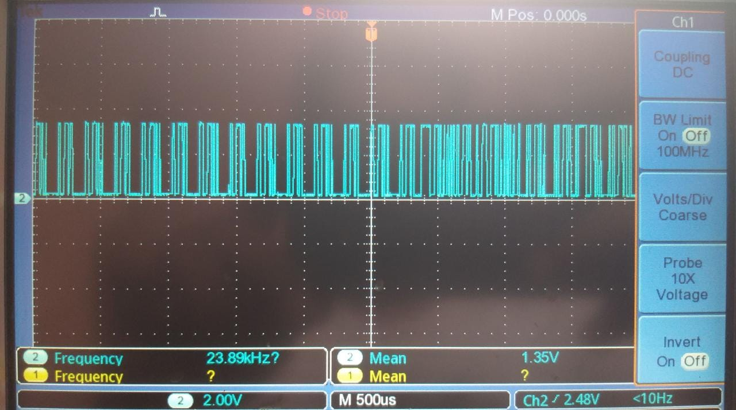

1. **LX_U17, NOT Working board, 3.3v**

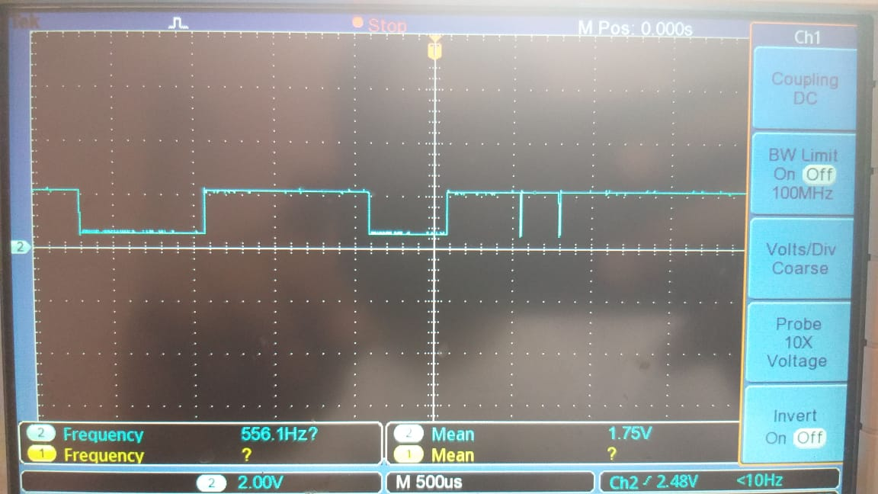

1. **LY_U17, Working board, 3.3v**

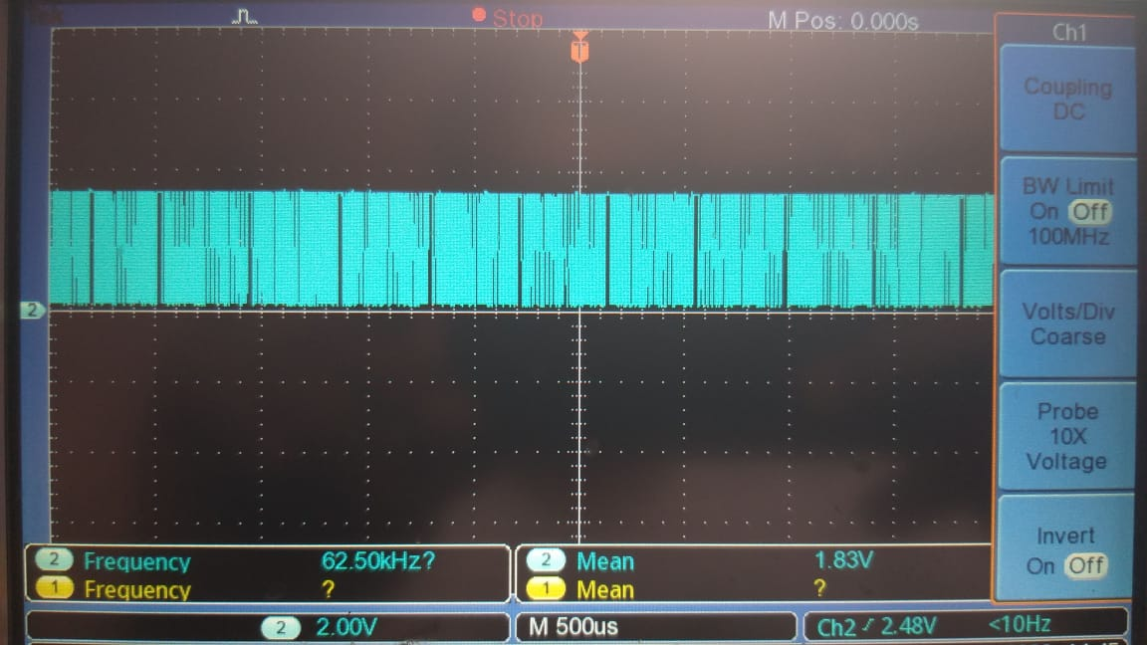

1. **LY_U17, NOT Working board, 3.3v**

