JPN | Description | MPN | MFR
513-10974 | DIODE, TVS SM 5.5VWM 11V SOT23-6 100W 4CH | TPD4E001DRLR | TEXASINSTR

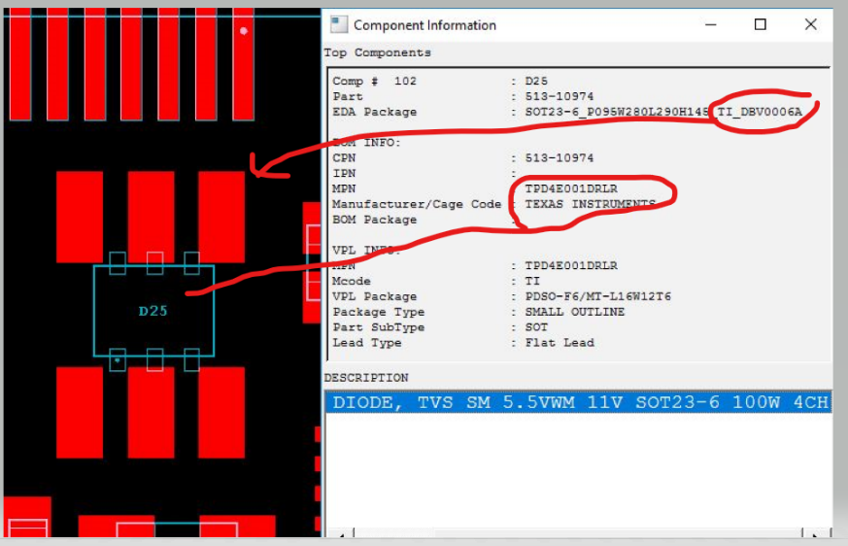
If Based on the MPN in material is this below : TPD4E001DRLR
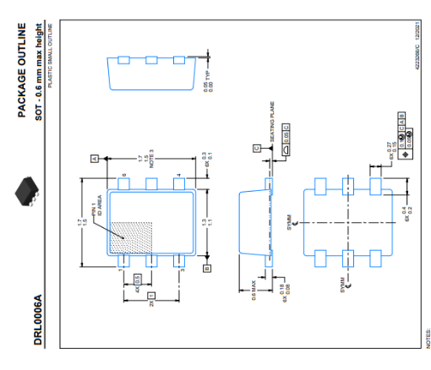
If use this MPN DRL packaging is not match with FOOTPRINT in CAD.
