Hi:
We are planning to use the TFP401 chip to receive a DVI signal with a resolution of 2560*1600, but consulting the TFP401's chip datasheet found that only 1600*1200 resolution DVi signals are supported. So we think that we can use two TFP401s to connect to the DVI interface to distinguish between the receiving parity pixels, and then splicing into a complete image using the FPGA; now we find that the DVI channel C TMDS clock pin is a pair of differential pairs, and I want to use A pair of channel C clocks are connected to RxC+ and RxC- on two TFP401s. Is this design reasonable and feasible? How to use the TFP401 to receive 2560*1600 resolution DVI interface image signal?
Regards
Figure 1 The block diagram of the DVI receive
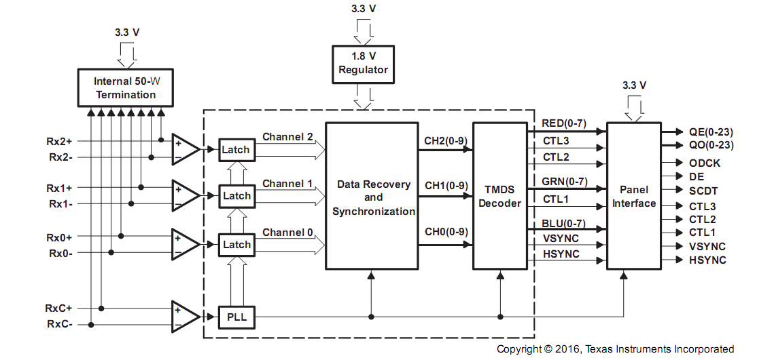
Figure 2 TFP401 Block Diagram

