1. **PROCEDURE**
   1. **FLASH MSP430 on EVM**
      1. Remove all the jumpers on the header bridge on the MSP430Launchpad

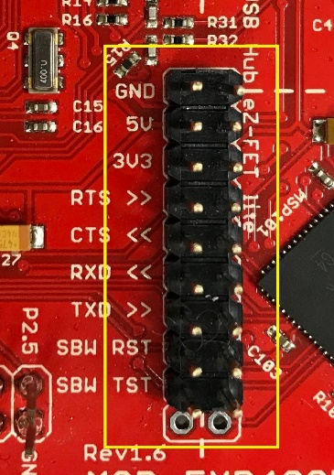 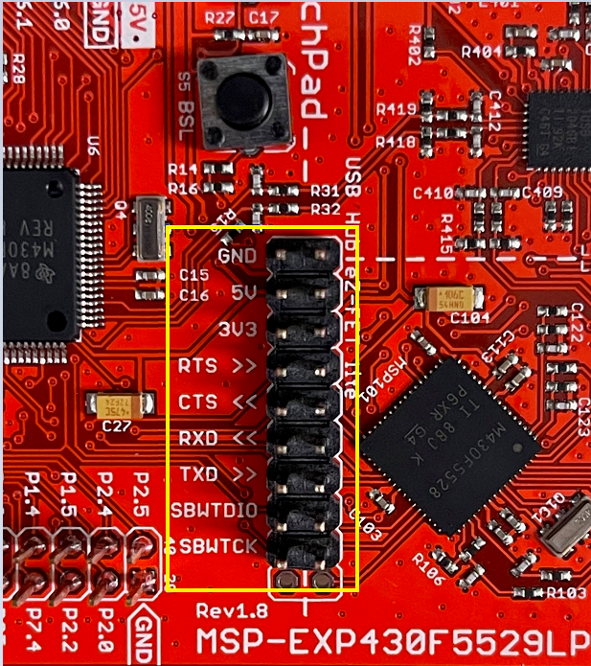

* + 1. Connect the USB cable to the micro-USB jack on the MSP430Launchpad.
    2. Connect a wire from the ‘SBW RST’ or ‘SBWTDIO’ on the MSP side (right side) of the MSP430Launchpad to the ‘RST’ pin located on the DP83TG720MC-EVM.MSP RST Pin
    3. Connect a wire from the ‘SBW TST’ or ‘SBWTCK’ on the MSP side (right side) of the MSP430Launchpad to the ‘TEST’ pin located on the DP83TG720MC-EVM.MSP TST Pin

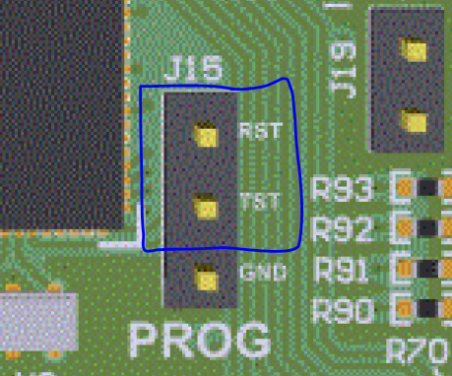

* + 1. Connect a ground pin from the MSP430Launchpad to any of the ground pins on the DP83TG720MC-EVM.
    2. Supply 5V to TP8 (TP9 is GND) on the 5-36V to turn on board
    3. Connect the other end of the USB cable to a computer with UniFlash installed and firmware files loaded.
    4. After making the connections as mentioned above, open the UNIFLASH software.

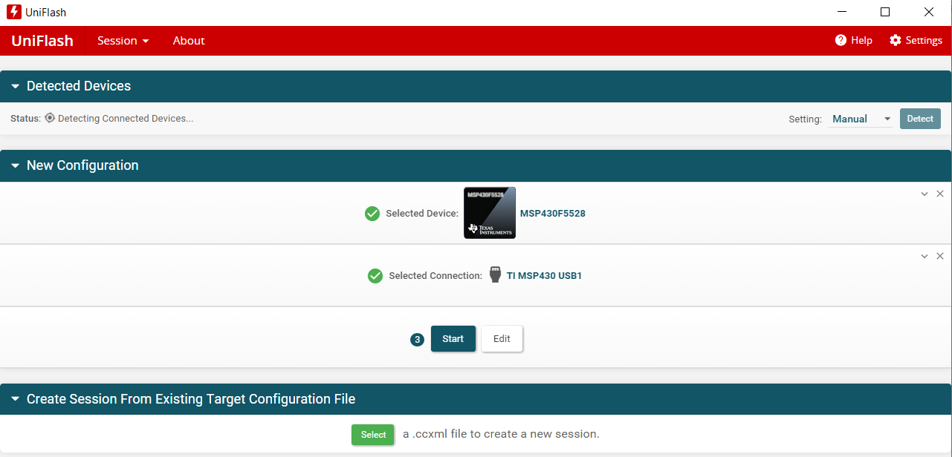

* + 1. After opening the UNIFLASH software, MSP430F5528 launch pad should be detected automatically by the software. If does not happen, check in device manager if MSP430 Com Port has been properly identified. Sometimes the MSP430 USB Com Port may crash. In such case, just disconnect and reconnect the MSP430 launchpad from windows PC.
    2. In the select device section, type ‘MSP430F5528’ and click on the device.
    3. Then in the connection section, select the ‘TI MSP430 USB1’ connection.
    4. Click Start.
    5. In the next page, there will be a option to load the firmware file. Click on ‘Browse’ and route to the location on PC where ‘msp430-usb-to-mdio-universal-v3.04.txt’ is located. This will be provided with the Test procedure document.

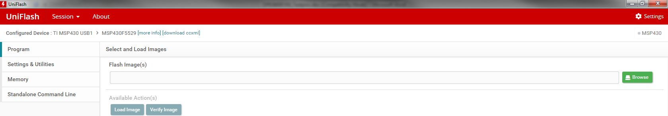

* + 1. Once the firmware file is located and the file path shows in UNIFLASH, click on Load Image. A load screen should start.