TX_CLK and RX_CLK signal similarly.

1. TX_CLK has a constant frequency of 2.5MHz when NO ethernet cable is connected.

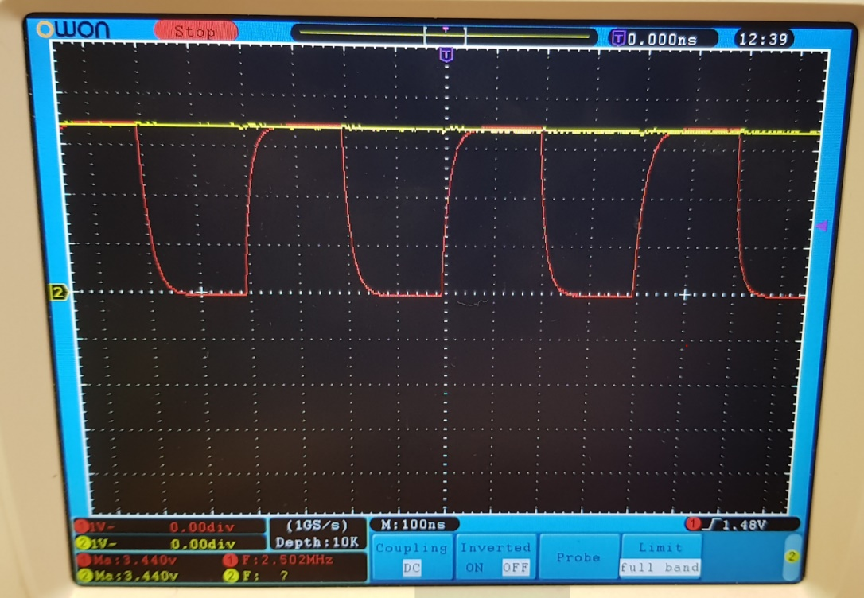

TX_CLK – RED

RD_M – YELLOW

1. When the ethernet cable is connected, I see the image below for about .5 seconds, then the above for about 2 seconds. This constantly repeats itself. TX and RX clock also changes to 25MHz

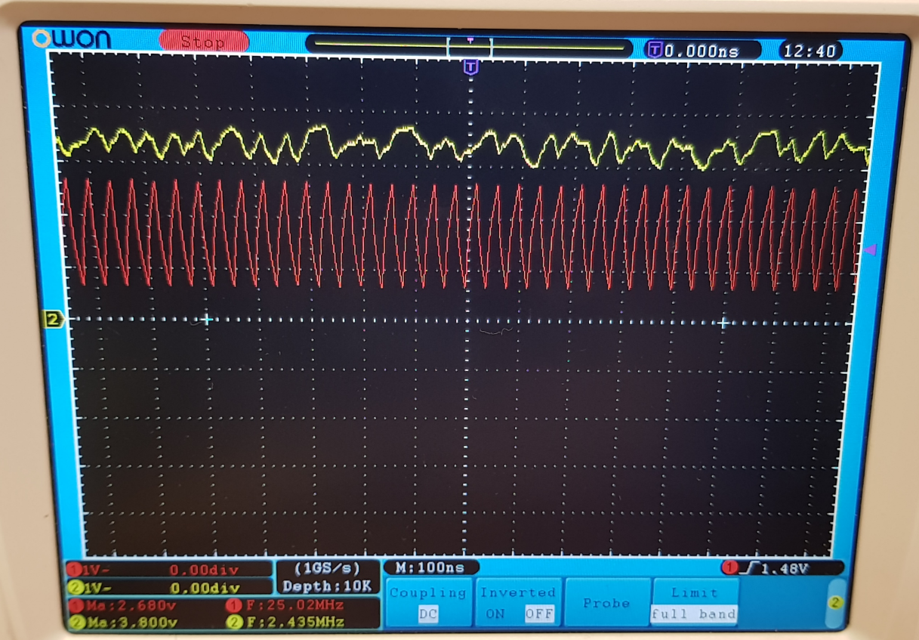

1. MDIO

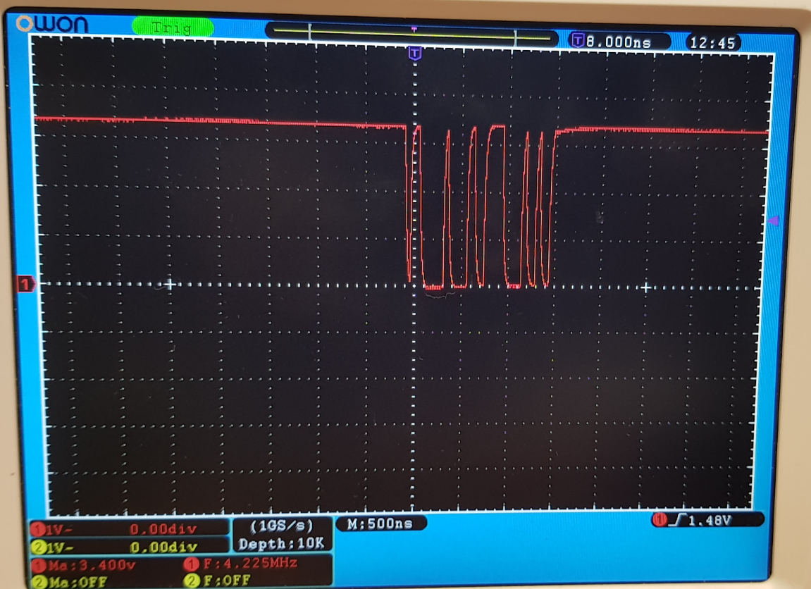

1. MDC at 20.07MHz

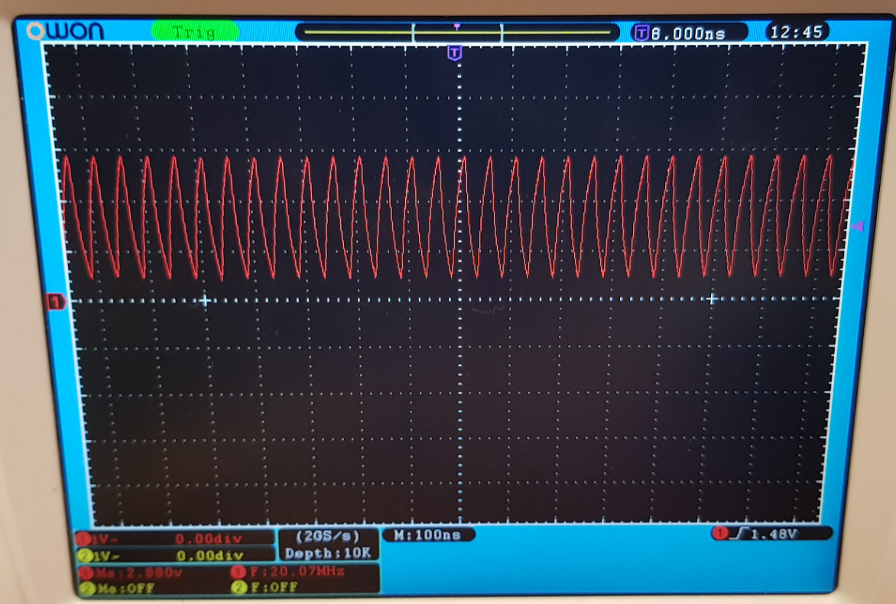

1. XO pin

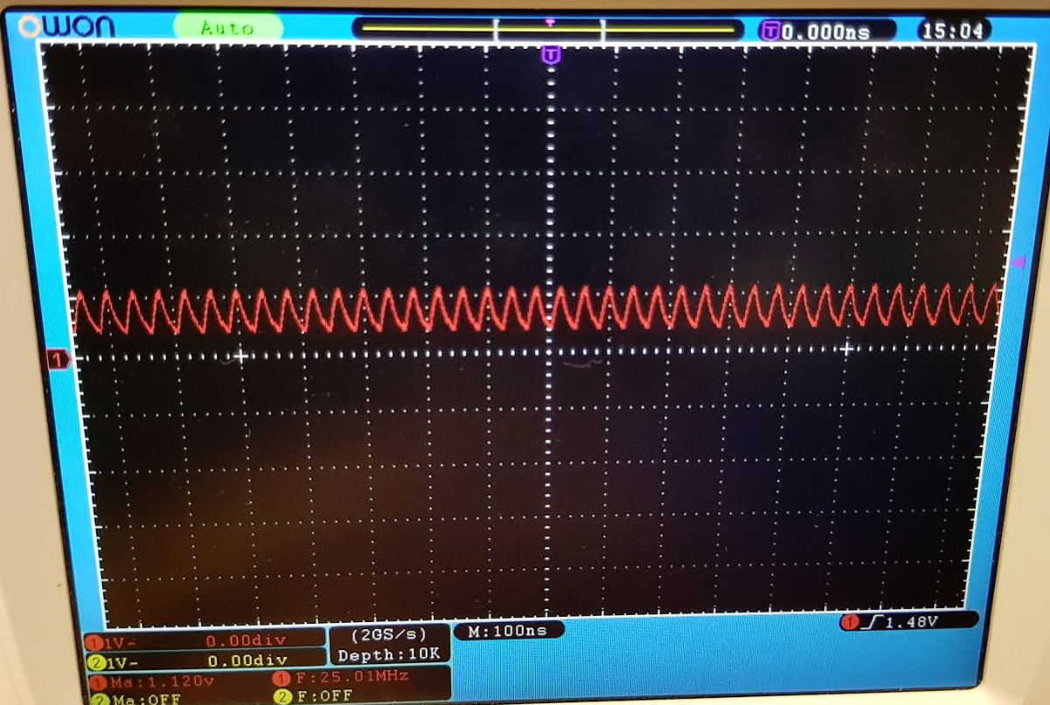

1. XI pin

