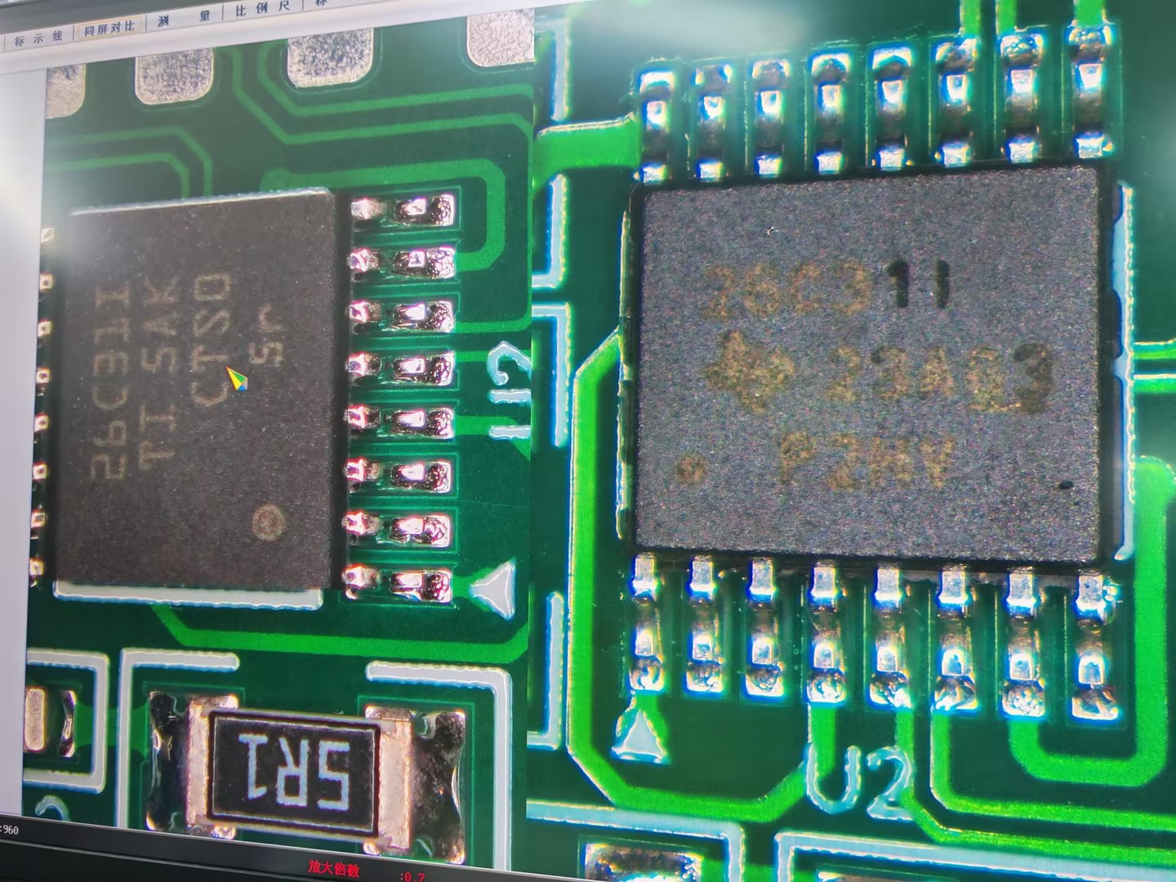
As shown in the above figure, the left side shows the AM26C31IPWR chip after the 2025 batch layout change, and the right side shows the chip before the layout change.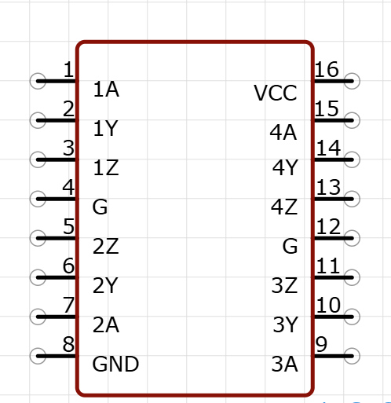
Phenomenon Description:
The impedance between the GND and signal pins of the AM26C31IPWR chip is inconsistent before and after the layout modification.
Measure the impedance between the 8-pin (GND) of the AM26C31IPWR chip and pins 2, 3, 5, 6, 7, 9, 10, 11, 13, 14, and 15 using the resistance range of a digital multimeter. Connect the red probe to the 8-pin (GND) and the black probe to the aforementioned pins. The measured value for the chip after the layout modification is approximately 0.5M, while the impedance for the previously unmodified chip is around 8M.
Question Consultation:
1.The newly revised chip measures a resistance of 0.5M, significantly lower than the previous 8M. Is this a normal phenomenon?
2. Is the impedance inconsistency caused by the addition of ESD protection modules at the pin level between the pre-layout and post-layout chips?
3. Will the impedance changes after the revision affect our normal communication usage?

