Pass/Fail Criteria (During Test): For the test mode(s) given in Table 3 all DUT samples must continuously meet the acceptance criteria for each signal parameter defined in Table 4 at the “Level 2” requirement for all frequencies and modulations identified in Table 11 of GMW3097:2022.
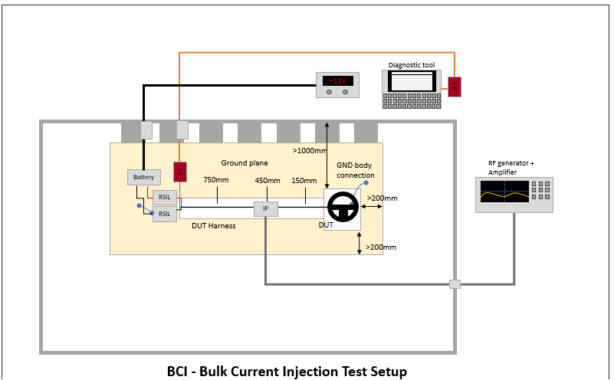
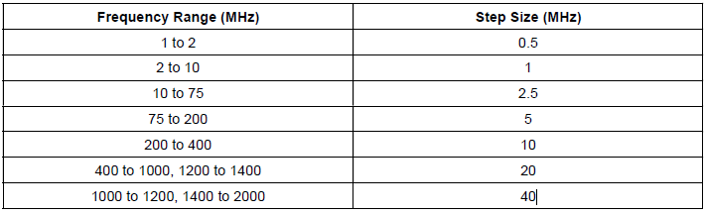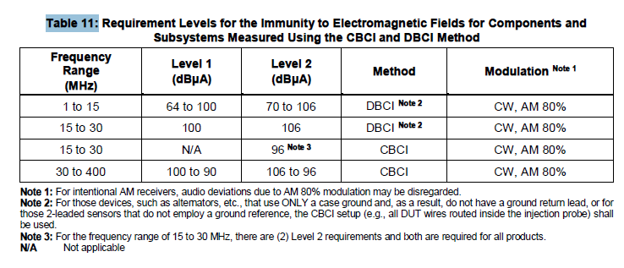
-Use wiring harness length of 1700 mm +300 mm/-0 mm.
-Dwell time: 2 s
-Position probe for DBCI: 1-30 MHz use only 150 mm and 450 mm
DBCI: 15-30 MHz use only 150 and 450 mm (level 2)
CBCI: 30-400 MHz use only 450 mm and 750 mm
Pass/Fail Criteria (Post Test): No permanent DUT damage or performance deviations shall be observed after exposure.
