EVB Charging problem

This document describes the problem we are facing using the” USB-CTM-MINIDK-EVM”.

<https://www.digikey.co.il/product-detail/en/texas-instruments/USB-CTM-MINIDK-EVM/296-46880-ND/7219507>

I need to charge a Tablet that is connected to the EVB board according to the picture below

As soon as we connect the Device to the USB Type A connector (Marked as D), and the Tablet is connected to one of the C Type connectors (Marked B or C), the well Sense board is being detected on the Tablet but the Tablet is not being charged.

The Input power is inserted using the Type C connector using a charger with up to 2A (Marked as A)

POWER IN

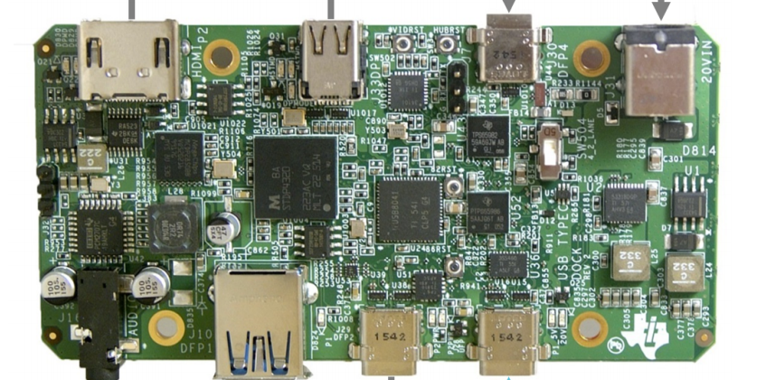

D

C

B

A

Device Board

Tablet

We need to have the ability to charge the Tablet using the configuration above