

RK-3399:

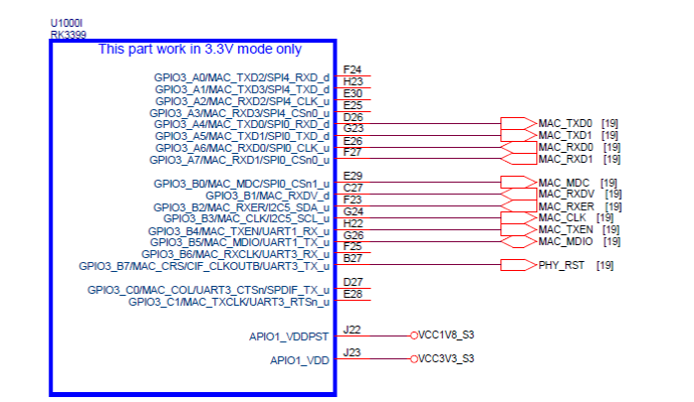

DP83825IRMQR SCH:

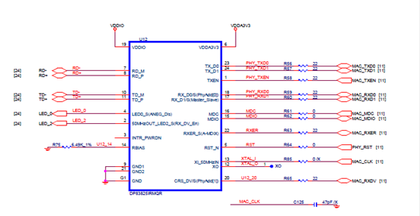

**1> MDC Signal waveform**

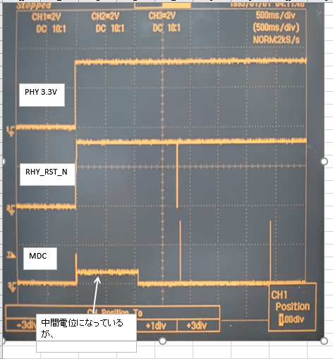

When the PHY is started, the midway voltage (intermediate potential) is applied to the MDC. Is there any problem in this part? (Please refer to the MDC signal waveform table)

**RESET TIMING**

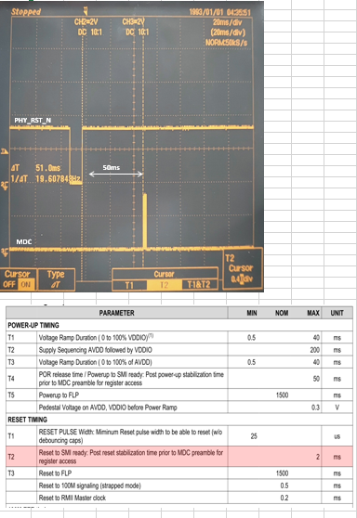

T2: MAX.: 2ms

The actual measured value is 50ms.

Will this be a problem?