RESET With R442 (RXD3)
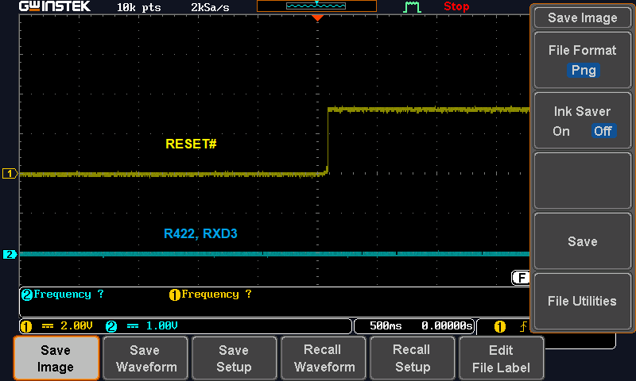

RESET With R447 (RXD2)

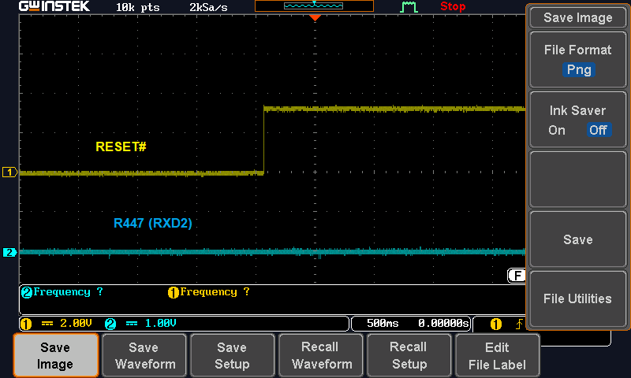

RESET With R444 (JTAG_TDO)
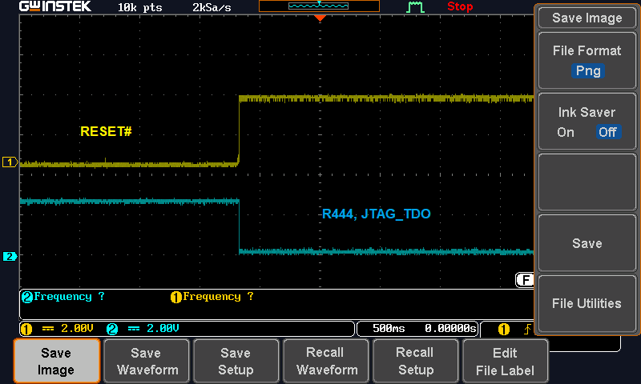

RESET With R449 (RXCTL)

