DS125111 retimer De - emphasis tunning result

i2cset -y 0 0x19 0x15 0x10 (de - emphasis = 0db)

i2cset -y 0 0x19 0x2d 0x84 (VOD = 1V )

eye diagrams and Tjitter measurement :

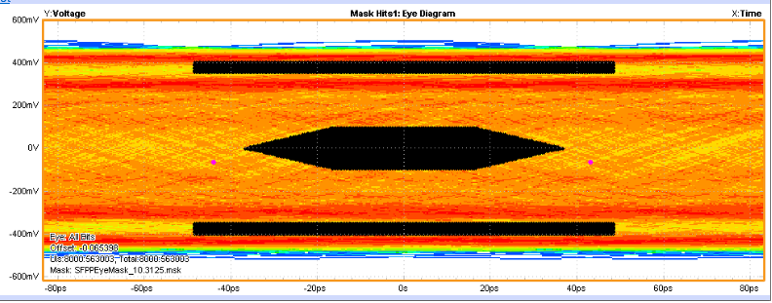

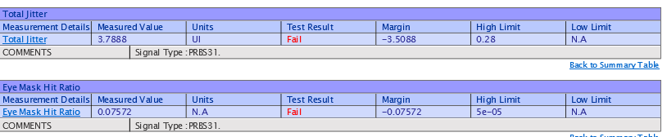

i2cset -y 0 0x19 0x15 0x10 (de - emphasis = 0db)

i2cset -y 0 0x19 0x2d 0x87 (VOD = 1.3V )

eye diagrams and Tjitter measurement :

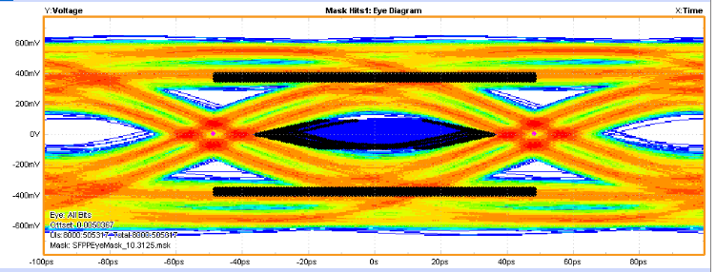

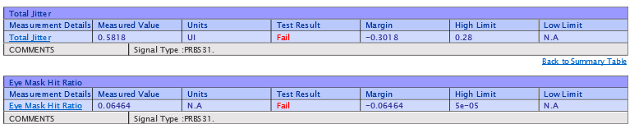

i2cset -y 0 0x19 0x15 0x12 (de - emphasis = -3.5db)

i2cset -y 0 0x19 0x2d 0x84 (VOD = 1V )

eye diagrams and Tjitter measurement :

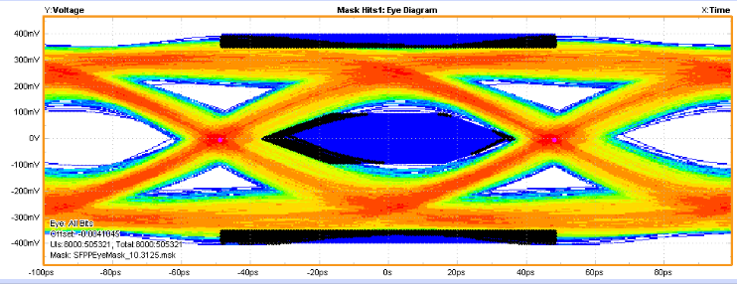

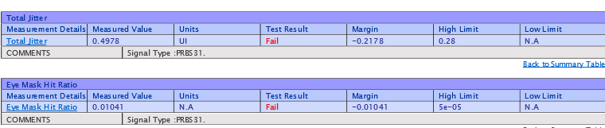

i2cset -y 0 0x19 0x15 0x12 (de - emphasis = -3.5db)

i2cset -y 0 0x19 0x2d 0x87 (VOD = 1.3V )

eye diagrams and Tjitter measurement :

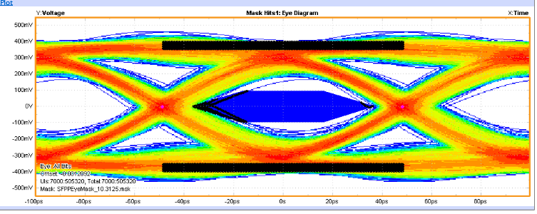

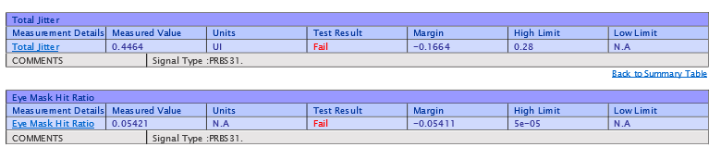

i2cset -y 0 0x19 0x15 0x14 (de - emphasis = -6db)

i2cset -y 0 0x19 0x2d 0x84 (VOD = 1V )

eye diagrams and Tjitter measurement :

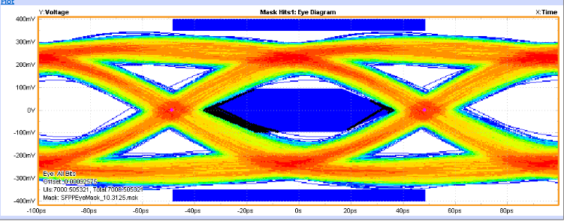

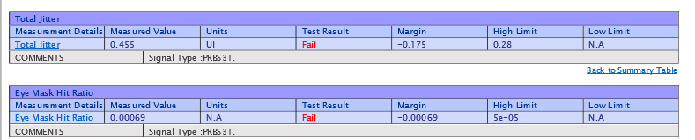

i2cset -y 0 0x19 0x15 0x14 (de - emphasis = -6db)

i2cset -y 0 0x19 0x2d 0x87 (VOD = 1.3V )

eye diagrams and Tjitter measurement :

